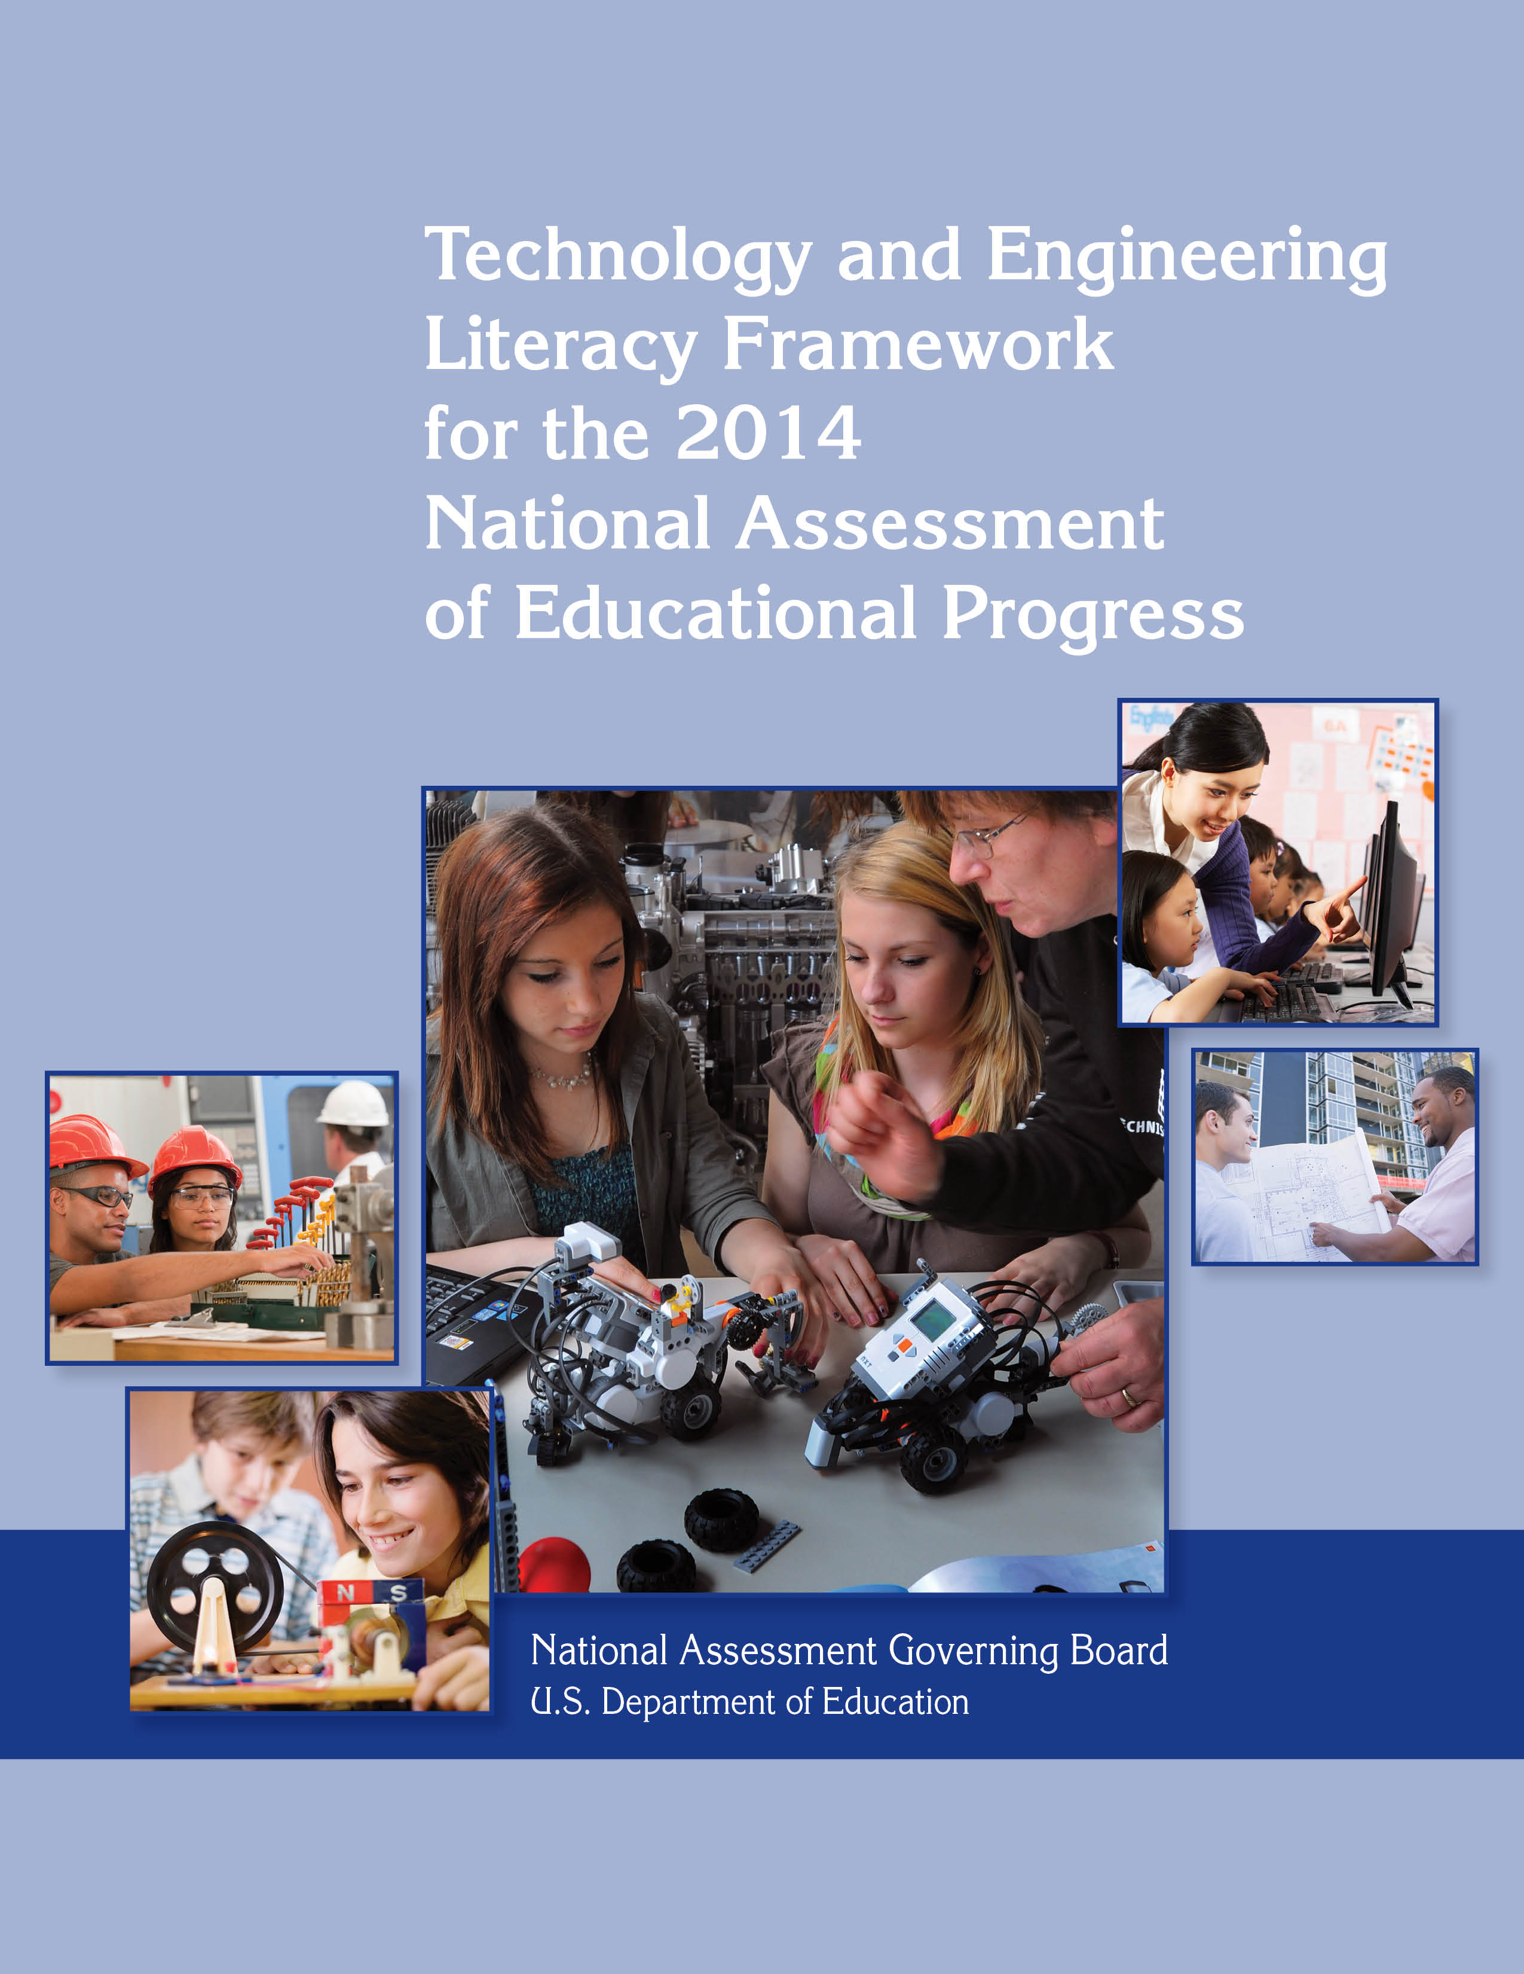
The National Assessment Governing Board

The National Assessment Governing Board was created by Congress to formulate policy for the National Assessment of Educational Progress (NAEP). Among the Board’s responsibilities are developing objectives and test specifications, and designing the assessment methodology for NAEP.

Members
Honorable David P. Driscoll,
Chair
Former Commissioner of Education
Melrose, Massachusetts

Susan Pimentel, Vice Chair
Educational Consultant
Hanover, New Hampshire

Andrés Alonso
Professor of Practice
Harvard Graduate School of Education
Harvard University
Cambridge, Massachusetts

Louis M. Fabrizio
Data, Research and Federal Policy Director
North Carolina Department of Public Instruction
Raleigh, North Carolina

Honorable Anitere Flores
Senator
Florida State Senate
Miami, Florida

Alan J. Friedman
Consultant
Museum Development and Science Communication
New York, New York

Rebecca Gagnon
School Board Member
Minneapolis Public Schools
Minneapolis, Minnesota

Shannon Garrison
Fourth-Grade Teacher
Solano Avenue Elementary School
Los Angeles, California
Doris R. Hicks
Principal and Chief Executive Officer
Dr. Martin Luther King, Jr. Charter School for Science and Technology
New Orleans, Louisiana

Andrew Dean Ho
Associate Professor
Harvard Graduate School of Education
Harvard University
Cambridge, Massachusetts

Honorable Terry Holliday
Commissioner of Education
Kentucky Department of Education
Lexington, Kentucky

Richard Brent Houston
Assistant Superintendent
Shawnee Public Schools
Shawnee, Oklahoma

Hector Ibarra
Eighth-Grade Teacher
Belin-Blank International Center and Talent Development
Iowa City, Iowa

Honorable Tom Luna
Idaho Superintendent of Public Instruction
Boise, Idaho

Terry Mazany
President and CEO
The Chicago Community Trust
Chicago, Illinois

Tonya Miles
General Public Representative
Mitchellville, Maryland
Dale Nowlin
Twelfth-Grade Teacher
Columbus North High School
Columbus, Indiana

Joseph M. O'Keefe, S.J.
Professor
Lynch School of Education
Boston College
Chestnut Hill, Massachusetts

W. James Popham
Professor Emeritus
University of California, Los Angeles
Wilsonville, Oregon

B. Fielding Rolston
Chairman
Tennessee State Board of Education
Kingsport, Tennessee

Cary Sneider
Associate Research Professor
Portland State University
Portland, Oregon

Honorable Leticia Van de Putte
Senator
Texas State Senate
San Antonio, Texas

Ex Officio Member
John Q. Easton
Director
Institute of Education Sciences
U.S. Department of Education
Washington, D.C.

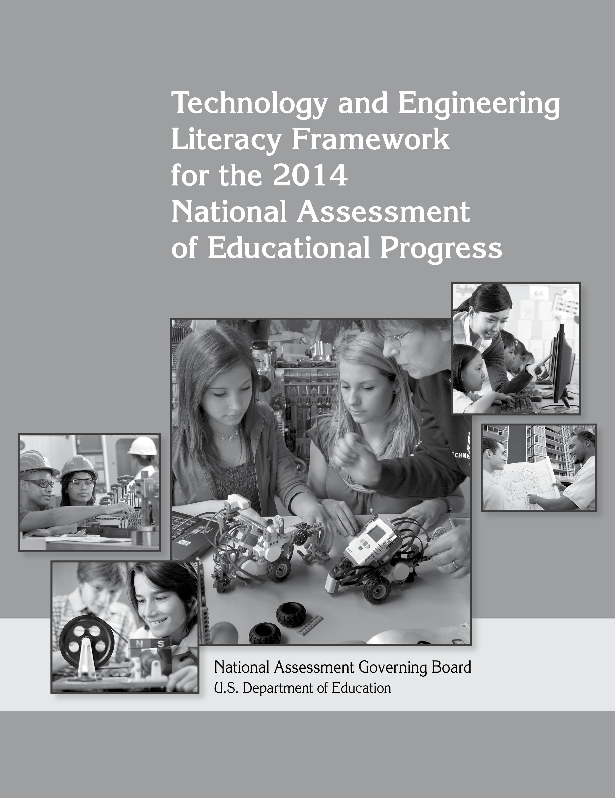

National Assessment Governing Board

Honorable David P. Driscoll
Chair

Susan Pimentel
Vice Chair

Cornelia S. Orr
Executive Director

Mary Crovo
Deputy Executive Director and
Project Officer

Michelle Blair
Senior Research Associate

Technology and Engineering Literacy Framework for the 2014 National Assessment
of Educational Progress

Developed for the National Assessment Governing Board under contract number
ED08CO0134 by WestEd

For further information, contact

National Assessment Governing Board
800 N. Capitol St. NW
Suite 825
Washington, DC 20002
www.nagb.org

September 2013
TABLE OF CONTENTS
NAEP Technology and Engineering Literacy project committees
and staff iv
Preface ix
Technology and Engineering Literacy x
Content xi
Areas of Technology and Engineering Literacy xii
Practices xii
Contexts xiii
Types of Tasks and Items xiii
Reporting Results xiv
Development of the Framework xiv
Chapter One: Overview 1-1
Need for a Framework in Technology and Engineering Literacy 1-1
Background of NAEP 1-2
Resources for Planning the Framework 1-3
Definitions of Key Terms Used in This Framework 1-4
Technology 1-5
Engineering 1-6
Technology and Engineering Literacy 1-6
Three Areas of Technology and Engineering Literacy 1-7
Three Practices 1-8
Educational Technology 1-9
The Relationship Among Science, Technology, Engineering, and Mathematics 1-10
The Framework Development Process 1-11
Summary of the Steering Committee Guidelines 1-12
Challenges of Developing the NAEP Technology and Engineering Literacy
Framework 1-13
Newness of the Endeavor 1-13
Diffuse Curriculum 1-14
Varying Definitions 1-14
Measurement Constraints 1-15
Time and Resource Constraints 1-16
Designing a Computer-Based Assessment 1-16
Predicting Future Changes in Technology 1-17
Overview of Framework Chapters 1-17
Chapter Two: Areas of Technology and Engineering Literacy 1-17
Chapter Three: Practices and Contexts for Technology and Engineering Literacy 1-18
Chapter Four: Overview of the Assessment Design 1-18
Chapter Five: Reporting Results of the NAEP Technology and Engineering Literacy Assessment 1-18
Chapter Two: Areas of Technology and Engineering Literacy 2-1
Introduction 2-1
Technology and Society 2-2
Design and Systems 2-3
Information and Communication Technology (ICT) 2-3
Resources Used in the Development of Assessment Targets 2-3
Technology and Society 2-4
A. Interaction of Technology and Humans 2-6
B. Effects of Technology on the Natural World 2-9
C. Effects of Technology on the World of Information and Knowledge 2-12
D. Ethics, Equity, and Responsibility 2-15
Design and Systems 2-18
A. Nature of Technology 2-19
B. Engineering Design 2-22
C. Systems Thinking 2-26
D. Maintenance and Troubleshooting 2-29
Information and Communication Technology (ICT) 2-32
A. Construction and Exchange of Ideas and Solutions 2-33
B. Information Research 2-36
C. Investigation of Problems 2-38
D. Acknowledgment of Ideas and Information 2-41
E. Selection and Use of Digital Tools 2-44
Conclusion 2-46
Chapter three: Practices and contexts for technology and
engineering literacy 3-1
Introduction 3-1
Practices 3-2
Understanding Technological Principles 3-2
Developing Solutions and Achieving Goals 3-3
Communicating and Collaborating 3-3
Examples of Practices Applied in Each of the Assessment Areas 3-5
Practices Applied in Technology and Society 3-5
Practices Applied in Design and Systems 3-11
Practices Applied in Information and Communication Technology (ICT) 3-17
Contexts 3-23
Contexts in Technology and Society 3-23
Contexts in Design and Systems 3-25
Contexts in Information and Communication Technology (ICT) 3-27
Chapter four: Overview of the assessment design 4-1
Introduction 4-1
Overview of the NAEP Technology and Engineering Literacy Assessment 4-1
Types of Tasks and Items 4-1
Scenario-Based Assessment Sets 4-2
Discrete Item Sets 4-2
Definitions of the Scenario-Based and Discrete Item Assessment Sets 4-2
Scenario-Based Assessment Sets 4-2
Discrete Item Sets 4-4
Descriptions of the Response Types Used in the Assessment Sets 4-4
Constructed Response 4-5
Selected Response 4-9
Ways of Measuring Student Responses 4-11
Balance of the Assessment 4-12
Assessment Balance by Major Assessment Area 4-14
Assessment Balance by Practice 4-15
Assessment Balance by Set Type 4-16
Assessment Balance by Response Type 4-17
Assessment Design and Student Diversity 4-17
Pilot Student Samples 4-18
Universal Design 4-18
Accommodations 4-19
Chapter five: reporting Results of the NAEP technology and
engineering Literacy Assessment 5-1
Introduction 5-1
How NAEP Results are Reported 5-1
Reporting Scale Scores and Achievement Levels 5-2
Achievement Level Definitions 5-3
Cut Scores 5-3
Examples of Students’ Responses 5-4
Reporting Background Variables 5-4
Uses of NAEP Reporting 5-5
Appendixes A-1
Appendix A: Glossary of Acronyms, Words, and Terms Used in the Framework A-1
Appendix B: Steering Committee Guidelines A-8
Appendix C: Alignment Table – Comparing the NAEP Technology and Engineering
Literacy Assessment Areas to U.S. Source Documents A-13
Appendix D: Alignment Table – Comparing the NAEP Technology and Engineering
Literacy Assessment Areas to International Source Documents A-16
Appendix E: Alignment Table – Comparing ICT Subareas to the ISTE NETS•S
and the Framework for 21st-Century Learning A-19
Appendix F: Alignment Table – Comparing Design and Systems Subareas
to the ITEEA Standards for Technological Literacy A-29
Appendix G: NAEP Technology and Engineering Literacy Preliminary
Achievement Level Definitions A-31
Bibliography B-1

NAEP Technology and Engineering Literacy Project Committees and Staff

steering committee

Don Knezek, Co-Chair
CEO
International Society for Technology in Education
Washington, D.C.

Senta Raizen, Co-Chair
Director
National Center for Improving Science Education
WestEd
Washington, D.C.

Jennifer Barrett
Manager
Professional Development
ASCD
Washington, D.C.

Phillip “Scott” Bevins
Director of Institutional Research
The University of Virginia’s College at Wise
Wise, Virginia

Laura Bottomley
Director
K-12 Outreach
College of Engineering
North Carolina State University
Raleigh, North Carolina

Rodger Bybee
President
Rodger Bybee & Associates
Golden, Colorado

Shelley Canright
Outcome Manager
Elementary, Secondary, and eEducation
NASA
Washington, D.C.

Vinton (Vint) Cerf
Vice President and
Chief Internet Evangelist
Google
Reston, Virginia

John Cherniavsky
Senior Advisor for Research
National Science Foundation
Arlington, Virginia

Matt Dawson
Director
REL Midwest
Chief Officer
Research
Learning Point Associates
Partnership for 21st Century Skills
Naperville, Illinois

Heidi Glidden
Assistant Director
American Federation of Teachers
Washington, D.C.

Paige Johnson
Global K-12 Education Manager Corporate Affairs
Intel Corporation
Portland, Oregon

Colleen Layman
Director of Regions
Society of Women Engineers
Manager of Water Treatment
Bechtel Power Corporation
Harpers Ferry, West Virginia

Johnny Moye
Supervisor
Career and Technical Education
Chesapeake Public Schools
Chesapeake, Virginia

Willard (Bill) Nott
ASME
Engineers Without Borders
FIRST
Castro Valley, California

Philip Patterson
President
National Christian School Association
Oklahoma City, Oklahoma

Greg Pearson
Senior Program Officer
National Academy of Engineering
Washington, D.C.

Andrea Prejean
Senior Policy Analyst
National Education Association
Washington, D.C.

Ryan Reyna
Policy Analyst
Education Division
National Governors Association
Washington, D.C.

Linda Roberts
Senior Advisor and Consultant
Former Director
Office of Educational Technology
U.S. Department of Education
Washington, D.C.

Jean Slattery
Senior Associate, Science
Achieve
Washington, D.C.

Yvonne Spicer
Vice President
Advocacy & Educational Partnerships
National Center for Technological Literacy
Museum of Science
Boston, Massachusetts

Kendall Starkweather
Executive Director and CEO
International Technology and Engineering Educators Association
Reston, Virginia
Martha Thurlow
Director
National Center on Educational Outcomes
University of Minnesota
Minneapolis, Minnesota

Mary Ann Wolf
Executive Director
State Educational Technology Directors Association
Arlington, Virginia

Planning committee

Edys Quellmalz, Co-Chair
Director
Technology Enhanced Assessments and Learning Systems
WestEd
Redwood City, California

Cary Sneider, Co-Chair
Associate Research Professor
Portland State University
Portland, Oregon

Marie Aloia, Treasurer
New Jersey Society of Women Engineers
Teacher
Engineering and Physical Sciences
Bayonne High School
Bayonne, New Jersey

David Ashdown
Coordinator for Instructional Technology Integration Programs
Washington-Saratoga-Warren-Hamilton-Essex Board of Cooperative Educational Services
Saratoga Springs, New York

Carlos Ayala
Associate Professor of Education
Sonoma State University
Rohnert Park, California

Susan Brooks-Young
Consultant and Author
SJ Brooks-Young Consulting
Lopez, Washington

Per Christiansen
Assessment Content Specialist
Massachusetts Department of Elementary and Secondary Education
Malden, Massachusetts

Gordon K. Dahlby
Director of Curriculum and Technology
West Des Moines Community School District
West Des Moines, Iowa

William E. Dugger, Jr.
Senior Fellow
International Technology and Engineering Educators Association
Hobe Sound, Florida/Blacksburg, Virginia

Maurice T. Frazier
Teacher
High School Technology Education
Chesapeake Public School System
Chesapeake, Virginia

Camilla Gagliolo
Instructional Technology Coordinator
Arlington Public Schools
Arlington, Virginia

Jocelyn Garcia-Thome
Manager
Corporate Citizenship and Corporate Affairs
IBM Corporation
San Jose, California

Joan Herman
Director
National Center for Research on Evaluation, Standards, and Student Testing
University of California, Los Angeles
Los Angeles, California

Janet Kolodner
Regents’ Professor
Interactive Computing
Georgia Institute of Technology
Atlanta, Georgia

Ellen Mandinach
Deputy Director
REL Appalachia
CNA Education
Alexandria, Virginia

Sylvia Martinez
President
Generation YES
Torrance, California

Pete Ribadeneira
Teacher
Pasteur Middle School
San Juan Unified School District
Orangevale, California

Saul Rockman
President
Rockman et al
San Francisco, California

Marlene Scott
Principal
Chesterfield County Public Schools
President
Technology Education Children’s Council
Midlothian, Virginia

Mary Ellen Scott
Pre-Engineering Department Chair
St. Edward High School
Lakewood, Ohio

Sharif Shakrani
Professor
Measurement and Quantitative Methods
Director
Education Policy Center
Michigan State University
East Lansing, Michigan

Guillermo (Willy) Solano-Flores
Professor
University of Colorado, Boulder
Boulder, Colorado

Wanda T. Staggers
Dean of Computer, Engineering, and Industrial Technologies
Orangeburg-Calhoun Technical College
Orangeburg, South Carolina
Tehyuan Wan
Coordinator
Education Technology Initiatives
New York State Education Department
Albany, New York

Brenda Williams
Executive Director
Office of Instructional Technology
West Virginia Department of Education
Charleston, West Virginia

national assessment governing board staff

Mary Crovo
Deputy Executive Director
Washington, D.C.

Michelle Blair
Senior Research Associate
Washington, D.C.

wested staff

Kevin Jordan
Research Assistant
Mathematics, Science, and Technology Program
Redwood City, California

Joyce Kaser
Senior Program Associate
Mathematics, Science, and Technology Program
Albuquerque, New Mexico

Kathleen Lepori
Program Coordinator
Mathematics, Science, and Technology Program
Redwood City, California

Mark Loveland
Research Associate
Mathematics, Science, and Technology Program
Redwood City, California

May Miller-Ricci
Program Assistant
Mathematics, Science, and Technology Program
Redwood City, California

Robert Pool
Writer/Editor
Tallahassee, Florida

Edys Quellmalz
Director
Technology Enhanced Assessments & Learning Systems
Mathematics, Science, and Technology Program
Redwood City, California

Senta Raizen
Director
National Center for Improving Science Education
Washington, D.C.

Steve Schneider
Senior Program Director
Mathematics, Science, and Technology Program
Redwood City, California

Matt Silberglitt
Senior Research Associate
Mathematics, Science, and Technology Program
Oakland, California

Mike Timms
Associate Program Director
Mathematics, Science, and Technology Program
Oakland, California

Jennifer Verrier
Administrative Assistant
Evaluation Research Program
Washington, D.C.

council of chief state school officers (CCSSO) staff

Rolf Blank
Director
Education Indicators
Washington, D.C.

Preface

We live in a world that is, to a large extent, shaped by technology. Our computers and our smartphones: technology. Our automobiles and airplanes: technology. Our homes and offices, our food and clothing, our heating and cooling, our entertainment, our medical care: They are all created and driven by technology.

Likewise, many of the critical challenges that we face as a society, and that our young people will eventually need to address, have large technological components such as the quest to link experts throughout the world, the search for sustainable energy, dealing with global pandemics, and the development of environmentally friendly agriculture to feed a growing world population.

Despite its importance, however, technology has not been a focus of instruction and assessment in our educational system, particularly at the elementary and secondary levels. Some technologies are being integrated into humanities, social science, science, and mathematics classes as methods for supporting learning in these subjects. Technologies are also becoming subjects of study, with the goal of developing an understanding of the technologies themselves, their various roles, and the engineering design processes to address human needs and wants. However, there are no standardized, national assessments to provide evidence of what technologically literate K-12 students know about technology and engineering and the roles they play in our lives, or the extent to which students can use technologies and understand how engineers design and develop them.

Technology and engineering are increasingly being incorporated into school coursework, ranging from instruction on the use of computers and information technology within school subjects to classes that examine the role of technology in society, or courses that teach engineering design. Information communication technologies have become integral tools of the trade in academic, workplace, and practical contexts. Technology and engineering are essential components of contemporary science, technology, engineering, and mathematics (STEM) education.

Because of this growing importance of technology and engineering in the educational landscape, the National Assessment Governing Board decided that an assessment of technological literacy would be an important addition to the National Assessment of Educational Progress (NAEP). For more than 35 years, NAEP has assessed achievement in a variety of key subjects by testing samples of students most often in the 4th, 8th, and 12th grades. The results, commonly referred to as The Nation’s Report Card, have become an important source of information on what U.S. students know and are able to do in a range of subject areas.

The Governing Board sought a framework of technological literacy knowledge and skills that identifies the understandings and applications of technology principles that are important for all students. The framework focuses on “literacy” as the level of knowledge and competencies needed by all students and citizens. People who are literate about technology and engineering are not expected to “do” engineering or produce technology in the professional sense. Therefore, the framework is not intended to address technical knowledge of specific technologies or types of engineering expertise taught in specialized courses to prepare some students for postsecondary engineering studies. At grade 4, for example, all students can be expected to identify types of technologies in their world, design and test a simple model, explain how technologies can result in positive and negative effects, and use common technologies to achieve goals in school and their everyday life. By grade 12, for example, all students can be expected to select and use a variety of tools and media to conduct research, evaluate how well a solution meets specified criteria, and develop a plan to address a complex global issue.

The Governing Board chose the contractor WestEd to recommend a framework for this new assessment. WestEd in turn assembled a broad array of individuals and organizations to take part in the effort.

The resulting framework is the culmination of a long, complex process that drew on the contributions of thousands of individuals and organizations with expertise in the use of technology for learning, technology education, and engineering. Eighteen outreach meetings held over a 15-month period gathered feedback from professional organizations, practitioners, and the general public. Surveys documented comments on drafts of the framework.

As the framework was being developed, it became clear that the terms “technology,” “engineering,” “information communication technology,” “21st-century skills,” and “literacy” are defined and used in significantly different ways in formal and informal education, in standards, by professional organizations, and in legislation. Therefore, the framework development committees recommended a change of the framework title from “technological literacy” to “technology and engineering literacy” to encompass general literacy about the use, effects, and designing of technologies. The 2014 NAEP Technology and Engineering Literacy Framework is a statement about what should be expected of students in terms of their knowledge and skills with technology, written to be the basis for an assessment of technology and engineering literacy appropriate for all students. It opens the door to seeing what our K-12 students know about technology and engineering, in the same way that NAEP assesses their knowledge and capabilities in reading, mathematics, science, and other subjects.

This framework describes the assessment of technology and engineering literacy at grades 4, 8, and 12, although not all 3 grades will be included in the initial assessment. The 2014 NAEP Technology and Engineering Literacy Assessment is planned as a probe. In the NAEP context, a probe is a smaller-scale, focused assessment on a timely topic that explores a particular question or issue and may be limited to particular grades.

Technology and Engineering Literacy

Any assessment of students’ technology and engineering literacy must start with a clear idea of exactly what technology and engineering literacy means. That in turn requires clear definitions of technology and engineering.

Research shows that most Americans associate technology with computers and related electronic devices. However, while the computer is certainly an important example of technology—and one that plays an especially important role in this framework—historically the term “technology” has had a much broader and deeper meaning, and it is this meaning that is represented in this framework:
- Technology is any modification of the natural world done to fulfill human needs or desires.

This definition sees technology as encompassing the entire human-made world, from the simplest artifacts, such as paper and pencil, to the most complex—buildings and cities, the electric power grid, satellites, and the Internet. Furthermore, technology is not just the things that people create. It includes the entire infrastructure needed to design, manufacture, operate, and repair technological artifacts, from corporate headquarters and engineering schools to manufacturing plants, media outlets, and distribution networks.

Engineers are the agents for designing the many technologies that modify the world. Engineers may not actually construct artifacts such as calculators, bridges, or airplanes. Engineers develop the plans and directions for how artifacts are to be constructed, as well as design processes such as assembly lines or procedures for clinical trials of pharmaceuticals. The framework uses the following definition of engineering:

- Engineering is a systematic and often iterative approach to designing objects, processes, and systems to meet human needs and wants.

This framework defines technology and engineering literacy in a broad fashion:

- Technology and engineering literacy is the capacity to use, understand, and evaluate technology as well as to understand technological principles and strategies needed to develop solutions and achieve goals.

Thus, technology and engineering literacy has much in common with scientific, mathematical, and language literacy. As with these other forms of academic literacy, technology and engineering literacy involves the mastery of a set of tools needed to participate intelligently and thoughtfully in society. The tools are different, but the ultimate goal is the same. One particularly important set of technological tools consists of information and communication technologies, and this framework sees knowledge of these particular technologies as an integral part of technology and engineering literacy.

Content

This framework describes the essential knowledge and skills that will be assessed on the NAEP Technology and Engineering Literacy Assessment, beginning in 2014. It is not possible to assess every facet of technology and engineering literacy—the field is far too broad—so the assessment targets have been selected to capture those aspects of the nature, processes, uses, and effects of technology that are particularly important to participation in the economic, civic, and social spheres of modern society.

Areas of Technology and Engineering Literacy

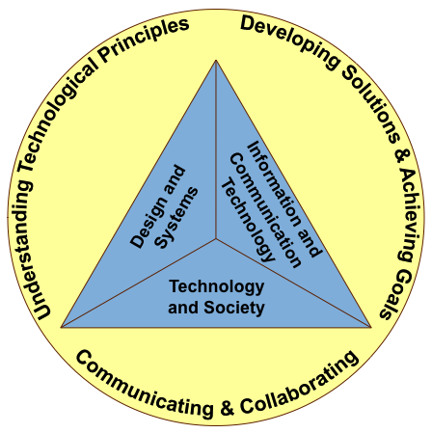
The assessment targets are organized into three major areas of technology and engineering literacy, each corresponding to a broad body of knowledge and skills with which students should be familiar:

- Technology and Society
- Design and Systems
- Information and Communication Technology

Technology and Society deals with the effects that technology has on society and the natural world and with the sorts of ethical questions that arise from those effects. Knowledge and capabilities in this area are crucial for understanding the issues surrounding the development and use of various technologies and for participating in decisions regarding their use.
Design and Systems covers the nature of technology, the engineering design process by which technologies are developed, and basic principles of dealing with everyday technologies, including maintenance and troubleshooting. An understanding of the design process is particularly valuable in assessing technologies, and it can also be applied in areas outside technology, since design is a broadly applicable skill.
Information and Communication Technology includes computers and software learning tools, networking systems and protocols, hand-held digital devices, and other technologies for accessing, creating, and communicating information and for facilitating creative expression. Although it is just one among several types of technologies, it has achieved a special prominence in technology and engineering literacy because familiarity and facility with it is essential in virtually every profession in modern society.
These three areas of technology and engineering literacy are closely interconnected. For example, to address an issue related to technology and society such as clean water, energy needs, digital-age communications, or global climate change, it is important to have an understanding of technological systems and the design process. Similarly, one must also be able to use various information and communication technologies to research problems, develop and communicate possible solutions, and achieve goals.

Practices

In all three areas of technology and engineering literacy, students are expected to be able to apply particular ways of thinking and reasoning when approaching a problem. These types of thinking and reasoning are referred to as practices, and the framework specifies three kinds in particular that students are expected to demonstrate when responding to test questions:

- Understanding Technological Principles
- Developing Solutions and Achieving Goals
- Communicating and Collaborating

Understanding Technological Principles focuses on how well students are able to make use of their knowledge about technology. This knowledge ranges from discrete declarative facts and concepts to higher-level reasoning about how facts, concepts, and principles are organized into various structures and relationships. Students should be able to use their knowledge about technology to develop explanations and make predictions, comparisons, and evaluations.

Developing Solutions and Achieving Goals refers to students’ systematic use of technological knowledge, tools, and skills to solve problems and achieve goals presented in realistic contexts. This practice includes both procedural and strategic capabilities—knowing how to apply simple steps and use technological tools to address real situations, as well as when and where to apply the tools and processes.

Communicating and Collaborating concerns how well students are able to use contemporary technologies to communicate for a variety of purposes and in a variety of ways, working individually or in teams, with peers and experts.

Contexts

Technology and engineering literacy requires not just that students know about technology but also that they are able to recognize the technologies around them and apply what they know to problems and projects involving particular technologies. Consequently, NAEP Technology and Engineering Literacy Assessment items will measure students’ technology and engineering literacy in the contexts of relevant societal issues and of actual problems that people are commonly called on to solve and goals they seek to achieve.

The contexts will vary according to the area of technology and engineering literacy and the practice being assessed, but they should include a broad sampling from the major technological fields in use today: medical technologies, information and communication technologies, energy and power technologies, transportation technologies, agriculture and biotechnology, and so forth.

Types of Tasks and Items

Technology and engineering literacy involves a range of knowledge and capabilities whose assessment requires having students perform a variety of actions using diverse tools to solve problems and meet goals within rich, complex scenarios that reflect realistic situations. To learn what students know and can do with regard to technology and engineering, the framework calls for the assessment to be totally computer-based. The use of computers makes it feasible to utilize scenario-based multimedia tasks developed for the assessment, along with more traditional item types. Although many items will be selected-response items, such as multiple choice, in which only the final answer is observed, there will also be a number of more complex items that allow the monitoring of the students’ actions as they manipulate components of the systems and models that are presented to them.

Reporting Results

Results of the NAEP Technology and Engineering Literacy Assessment will be reported in terms of percentages of students who attain each of the three achievement levels—Basic, Proficient, and Advanced—as is typical for NAEP results in other subjects. In addition, results of the assessment will be reported in terms of NAEP scale scores, on a 0-500 scale, for example. Scale scores will be reported for each of the three major assessment areas of technology and engineering literacy: Technology and Society, Design and Systems, and Information and Communication Technology. An overall composite score will also be reported.

In addition to scores, data will be collected on student gender, race/ethnicity, eligibility for free and reduced-price lunch, disabilities, and English language learner status, as well as a series of background variables specific to this content area. This enables analysis of the achievement data based on these factors. As the assessment is administered in years beyond the initial probe, a trend line can be established to track changes in student achievement over time.

Development of the Framework

The development of the NAEP Technology and Engineering Literacy Framework required the participation of a broad array of individuals and organizations to consider the various definitions of “technology,” “engineering,” and “technology and engineering literacy” and to devise a single framework that takes all of them into account. Among the organizations whose representatives provided advice and feedback were the Council of Chief State School Officers, the International Society for Technology in Education, the International Technology and Engineering Educators Association, the National Academy of Engineering, the Partnership for 21st Century Skills, and the State Educational Technology Directors Association. Eighteen outreach meetings were held across the country to solicit feedback on drafts of the framework, with approximately 2,000 participants. Online and paper-based surveys provided specific written feedback from 350 respondents.

In determining what students should know and be able to do in the areas of technology and engineering and to set forth criteria for the design of the assessment, the framework developers drew from a wide variety of sources. These included state, national, and international technology and engineering standards; research studies and reports; and a broad array of publications on technology and engineering literacy, educational standards, and assessment. To allow for some in-depth probing of fundamental knowledge and skills, the framework and the specifications represent a distillation rather than a complete representation of the universe of achievement outcomes targeted by teaching about technology and engineering.

Developers of the framework discussed various constraints regarding exactly what can be measured. In particular, there are important aspects of technology and engineering literacy that are difficult and time-consuming to measure—such as habits of mind, sustained design and research projects, and working as part of a team—but that are valued by engineers, technology and engineering educators, and the business community. These can be only partially represented in the NAEP Technology and Engineering Literacy Assessment.

Developing a technology and engineering literacy assessment from this framework will pose a number of challenges. For example, because of the current underdeveloped state of assessing technology and engineering literacy, there are few existing sample tasks to serve as examples for assessment development.

The framework developers believe this assessment will provide a rich and accurate measure of the technology and engineering literacy that students need both for their schooling and for their lives. Development of these technology and engineering literacy skills and capabilities is the responsibility of all teachers—not only technology and engineering educators but also teachers across the curriculum—and also involves the expectations of parents and society.

Chapter One: Overview

Need for a Framework in Technology and Engineering Literacy

To what extent can young people analyze the pros and cons of a proposal to develop a new source of energy? Construct and test a model or prototype? Use the Internet to find and summarize data and information to solve a problem or achieve a goal?

The exploding growth in the world of technology and the need to answer questions similar to those above led the National Assessment Governing Board to sponsor the development of a framework for a national assessment of technology and engineering literacy. For generations students have been taught about technology and have been instructed in the use of various technological devices, but there has been no way to know exactly what students understand about technologies and their effective use.

As the framework was being developed, it became clear that the terms “technology,” “engineering,” “information communication technology,” “21st-century skills,” and “literacy” are defined and used in significantly different ways in formal and informal education, in standards, by professional organizations, and in legislation. Therefore, the framework development committees recommended a change of the framework title from “technological literacy” to “technology and engineering literacy” to encompass general literacy about the use, effects, and designing of technologies. The 2014 NAEP Technology and Engineering Literacy Framework is a statement about what should be expected of students in terms of their knowledge and skills with technology, written to be the basis for an assessment of technology and engineering literacy appropriate for all students. It opens the door to seeing what our K-12 students know about technology and engineering, in the same way that NAEP assesses their knowledge and capabilities in reading, mathematics, science, and other subjects.

Technology and engineering literacy has been defined in a variety of ways, but here it will be thought of as the capacity to use, manage, and evaluate the technologies that are most relevant in one’s life, including the information and communication technologies that are particularly salient in the world today, as well as to understand technological principles and strategies needed to develop solutions and achieve goals.

Because technology is such a crucial component of modern society, it is important that students develop an understanding of its range of features and applications, the design process that engineers use to develop new technological devices, the trade-offs that must be balanced in making decisions about the use of technology, and the way that technology shapes society and society shapes technology. Indeed, some have argued that it is time for technology and engineering literacy to take its place alongside the traditional literacies in reading, mathematics, and science as a set of knowledge and skills that students are expected to develop during their years in school. Others go further in conceptualizing “new literacies” in which technologies are seen to restructure and support the development of academic and workplace expertise through “cyberlearning” in the networked world (National Science Foundation [NSF], 2008).

As of 2008, all 50 states were required to report to the U.S. Department of Education on technology literacy, using Information and Communication Technology (ICT) standards based on the National Education Technology Standards for Students (NETS•S) (International Society for Technology in Education [ISTE], 2007). Seven states have formal assessments for technology literacy (Metiri Group, 2009). The Standards for Technological Literacy developed by the International Technology and Engineering Educators Association (ITEEA) were being used in 41 states for technology education courses at either the state level or in local school districts (Dugger, 2007). A dozen states required technology education for students in at least some grades; 22 states offered technology education as an elective. Engineering-based technology education may be offered as a separate subject or embedded into other subject areas, such as science or social studies.

Reflecting the increasing importance of the role of technologies in 21st-century life, the National Assessment Governing Board decided to develop a framework for a national assessment of technology and engineering literacy. In announcing the NAEP Technology and Engineering Literacy Assessment, the Governing Board stated that the goals and objectives of the framework should be based on the future needs of the nation and individuals, and on the levels of technological literacy likely to be expected of students in the first half of the 21st century.

The primary audience for this framework is the general public. For that reason, the developers have attempted to use a minimal amount of technical language and have provided definitions when employing terms with which readers may not be familiar. There is also a glossary of terms in appendix A. The framework contains sufficient information for policymakers, educators, and other interested parties to understand the nature and scope of the assessment. Those interested in more technical information can consult the companion document, Assessment and Item Specifications for the 2014 NAEP Technology and Engineering Literacy Assessment.

It is important to note that this framework is an assessment framework, not a curriculum framework. That is, although it provides a definition of what students should know and be able to do concerning technology and how NAEP will measure that content, it is not intended to tell teachers and administrators what should be taught in the classroom, when it should be taught, or how it should be taught.

In addition to laying out the need for a technology and engineering literacy assessment framework, this chapter offers background information on NAEP and provides a list of resources used to develop the framework, definitions of key terms, a description of the process used for developing the framework, an explanation of the challenges of developing a technology and engineering literacy assessment framework, and an overview of the framework.

Background of NAEP

For more than 35 years, NAEP has measured student achievement nationally, state by state, and among 20 large urban districts. NAEP has served as an independent monitor of what students know and can do in various subject areas, including reading, mathematics, science, U.S. history, and writing. For each subject area measured by NAEP, a framework is used to provide recommendations on the content and processes to be assessed, the types of assessment questions to be asked, and the administration of the assessment. Each framework is designed to guide the assessment for about a decade until it is updated.

NAEP results, commonly referred to as The Nation’s Report Card, have become an important source of information on what U.S. students know and are able to do in a range of subject areas. The resulting data on student knowledge and performance have been accompanied by background information that allows analyses of a number of student demographic and instructional factors related to achievement. The assessments have been designed to allow comparisons of student performance over time and among subgroups of students defined according to region, parental education, gender, and race/ethnicity. The Trial Urban District Assessment (TUDA) was initiated in 2002 to report on the achievement of public school students in large urban districts. Under this program, NAEP has administered its mathematics, reading, science, and writing assessments to samples of students in large urban districts that have volunteered to participate in NAEP.

Resources for Planning the Framework

Any NAEP framework must be guided by NAEP purposes as well as the policies and procedures of the Governing Board, which oversees NAEP. For the NAEP Technology and Engineering Literacy Assessment, the main purpose of the framework is to establish what students should know about and be able to do with technology and to set forth criteria for the design of the 2014 assessment and future assessments. Meeting this purpose requires a framework built around what the communities involved in technology, technology education, educational technology, and technology and engineering literacy consider to be the knowledge and skills that are most important for NAEP to report.

In prioritizing the content, the framework developers used the NAEP technological literacy steering committee guidelines (summarized later in this chapter). These guidelines recommended drawing from the following sources:
- Existing technology standards from various individual states;
- National Education Technology Standards by the International Society for Technology in Education (ISTE, 2007);
- Standards for Technological Literacy: Content for the Study of Technology by the International Technology and Engineering Educators Association (ITEEA, 2007);
- Framework for 21st Century Learning from the Partnership for 21st Century Skills (P21, 2007);
- Influential technology standards from other countries (for example, the United Kingdom);
- Science Framework for the 2009 National Assessment of Educational Progress (National Assessment Governing Board, 2008);
- Benchmarks for Science Literacy by the American Association for the Advancement of Science (AAAS, 1993);
- National Science Education Standards from the National Research Council (NRC, 1996);
- Definitions of technological literacy contained in the No Child Left Behind Act of 2001 (NCLB, 2001) and the American Recovery and Reinvestment Act of 2009 (ARRA, 2009); and
- Research studies and reports, for example, Technically Speaking and Tech Tally: Approaches to Assessing Technological Literacy from the National Academy of Engineering (NAE) and the National Research Council (NRC); The Intellectual and Policy Foundations of the 21st Century Skills Framework (P21, n.d.); and Fostering Learning in the Networked World: The Cyberlearning Opportunity and Challenge (NSF, 2008).

Tables illustrating how the major assessment areas presented in chapter two are aligned with these source documents are presented in appendixes C and D. These sources embody a wealth of information about technological literacy and technology education. All of them address similar issues of K-12 content and assessment, and in many ways they converge on a broad vision of technology and engineering literacy. However, the various documents do not always agree on definitions of terms, and in many cases they attach different meanings to phrases such as “educational technology” and “technology education,” which a reader outside the field would find confusing. Consequently, it is important to establish clear definitions for the purpose of this framework and the work of NAEP that will follow. (See the glossary in appendix A for full definitions of relevant terms used in this framework.)

Definitions of Key Terms Used in This Framework

Because of the variety of meanings associated with words and terms that are used throughout this document, meanings and usages specific to this framework are offered here. The particular words and terms at issue are technology, engineering, technology and engineering literacy, and educational technology. It is important to note that these definitions have been developed for the sole purpose of informing NAEP about the field of technology and engineering literacy. No additional claim is made regarding the usefulness of these definitions for other purposes—and, in particular, they should not be used for the interpretation of state and local assessments, since these may be based on different definitions of technology and engineering literacy. This framework defines technology, engineering, and technology and engineering literacy as:
Technology is any modification of the natural or designed world done to fulfill human needs or desires.

Engineering is a systematic and often iterative approach to designing objects, processes, and systems to meet human needs and wants.

Technology and engineering literacy is the capacity to use, understand, and evaluate technology as well as to understand technological principles and strategies needed to develop solutions and achieve goals. For purposes of this framework, it comprises three areas: Technology and Society, Design and Systems, and Information and Communication Technology.

The following sections expand and elaborate on the above brief definitions of “technology,” “engineering,” and “technology and engineering literacy” with the goal of describing the knowledge and capabilities that are essential for citizens in the 21st century—and, in particular, in a way that can be assessed through an on-demand, large-scale assessment.

Technology

Research shows that most Americans associate technology mainly with computers and related electronic devices (Cunningham, Lachapelle, & Lindgren-Streicher, 2005). However, while the computer is certainly an important example of technology—and one that plays an especially important role in this framework—the term “technology” has a broader and deeper meaning. Broadly speaking, technology is any modification of the natural or designed world done to fulfill human needs or desires. This definition sees technology as encompassing the entire human-made world, from the simplest artifacts, such as paper and pencil or a wooden flute, to the most complex, including the Internet, medical imaging devices, and a country’s entire transportation system. Technology helps people do their jobs: giant particle colliders for physicists, oil paints and canvases for artists, and email for just about everyone. Technology also makes leisure time more enjoyable: movies, music, and electronic games to entertain, automobiles to get people where they want to go, audio and imaging tools to support creative expression, and books (either e-books or the traditional paper version) to tell stories of other places and times.

But technology is not just the products or things that people create. It includes the entire infrastructure needed to support the processes used to design, manufacture, operate, and repair technological artifacts, from corporate headquarters and engineering schools to manufacturing plants, media outlets, and distribution networks (Shakrani & Pearson, 2008). Technology also includes the cyberinfrastructure and participatory technologies that open up greater access to complex learning and connections of experiences across settings (NSF, 2008).

Throughout history, technology has been one of the major factors shaping human life and human civilization, and, indeed, major periods of human development have typically been identified by the dominant technologies of the period: Stone Age, Bronze Age, Iron Age, Industrial Age, and, today, the Information Age. Technology itself is constantly changing and evolving, as are its effects on society. Ten thousand years ago humans took the first steps toward agriculture with the purposeful planting of seeds; 100 years ago, farmers and plant scientists were regularly improving crops through hybridization; today, genetic engineering has been harnessed to create specially designed crops and farm animals. Perhaps the most dramatic example of technological evolution from today’s perspective is the rapid development of communications technology, from the invention of the telegraph and telephone in the 19th century to the development of radio, television, and the Internet in the 20th century—and to the past decade’s explosion of electronic communication, and social networking (Solomon & Schrum, 2007). Technology has become an enabling force behind globalization, knowledge work, and entrepreneurship (Metiri Group, 2006). With each of these changes comes new capabilities—and new challenges.

Engineering

Engineering is the process of designing the human-made world. The process typically begins with the specifications of needs or wants. Engineers identify constraints, analyze the features of systems, and devise plans for developing solutions. Solutions may take the form of artifacts such as computer chips or bridges. Solutions may also take the form of improved processes such as assembly lines or traffic control. Engineering processes are typically iterative, involving testing and revisions. Engineers understand the nature of the technology area to be modified, engage in systems thinking, work through engineering design processes, and conduct maintenance and troubleshooting.

Technology and Engineering Literacy

Having defined “technology” and “engineering” broadly in these ways, “technology and engineering literacy” can be defined in an equally broad fashion as the capacity to use, understand, and evaluate technology as well as to understand technological principles and strategies needed to develop solutions and achieve goals. Technology and engineering literacy, like scientific, mathematical, or language literacy, is a measure of how well individuals have mastered the processes and tools they need to participate intelligently and thoughtfully in the world around them. As described in reports from the National Academy of Engineering (NAE, 2006), the International Society for Technology in Education (ISTE, 2007), and the International Technology and Engineering Educators Association (ITEEA, 2007), technological literacy includes knowledge, capabilities, and critical thinking and decision-making skills (McAnear, 2009). From these documents, lists can be extracted of what a person who is literate in technology and engineering should know and be able to do.

Figure 1 depicts the major assessment areas and practices of the NAEP Technology and Engineering Literacy Framework. At the center, in blue, are the three areas of technology and engineering literacy that will be assessed by NAEP: Technology and Society, Design and Systems, and Information and Communication Technology (ICT). The surrounding yellow circle represents three overarching types of thinking and reasoning that generalize across the major assessment areas. These crosscutting practices will apply across tasks and individual test questions, also referred to as items, in the areas of Technology and Society, Design and Systems, and ICT. These key components of the 2014 NAEP Technology and Engineering Literacy Framework are described on the next page.

Three Areas of Technology and Engineering Literacy

In recent decades, students in the United States have experienced three quite different (though by no means inconsistent) approaches to technology and engineering literacy. These are the science, technology, and society approach; the technology education approach; and the information and communication technology approach. In recognition of the importance, educational value, and interdependence of these three approaches, this framework includes all three under its broad definition of technology and engineering literacy. In recognition of the distinct goals and teaching methods involved in each, this framework recommends that assessment results be reported for each of these areas to monitor and analyze the results of each approach over time. The next few paragraphs present a brief description of each of these approaches.
Figure 1 – Major Assessment Areas and Practices of Technology and Engineering Literacy

• The Technology and Society assessment area has its roots in the science, technology, and society (STS) approach. In 1990 the board of directors of the National Science Teachers Association defined STS as the “teaching and learning of science and technology in the context of human experience” (NSTA, 2006, pp. 229–230). In practice many STS programs use societal issues as course organizers, including space travel, insecticide use, nutrition, disease, ozone, global warming, and other concerns reported in the popular press. Since technological advances and decisions lie at the core of such issues, the focus in discussing them is often on the technology involved (Yager & Akcay, 2008). A survey of engineering and technology in state science standards found that a majority of state standards reflect the STS approach (Koehler, Faraclas, Giblin, Kazerounian, & Moss, 2006). The STS approach is represented in this framework under “Technology and Society.”

• The Design and Systems assessment area is partly rooted in the school subject known as industrial arts (Dugger, 2005), a popular subject area throughout most of the 20th century, which provided education in the use of hand and power tools for fabricating objects from wood, metal, or other materials, as well as instruction on industrial processes. As conceived today by the field’s professional organization, the International Technology and Engineering Educators Association (ITEEA), technological literacy “involves a vision where each citizen has a degree of knowledge about the nature, behavior, power, and consequences of technology from a broad perspective. Inherently, it involves educational programs where learners become engaged in critical thinking as they design and develop products, systems, and environments to solve practical problems” (ITEEA, 1996, p. 1). Goals in technology education include creating a broad understanding of technology and engineering as well as developing specific capabilities in both areas (ITEEA, 2007). A survey of state science standards (Koehler et al, 2006) found that many states, especially those in the Northeast, include standards consistent with this approach, although not as many as those whose standards relate to STS. The engineering design approach is represented in this framework under the heading “Design and Systems.”

• Information and communication technology (ICT) is a third approach that has been growing in importance over the past three decades. The pervasiveness of technology in school, home, work, and play has profound implications for learning in schools and throughout life (p. 21, n.d.). The field’s major professional organization, the International Society for Technology in Education (ISTE), was formed in 1989 by the merger of two associations concerned primarily with the use of computers in education. Today, the vision of ICT is much broader than the use of computers alone, having expanded from the earlier vision of technology as a teaching tool to today’s philosophy of technology as a learning tool. That is, the focus is no longer on using technology to assist teachers but rather on giving students new and more powerful ways to gather and assess information, think creatively, solve problems, and communicate. As expressed in the society’s National Educational Technology Standards (ISTE, 2007), ICT includes a variety of student skills that overlap with other areas, such as creativity and innovation; communication and collaboration; research and information fluency; and critical thinking, problem-solving, and decision-making. These skills are applied specifically to the use of digital technologies and media, including the Internet and other networking applications.

Although these information technologies make up one component of technology, broadly defined, they have been responsible for many of the most profound changes that have taken place in society over the past several decades. And the variety, uses, and power of such information tools are expected to grow rapidly over the next decade (The New Media Consortium, 2009). Media, telecommunication, and networked technologies are evolving into powerful support systems for acquiring skills needed in the 21st century (p. 21, n.d.).

“Every young person will need to use ICT in many different ways in their adult lives, in order to participate fully in a modern society” (Organisation for Economic Co-operation and Development [OECD], 2006). The ICT approach to technology and engineering literacy is represented in this framework under the heading “Information and Communication Technology.”

Three Practices

A person who is literate in technology and engineering should be able to apply “crosscutting practices,” or generalizable ways of thinking, reasoning, and acting that are important across all areas of technology and engineering literacy. As depicted in figure 1, these practices are employed within and across the 3 major assessment areas. The practices can be grouped into these three broad categories, with several examples of each type of practice:

Understanding Technological Principles
- Understands the nature of technology in its broadest sense
- Is aware of the various digital tools and their appropriateness for different tasks
- Knows how technology is created and how it shapes society and in turn is shaped by society
- Understands basic engineering concepts and terms, such as systems, constraints, and trade-offs
- Understands how cultural differences can affect technological choices

Developing Solutions and Achieving Goals
- Demonstrates appropriate usage of a wide range of technological tools and systems, ranging from kitchen appliances and alarm clocks to cars, computers, communication devices, and the Internet
- Can apply technological concepts and skills creatively, including those of engineering design and information technology, to solve problems and meet goals
- Collects and analyzes data to develop a solution and complete a project
- Uses multiple processes and diverse perspectives to explore alternative solutions
- Can evaluate claims and make intelligent decisions

Communicating and Collaborating
- Communicates information and ideas effectively to multiple audiences using a variety of media and formats
- Participates thoughtfully and productively in discussing critical societal issues involving technology related to humans, the environment, knowledge, and citizenship
- Collaborates with peers and experts

The framework recommends that results of the NAEP Technology and Engineering Literacy Assessment be reported separately for the three major assessment areas of Technology and Society, Design and Systems, and ICT, although it cannot be stressed strongly enough that today’s youth are expected to acquire knowledge and skills in all three areas of technology and engineering literacy. These areas are neither learned separately nor applied separately; they overlap and interact. A person who is literate in technology and engineering understands and is able to analyze the relationship between technology and society, has a broad understanding of technology and can solve problems using the engineering design process, and is able to make fluent use of digital technologies and media in creative and innovative ways. Specific assessment targets related to the three areas are described at length in chapter two.

Educational Technology

Although it is not an assessment target for the purposes of NAEP, the field of educational

technology provides another example of a common use of the term “technology.” Broadly speaking, the field of educational technology is concerned with the use of various types of equipment as teaching and learning aids. Many teachers remember when overhead projectors were in widespread use or when whiteboards replaced chalkboards. Advocacy for the use of computers in classrooms began more than 20 years ago, and the uses of computers have evolved rapidly from computers-as-teachers to computers-as-learning-tools. Today a vast array of computer applications is available for use in all school subjects, and these applications are fundamentally altering the way students learn in school, giving them unprecedented input into and control of their own learning. Some devices, such as interactive whiteboards, combine technologies for entirely new purposes. An area of digital or cyber literacy is emerging that encompasses newer forms of technology and media (Kress, 2003; Livingstone, van Couvering, and Thumin, 2008). Traditions of media and information literacy are converging and focusing on skills needed to take advantage of digital systems for representing and distributing information (Livingstone, 2002). The variety and use of such tools for learning, expression, and communication are expected to expand rapidly over the next decade, affecting the way all people—not just students—work, collaborate, and communicate (The New Media Consortium, 2009). The 2014 NAEP Technology and Engineering Literacy Assessment will take advantage of new developments in educational technology as one of the first NAEP assessments to be administered entirely by computer.

The Relationship Among Science, Technology, Engineering, and Mathematics

Science, technology, engineering, and mathematics are so closely interlinked that it is often difficult to know where one starts and the other ends. Students in science classes are often taught about technology, engineering, and mathematics, while students in technology classes learn about science, engineering, and mathematics. Technologies are changing fundamentally the ways scientists work, and are becoming important components of science education. Students’ skills in using the tools of science are becoming components of the “new literacies” (Quellmalz and Haertel, 2008). In a recent report on cyber learning, the National Science Foundation points out that research has demonstrated that “incorporating information and communications technology into science and mathematics can restructure the necessary expertise for reasoning and learning in these domains, in effect opening up greater access to complex subject matter.” Examples include multiple linked representations in mathematics and modeling and visualizations for understanding and investigating complex science (NSF, 2008, p. 13).

For the purposes of designing a framework to assess technology and engineering literacy, it is important to keep the distinctions among the science, technology, and engineering clear. The relationship among engineering, science, and technology is explained this way in the joint National Academy of Engineering/National Research Council publication Technically Speaking:

Science and technology are tightly coupled. A scientific understanding of the natural world is the basis for much of technological development today. The design of computer chips, for instance, depends on a detailed understanding of the electrical properties of silicon and other materials. The design of a drug to fight a specific disease is made possible by knowledge of how proteins and other biological molecules are structured and how they interact.

Conversely, technology is the basis for a good part of scientific research. The climate models meteorologists use to study global warming require supercomputers to run the simulations. And like most of us, scientists in all fields depend on the telephone, the Internet, and jet travel (NAE & NRC, 2002, pp. 13-14).

One other distinction that is important to make is between technology and engineering. Again the explanation from Technically Speaking is helpful:

Technology is a product of engineering and science, the study of the natural world. Science has two parts: (1) a body of knowledge that has been accumulated over time, and (2) a process—scientific inquiry—that generates knowledge about the natural world. Engineering, too, consists of a body of knowledge—in this case, knowledge of the design and creation of human-made products—and a process for solving problems (NAE & NRC, 2002, p. 13).

Of the three terms—science, technology, and engineering—the clearest parallel is between science and engineering, as both represent an approach to knowledge taken by a group of well-trained professionals. As explained in the National Science Education Standards (NRC, 1996, p. 166), “Scientists propose explanations for questions about the natural world, and engineers propose solutions relating to human problems, needs, and aspirations.”

A fourth area that is often associated with these other three is mathematics. Although mathematics is a field in its own right, distinct from science and engineering, mathematical tools are essential to the work of both scientists and engineers. In fact, science, technology, engineering, and mathematics are so intimately connected that they are frequently referred to by the acronym STEM.

The Framework Development Process

In October 2008, the Governing Board awarded a contract to WestEd to develop a framework and specifications for assessing technological literacy. In carrying out its work, WestEd collaborated with the Council of Chief State School Officers (CCSSO), ISTE, ITEEA, the Partnership for 21st Century Skills, and the State Educational Technology Directors Association (SETDA). In working with these groups, WestEd used a process for developing the framework and related products that was inclusive, deliberate, and designed to achieve as much broad-based input as possible.

A two-tiered committee structure with a steering committee and a planning committee provided the expertise to develop the framework as specified by the Governing Board. (See “NAEP Technology and Engineering Literacy Project Committees and Staff” section for lists of committee members.) The two committees were composed of members who were diverse in terms of role, gender, race or ethnicity, region of the country, perspective, and expertise regarding the content of the assessment to be developed.

The steering committee members included leaders from a variety of fields and subject areas, including schools, engineering, education, 21st-century skills, the Internet, business, science education, general education, and assessment. The co-chairs were balanced, with one representing technology in schools, and the other, STEM and assessment. Functioning as a policy and oversight body, this group outlined the planning committee’s responsibilities in developing the framework. The committee reviewed and provided feedback on drafts of the framework and related materials. The interaction between the two committees was iterative over the course of the project.

The planning committee, as supported by the project staff, was the development and production group responsible for drafting the framework, specifications, recommendations for background variables, and preliminary technology and engineering literacy achievement level definitions. This committee was composed of business leaders, researchers, state and district technology coordinators, teachers, and representatives from educational organizations as well as experts in research, assessment, and evaluation. As with the steering committee, the planning committee co-chairs were balanced, with one being an expert in ICT-based learning and assessment and the other being an expert in K-12 science and engineering education.
Summary of the Steering Committee Guidelines

- The following definition of technology and engineering literacy should be used: Technology and engineering literacy is the capacity to use, understand, and evaluate technology as well as to understand technological principles and strategies needed to develop solutions and achieve goals. The steering committee also suggested that the planning committee examine other definitions of technology and engineering literacy, especially those used by the states.
- The assessment should consist of technological content areas, to be reported as scale scores, and technological practices that characterize the field. The content areas must include Design and Systems, Information and Communication Technology (ICT), and Technology and Society.
- Three practices should be addressed in the assessment: Understanding Technological Principles, Developing Solutions and Achieving Goals, and Communicating and Collaborating.
- The content and context for the assessment should be informed by state standards and assessments, national and international standards, and research.
- Assessment tasks and items should minimize the need for prior knowledge of specific technologies other than ICT; tasks should relate to real-world problems and contexts.
- As far as possible, life situations familiar to students and local and contemporaneous conditions should be used to design tasks as a way to confer relevance to each grade level being assessed.
- The assessment should focus on a broad base of knowledge and skills, not on specific technological processes that may change.
- The assessment should use innovative computer-based strategies that are informed by research on learning and are related to the assessment targets.
- The computer-based assessment strategies should be informed by what is known about all learners, including English language learners (ELL) and students with disabilities.
- All the items and tasks included as exemplars in the framework and specifications documents should have feasible responses that can be awarded score points.

The planning committee’s work was guided by policies, goals, and principles identified by the steering committee (see summary box on the previous page; for full text, see appendix B). In addition to the sources cited previously, the planning committee relied on guidance provided by NAEP Technological Literacy Framework and Specifications Development: Issues and Recommendations, a paper prepared by Sharif M. Shakrani and Greg Pearson for the Governing Board.

The work was carried out in a series of meetings, with numerous telephone calls and email exchanges between meetings. From December 2008 through September 2009, the steering committee met four times and the planning committee met six times. Three steering committee and planning committee meetings overlapped so that the two committees could share understandings and discuss critical issues. Governing Board staff supported and participated in all of the meetings. In addition, between formal work sessions, Governing Board members and staff provided feedback and guidance on project documents and processes.

After the development of initial drafts of the framework, WestEd led a series of outreach efforts to solicit feedback. Formal activities included, but were not limited to, presentations and sessions with industry representatives (for example, IBM and Cisco), ITEEA, the Organisation for Economic Co-Operation and Development (OECD) International ICT Research Workshop, CCSSO, SETDA, ISTE, and the Partnership for 21st Century Skills Webinar. (See NAEP Technology and Engineering Literacy Project Committees and Staff section for more complete lists of individuals and organizations that contributed to the development of this framework.) The planning committee reviewed feedback from these groups as well as from the steering committee and made revisions, as it deemed appropriate. Governing Board members and staff closely monitored the project and provided comments on draft documents. After final approval from the steering committee, the framework was submitted to the Governing Board for action.

Challenges of Developing the NAEP Technology and Engineering Literacy Framework

There were a number of challenges in developing the 2014 NAEP Technology and Engineering Literacy Framework that were not necessarily encountered in developing other NAEP frameworks. These included: (1) the newness of the endeavor, (2) diffuse curricula, (3) varying definitions, (4) measurement constraints, (5) time and resource constraints, (6) designing an entirely computer-based assessment, and (7) predicting future changes in technology. Each of these challenges is discussed below.

Newness of the Endeavor

Technology and engineering literacy is a growing and evolving area. Unlike other NAEP subjects, such as reading or mathematics, there is no existing NAEP framework to draw on. Moreover, the existing item banks in the United States and other countries are very limited (NAE, 2006). The technology and engineering literacy staff and committee members obtained only a limited number of sample items from outside sources, reflecting the immature state of assessing technology and engineering literacy.

Diffuse Curriculum

Unlike science and mathematics, which have a sequential curriculum taught by subject-area specialists in high school or by generalists in elementary school, technology and engineering education as a whole does not have a unified scope and sequence. Some individual courses (for example, science, technology, and society; pre-engineering; and computer modeling) are likely to follow state standards and have a specified curriculum with a scope and sequence, but these individual courses are generally not grouped together under the rubric of technology courses. When they are, the courses under such a heading may vary from place to place. ICT has also been integrated into the curriculum in a variety of ways. While ICT learning is often infused into existing core subjects, it is not always assessed and reported as part of these subjects. In addition, there is not a clear scope and sequence for ICT knowledge and skills, either as a stand-alone curriculum or integrated into core subjects, which may result in an inconsistent application of technology literacy standards across different grades, subjects, and states. As mentioned earlier, all teachers have a role in teaching technology, so in most cases, teachers are not singled out as technology teachers in the same way that, for example, mathematics or history teachers are identified with those subject areas. The result (and implication for this assessment) is that the specific technology concepts and practices to which students have been exposed are hit-and-miss and mostly unknown. Students can say what mathematics or science courses they have taken, but specifying the range of their education in technology and engineering and their use is more ambiguous.

Varying Definitions

One of the most debated issues in developing the framework was the definition of “technology and engineering literacy,” as different definitions abound. Indeed, even the terms are not agreed upon, as some organizations refer to “technological literacy” while others refer to “technology literacy” or “engineering literacy.” In this report, for consistency, the term “technology and engineering literacy” will be used throughout while recognizing that this terminology differs from what is used by some groups. ITEEA, the National Research Council, and ISTE have definitions of technology and engineering literacy. Meanwhile, the federal No Child Left Behind Act of 2001 (NCLB) required that every student be “technologically literate by the time the student finishes the eighth grade,” but the law itself is vague in defining what technological literacy is. States have therefore had flexibility in determining what technology and engineering literacy means and how it should be assessed.

Many states have adopted a common definition worked out by SETDA in 2002, which states, “Technology literacy is the ability to responsibly use appropriate technology to communicate, solve problems, and access, manage, integrate, evaluate, and create information to improve learning in all subject areas and to acquire lifelong knowledge and skills in the 21st century.” The federal American Recovery and Reinvestment Act of 2009 adds real-world consequences to this shared definition by providing grants to state and local agencies and schools based on their abilities to meet goals defined by long-range educational technology plans, most of which include this definition.

The NAEP Technology and Engineering Literacy Framework attempts to unify the concepts and skills presented in these and other definitions under one umbrella definition. The definition presented earlier in this chapter is used only to understand the results of the NAEP assessment in technology and engineering literacy. While this framework and subsequent NAEP results may be informative to education administrators, policyholders, industry and business leaders, and the general public, the definition of technology and engineering literacy presented here should not be used to interpret results from other assessments used at state and local levels. To further distinguish the 2014 NAEP Technology and Engineering Literacy Assessment from other technology and engineering literacy assessments, the project committees have recommended that the results be reported in terms of three individual scores, each reflecting performance in one of the three main areas of technology and engineering literacy: Technology and Society, Design and Systems, and Information and Communication Technology. An overall composite score will also be reported.

Measurement Constraints

NAEP, like any large-scale assessment in education, the workplace, or clinical practice, is constrained in what it can measure. This has implications for the proper interpretation of NAEP Technology and Engineering Literacy Assessment results. The framework is an assessment framework, not a curriculum framework. Although the two are clearly related, each has a different purpose and a different set of underlying assumptions. A curriculum framework is designed to inform instruction, to guide what is taught, and, often, to guide how it is taught. It represents a wide universe of learning outcomes from which educators pick and choose what and how they teach. An assessment framework is a subset of the achievement universe from which assessment developers must choose to develop sets of items that can be assessed within time and resource constraints. Hence, the content to be assessed by NAEP has been identified as that considered central to technology and engineering literacy.

As a result, some important outcomes of technology and engineering literacy (broadly defined) that are valued by general educators, engineers, teachers of technology, and the business community but that are difficult and time-consuming to measure—such as habits of mind, sustained projects, and collaboration—will be only partially represented in the framework and on the NAEP Technology and Engineering Literacy Assessment. Moreover, the wide range of technology and engineering standards in the guiding national documents that were incorporated into the framework had to be reduced in number to allow some in-depth probing of fundamental knowledge and skills. As a result, the framework and the specifications represent a distillation rather than a complete representation of the original universe of achievement outcomes specified by technology and engineering education documents.

Time and Resource Constraints

Time and resources limit what NAEP can assess. Like most standardized assessments, NAEP is an “on-demand” assessment. That is, it is given as a scheduled event outside the normal classroom routine with uniform conditions for all of the students being assessed. In particular, NAEP has a limited amount of time—in this case, approximately one hour per student—to ascertain what students know and can do. However, standards presented by professional associations and the states contain goals that require an extended amount of time (days, weeks, or months) to assess. To assess the achievement of students in the kinds of extended activities that are a central feature of these other standards and of many curricula, it would be necessary to know a number of things about the students, including their:
- Reasoning while framing their goals;
- Planning for projects and the implementation of the plan;
- Skills in using technologies to gather, manage, and analyze data and information related to project goals;
- Capabilities to meet unpredictable challenges that arise during actual, ongoing problem-solving and achievement of goals;
- Lines of argument in deciding how to alter their approaches in the light of new evidence;
- Engagement with peers and experts in addressing goals and deciding how to achieve them; and
- Deliberations and reasoning when evaluating progress, trade-offs, and results.

NAEP, like other on-demand assessments, then, cannot be used to draw conclusions about student achievement with respect to the full range of goals of technology education, broadly defined. States, districts, schools, and teachers can supplement NAEP and other standardized assessments to assess the full range of education standards that address technology and engineering literacy. In addition to describing the content and format of an examination, assessment frameworks, like this one, signal to the public and to teachers some core elements of a subject that are important.

Designing a Computer-Based Assessment

Although some NAEP assessments (the 2009 Science Assessment, for example) have called for interactive computer tasks, so far only the NAEP Writing Assessment has been totally computer-based. The design challenges of creating such an assessment include:
- Developing the requisite number of tasks and items (test questions), especially since so few tasks and items exist that can serve as samples.
- Constructing tasks and items that provide whatever prior knowledge is required to answer the question. As so many contexts are available in which to set items, developers cannot assume that students will have prior knowledge of the specific topics (for example, core subjects such as the humanities or mathematics) or technologies (for example, transportation, health, or electronics) within the context. Items must not require students to have prior knowledge of specific technologies, and the knowledge required about particular technologies must be presented in the item.
- Determining the features and functions of the complete tools students will use.
- Determining what aspects of student responses to an item need to be assessed. Are the attempts a student makes while trying out a design or using a simulation important to capture? What about the pathway the student follows or the number of mistakes made before getting a correct answer? Rather than a single question and answer, an item might have several components that are assessed.

In addition to the issues above, there will also be administrative challenges, such as whose computers the students use to complete the assessment, handling students’ different levels of access to computer technology, and contingencies in case equipment malfunctions. The framework designers were aware of these factors when developing the framework, but they focused on the design factors, leaving the challenge of determining how best to administer the NAEP Technology and Engineering Literacy Assessment to those involved in the assessment development phase.

Predicting Future Changes in Technology

The framework attempts to strike a balance between what can reasonably be predicted about future technology and engineering literacy education and what students are likely to encounter in their curriculum and instruction now and over the next decade. For example, specific communication technologies in use today (Internet-connected multimedia smartphones and personal digital assistants [PDAs]) would not have been familiar to students a decade ago and may well be obsolete a decade from now.

The framework is intended to be both forward-looking (in terms of what technology content and usage will be of central importance in the future) and reflective (in terms of current technology). Because it is impossible to predict with certainty the shape of educational technology and technology education, the choices made for 2014 should be revisited in response to future developments.

It is a significant challenge to write a framework for the future, and the challenge is especially great for the subject of technology and engineering literacy.

Overview of Framework Chapters

The following text describes the content of the remaining four chapters of the 2014 NAEP Technology and Engineering Literacy Framework.

Chapter Two: Areas of Technology and Engineering Literacy

This core chapter identifies the assessment targets for the 2014 assessment of technology and engineering literacy. The targets are grouped into the three major areas: Technology and Society, Design and Systems, and Information and Communication Technology (ICT). Each of the major areas is broken down into subareas. Each subarea has a listing of key principles and a chart identifying what students should know and be able to do at grades 4, 8, and 12. Each subarea has between 6 and 15 assessment targets.

Chapter Three: Practices and Contexts for Technology and Engineering Literacy

Chapter three has two major purposes. First, it articulates the kinds of thinking and reasoning that students are expected to demonstrate when responding to the assessment tasks and items. Three practices are presented: (1) understanding technological principles, (2) developing solutions and achieving goals, and (3) communicating and collaborating. Each practice is applied to the three major technology and engineering literacy areas in a chart. There are also tables that apply the practices to selected principles and to the subareas. Illustrative tasks and items suggest how the practices can be represented along with targets in each of the areas and subareas.

Next, the chapter describes the contexts for the assessment—that is, the core school subjects and areas of technology, such as humanities, social sciences, medical imaging, publishing, or recycling, that will serve as backdrops for assessment questions. The choice and presentation of contexts are important because the framework cannot assume that students have prior knowledge of a specific topic or technology. If information about a specific type of technology is needed to respond to an item, this information must be provided to students in the item as contextual detail. Potential contexts are discussed within the three major areas: Technology and Society, Design and Systems, and Information and Communication Technology. Each of the three areas has a chart that provides examples of how different contexts can be used to formulate tasks and items in each of the three assessment areas.

Chapter Four: Overview of the Assessment Design

This chapter is an overview of the major components of the NAEP Technology and Engineering Literacy Assessment. It discusses the types of tasks and items to which students will respond. These will be scenario-based items and discrete items. Examples illustrate how students might respond and what parts of their response would be assessed. Balance in four ways is an important requirement in the assessment: balance by major assessment areas and grades, balance by technological practices and grades, balance by assessment set types and grades, and balance by response types and grades. The chapter has charts containing percentages of testing time recommended for each of these features. The chapter concludes with suggestions for universal design and adaptations for students with disabilities, and English language learners.

Chapter Five: Reporting Results of the NAEP Technology and Engineering Literacy Assessment

The last chapter of the framework discusses the issues involved in reporting data from the Technology and Engineering Literacy Assessment. Topics include NAEP sampling techniques, how NAEP results are reported, reporting scale scores and achievement levels, and reporting background variables. Appropriate and inappropriate uses of NAEP reporting are also discussed, especially in light of the varying definitions of technology and engineering literacy.

Chapter Two: Areas of Technology and Engineering Literacy

Introduction

This chapter describes the essential knowledge and capabilities that will be assessed on the NAEP Technology and Engineering Literacy Assessment beginning in 2014. Although it is not possible to assess every aspect of technology and engineering literacy, this framework identifies a set of assessment targets related to the nature, processes, and uses of technology and engineering that are essential for 21st-century citizens. The assessment targets are organized into three major areas: Technology and Society, Design and Systems, and Information and Communication Technology.

These three areas of technology and engineering literacy are interconnected. The relationship among these three major assessment areas can be illustrated as a three-sided pyramid in which each side supports the other two. For example, to address an issue related to technology and society, such as clean water, energy needs, or information research, a person who is literate in technology and engineering must understand technological systems and the engineering design process and be able to use various information and communication technologies to research the problem and develop possible solutions. | 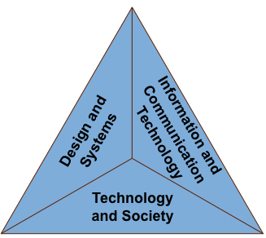

This chapter provides descriptions of each of the major areas of technology and engineering literacy as well as subareas and tables of assessment targets that specify what students in grades 4, 8, and 12 should know and be able to do. The assessment targets describing what students should be able to do foreshadow the crosscutting “practices”—ways of thinking and reasoning—described in chapter three.

It will be apparent when reading assessment targets across the grade-level rows that learning is cumulative—that is, later grades build on what has been learned in earlier grades, so that students develop a greater sophistication and depth of understanding as they advance in school. For instance, elementary school students think of a technological change in terms of a succession of “products,” as in the evolution of writing technology from clay tablets to pen and paper and to computers and printers. Middle school students are able to think in terms of technological “processes,” such as the processing of food, or the extraction of metal from ore. High school students have learned to think in terms of technological “systems,” such as a city’s public transportation system or water purification system.

There is some overlap among the three major assessment areas. For example, there may be references to Information and Communication Technology (ICT) and to Design and Systems within the Technology and Society area. This is due in part to the mutual support that these technological principles and skills lend to each other, and it serves to emphasize that individuals who are literate in technology and engineering can bring these ways of thinking and acting to bear on any problem or goal. Thus, ICT knowledge and skills are called on during the design of technologies; information and communication technologies are developed by engineering design processes; and the myriad technologies designed to meet human needs, including the ubiquitous information and communication technologies, are influenced by and have impacts on society.

The 3 major assessment areas of technology and engineering literacy and their corresponding subareas are presented in table 2.1 and briefly summarized below.

Table 2.1 Major areas and subareas of 2014 NAEP Technology and Engineering Literacy Assessment

Technology and Society | Design and Systems | Information and Communication Technology (ICT)
- Interaction of Technology and Humans  - Effects of Technology on the Natural World  - Effects of Technology on the World of Information and Knowledge  - Ethics, Equity, and Responsibility | - Nature of Technology  - Engineering Design  - Systems Thinking  - Maintenance and Troubleshooting | - Construction and Exchange of Ideas and Solutions  - Information Research  - Investigation of Problems  - Acknowledgment of Ideas and Information  - Selection and Use of Digital Tools

Technology and Society

A. Interaction of Technology and Humans concerns the ways society drives the improvement and creation of new technologies, and how technologies serve society as well as change it.
B. Effects of Technology on the Natural World is about the positive and negative ways that technologies affect the natural world.
C. Effects of Technology on the World of Information and Knowledge focuses on the rapidly expanding and changing ways that information and communications technologies enable data to be stored, organized, and accessed and on how those changes bring about benefits and challenges for society.

D. Ethics, Equity, and Responsibility concerns the profound effects that technologies have on people, how those effects can widen or narrow disparities, and the responsibility that people have for the societal consequences of their technological decisions.
Design and Systems

A. Nature of Technology offers a broad definition of technology as consisting of all the products, processes, and systems created by people to meet human needs and desires.
B. Engineering Design is a systematic approach to creating solutions to technological problems and finding ways to meet people’s needs and desires.
C. Systems Thinking is a way of thinking about devices and situations so as to better understand interactions among components, root causes of problems, and the consequences of various solutions.
D. Maintenance and Troubleshooting is the set of methods used to prevent technological devices and systems from breaking down and to diagnose and fix them when they fail.

Information and Communication Technology (ICT)

A. Construction and Exchange of Ideas and Solutions concerns an essential set of skills needed for using Information and Communication Technology (ICT) and media to communicate ideas and collaborate with others.
B. Information Research includes the capability to employ technologies and media to find, evaluate, analyze, organize, and synthesize information from different sources.
C. Investigation of Problems concerns the use of Information and Communication Technology to define and solve problems in core school subjects and in practical situations.
D. Acknowledgment of Ideas and Information involves respect for the intellectual property of others and knowledge of how to credit others’ contributions appropriately, paying special attention to the misuse of information enabled by rapid technological advances.
E. Selection and Use of Digital Tools includes both knowledge and skills for choosing appropriate tools and using a wide variety of electronic devices, including networked computing and communication technology and media.

Resources Used in the Development of Assessment Targets

The process of developing the assessment targets drew heavily on documents created over the past two decades by national experts in a wide variety of fields. Primary source documents include:
- Benchmarks for Science Literacy (AAAS, 1993);
- Engineering in K-12 Education (NRC, 2009);
- Framework for 21st Century Learning (Partnership for 21st Century Skills, 2007);
- National Educational Technology Standards (ISTE, 2007);
- National Science Education Standards (NRC, 1996);
- Science for All Americans (AAAS, 1989);
- Standards for Technological Literacy (ITEA, 2002);
- Standards for the 21st Century Learner (American Association of School Librarians, 2007).
- Tech Tally: Approaches to Assessing Technological Literacy (NAE, 2006); and
- Technically Speaking: Why All Americans Need to Learn More About Technology (NRC & NAE, 2002).

Other documents that focused on science but recognized the importance of knowledge and skills in technology were valuable resources as well. These included:
- The Assessment & Teaching of 21st Century Skills, a Cisco/Intel/Microsoft project;
- Benchmarking for Success: Ensuring U.S. Students Receive a World Class Education (National Governors Association, Council of Chief State School Officers, and Achieve, 2008);
- Best practices in various state frameworks on science, technology, and engineering;
- Key Competencies for Lifelong Learning: European Reference Framework (European Communities, 2007);
- PISA 2006: Science Competencies for Tomorrow’s World (Organisation for Economic Co-operation and Development, 2007);
- Science Framework for the 2009 National Assessment of Educational Progress (National Assessment Governing Board, 2008); and
- Trends in International Mathematics and Science Study (TIMSS) (National Center for Education Statistics, 2008).

The steering and planning committees recognize and appreciate the efforts of Achieve, Inc., the American Association for the Advancement of Science, the International Society for Technology in Education, the International Technology and Engineering Educators Association, the National Academy of Engineering, the National Research Council, and the Partnership for 21st Century Skills for their efforts in developing these source materials, for giving permission to quote the materials when desired, and for assisting in developing this framework.

Technology and Society

From the beginning of human culture, technology and society have been closely intertwined. From stone tools to computers and the Internet, technologies have allowed people to shape the physical world and the world of knowledge to meet their needs and wants, to extend the reach of their bodies, hands, and minds, to span rivers, and to traverse continents. From arrowheads to communication devices, technologies have always been an intrinsic part of civilization, and this is particularly true today, in the early part of the 21st century. This relationship is reflected in all of the national standards documents reviewed for this framework. It follows that awareness of the relationship between technology and society is an essential aspect of technology and engineering literacy.

Essential knowledge and skills for this facet of technology and engineering literacy are divided into four subareas:
A. Interaction of Technology and Humans;
B. Effects of Technology on the Natural World;
C. Effects of Technology on the World of Information and Knowledge; and
D. Ethics, Equity, and Responsibility.

A fundamental principle in the area of Interaction of Technology and Humans is that societies shape the technologies that are developed and used, and that those technologies in turn shape societies. Students are expected to demonstrate their understanding of the positive and negative effects that technologies may have on different aspects of society, as well as their capability to analyze historical and current examples of the technology-society relationship using concepts such as criteria, constraints, trade-offs, and consequences. Students should weigh societal and behavioral changes along with purely technological solutions. For example, encouraging the recycling and reuse of household materials may be more cost-effective than building new waste facilities.

Effects of Technology on the Natural World takes a nuanced view of the relationship between technology and environmental change, recognizing both the negative impacts of technology on the environment and the ways in which people have used technology to restore and protect natural environments. Students are expected to recognize that technological decisions involve competing priorities and also to consider the consequences of alternative decisions in developing sustainable solutions to environmental problems.

Effects of Technology on the World of Information and Knowledge addresses the increasing access permitted by information technology to expertise and information, the many powerful methods for storage and management of information, the expansion of the capability to express ideas and representations of dynamic phenomena, and the support of distributed teamwork.

The area of Ethics, Equity, and Responsibility addresses one of the most important aspects of technology and engineering literacy: the fact that technological decisions made by some people have significant impacts on others. Many of the thorniest technological issues in society concern effects that cross borders, such as acid rain, and many of them have global implications, such as the attribution and ownership of ideas and products and the effects of fossil fuel use on climate. The focus of this area is on general principles that can be applied when thinking about ethical issues that concern various technologies, although individual assessment items will inevitably tend to focus on a specific technology. The framework identifies the knowledge and skills that students should have for analyzing the issues, gathering evidence that could support multiple perspectives, and presenting alternative solutions to technological issues that have ethical implications. The framework does not take positions on controversial issues.

The following narrative provides an overview of each subarea, followed by tables that detail the knowledge and skills that will be assessed by the 2014 NAEP Technology and Engineering Literacy Assessment in the area of Technology and Society.

A. Interaction of Technology and Humans

Many students are first exposed to the interaction between technology and human society through the study of history. They learn about the “ages of civilization,” starting with the Stone Age, the Bronze Age, the Iron Age, the Industrial Age, and, most recently, the Information Age. So these students have already been provided with a number of examples of how societies meet their needs by transforming the natural materials in the world around them to create new technologies, and they have seen how these technologies in turn shape their societies and their relationship to other societies through such mechanisms as trade, communication, war, and assimilation.

Students are also expected to know from history and from their personal experiences that the relationship between technology and society is reciprocal. Society drives technological change, while changing technologies in turn shape society.

Although the effects of technological change are more difficult to discern when the period of observation is a few years rather than a number of centuries, students are still capable of reflecting on the technological changes that have occurred during their lifetimes. They should also be able to observe how the technological changes that are underway are driven by the needs of society, and they should be able to predict what some of the consequences of those new technologies might be. Examples of technological changes that nearly all students will have observed include new kinds of media, computers, and communication systems; the development of more fuel-efficient cars; the construction of new or improved buildings, roads, and bridges; and new foods and types of clothing.

Key principles in the area of Interaction of Technology and Humans that all students can be expected to understand at increasing levels of sophistication are:
- The relationship between technology and society is reciprocal. Society drives technological change, while changing technologies in turn shape society.
- Technological decisions should take into account both costs and benefits.
- When considering technological decisions that involve competing priorities, it is helpful to consider the trade-offs among alternative solutions.
- Technologies may have unanticipated consequences, which become apparent only over time as the technology becomes more pervasive or powerful.
- Technological solutions are developed and evaluated on the basis of criteria and constraints.

Fourth graders are expected to know that people’s needs and desires determine which technologies are developed or improved. For example, cellphones were invented, produced, and sold because people found it useful to be able to communicate with others wherever they were. Students should also know that these new products, tools, and machines in turn affect the lives of individuals, families, and whole communities. An example is how transportation and communications systems enable people who live far apart to work together and interact with each other in new ways.

Eighth graders are expected to understand how technologies and societies coevolve over significant periods of time. For example, the need to move goods and people across distances prompted the development of a long series of transportation systems from horses and wagons to cars and airplanes. They should also recognize that technologies may have effects that were not anticipated and that do not become apparent until the technology becomes widespread. For example, it was not until cellphones were widely used that it became apparent that people would use them while driving, creating an increased risk of accidents. Finally, eighth graders should be able to compare the effects of the same technology on different societies.

Twelfth graders are expected to realize that the interplay between culture and technology is dynamic, with some changes happening slowly and others very rapidly. They should be able to use various principles of technology design—such as the concepts of trade-offs and unintended consequences—to analyze complex issues at the interface of technology and society, and to consider the implications of alternative solutions. For example, modern medical technologies have greatly increased average lifespan, but many of these new technologies are very costly and not available to everyone. The availability of advanced medical technologies also differs from country to country as a result of differing economic and political conditions and cultural values.
Table 2.2 Interaction of Technology and Humans assessment targets for grades 4, 8, and 12

A. Interaction of Technology and Humans
Fourth graders should be aware of how products, tools, and machines affect communities and make it possible for people to work together. Eighth graders should understand how society drives technological change and how new or improved technologies affect a society’s economy, politics, and culture. Twelfth graders should have a heightened cultural sensitivity and attain a global view of the interplay between technology and culture.
Grade 4 | Grade 8 | Grade 12
Students know that:  T.4.1: People’s needs and desires determine which new tools, products, and machines are developed and made available. | Students know that:  T.8.1: Economic, political, social, and cultural aspects of society drive improvements in technological products, processes, and systems. | Students know that:  T.12.1: The decision to develop a new technology is influenced by societal opinions and demands. These driving forces differ from culture to culture.
T.4.2: The introduction of a new tool, product, or machine usually brings both benefits and costs, and it may change how people live and work. | T.8.2: Technology interacts with society, sometimes bringing about changes in a society’s economy, politics, and culture, and often leading to the creation of new needs and wants. | T.12.2: Changes caused by the introduction and use of a new technology can range from gradual to rapid and from subtle to obvious, and can change over time. These changes may vary from society to society as a result of differences in a society’s economy, politics, and culture.
Students are able to:  T.4.3: Identify potential positive and negative effects of the introduction of a new technology into a community. | Students are able to:  T.8.3: Describe and analyze positive and negative impacts on society from the introduction of a new or improved technology, including both expected and unanticipated effects. | Students are able to:  T.12.3: Choose an appropriate technology to help solve a given societal problem, and justify the selection based on an analysis of criteria and constraints, available resources, likely trade-offs, and relevant environmental and cultural concerns.
T.4.4: Compare the effects of two different technologies on their own lives by imagining what their lives would be like without those technologies. | T.8.4: Compare the impacts of a given technology on different societies, noting factors that may make a technology appropriate and sustainable in one society but not in another. | T.12.4: Analyze cultural, social, economic, or political changes (separately or together) that may be triggered by the transfer of a specific technology from one society to another. Include both anticipated and unanticipated effects.

B. Effects of Technology on the Natural World

As with technology’s influences on culture and society, the effects of a technology on the environment can be either positive or negative. Since the Industrial Revolution and the rapid growth of human populations, the potential for technology to have a major impact on the environment has grown. Consequently, an essential aspect of technology and engineering literacy is an understanding of certain key principles about the effects of technology on the natural environment and of the many important efforts that people have made to preserve natural habitats, reduce air and water pollution, and maintain a healthful environment.

Individuals who are literate in technology and engineering should be aware of methods that have been developed to reduce the environmental impacts of technology. For example, an important step in designing a new product is to take the product’s life cycle into account. Such an analysis may start with the raw materials that need to be mined or grown, the industrial processes and energy needed to manufacture the product, the transportation technologies required to get it to market, and its eventual disposal when the product is no longer needed.

Other ways to reduce environmental impact include the use of communication technologies to allow people to work at home rather than physically commute, the use of computer models to optimize industrial processes to conserve energy and reduce waste, and the expansion of alternative energy sources such as wind power.

In finding a balance between technological development and environmental protection, a key overarching principle is that one should attempt, when possible, to find sustainable solutions. As defined by the Brundtland Commission in 1987, “sustainable solutions” are those that meet the needs of the present without compromising the ability of future generations to meet their own needs.

Key principles in the area of Effects of Technology on the Natural World that all students can be expected to understand at increasing levels of sophistication are:
- The use of technology may affect the environment positively or negatively.
- Some technological decisions put environmental and economic concerns in competition with one another, while others have positive effects for both the economy and the environment.
- Reusing, recycling, and using fewer resources can reduce environmental impacts.
- Resources such as oceans, fresh water, and air, which are shared by everyone, need to be protected by careful planning and regulation of technological systems.
- Some technologies can reduce the negative impacts of other technologies.
- Sustainable solutions are those that meet the needs of the present without compromising the ability of future generations to meet their own needs (Brundtland Commission, 1987).

At the fourth-grade level, students are expected to know that sometimes technology can cause environmental harm. For example, litter from food packages and plastic forks and spoons discarded on city streets can travel through storm drains to rivers and oceans, where they can harm or kill wildlife. However, such negative effects can be lessened by reusing or recycling products as well as by reducing the amount of resources used in producing the products.

Eighth graders are expected to recognize that technology and engineering decisions often involve weighing competing priorities, and there are no perfect solutions. For example, dams built to control floods and produce electricity have left wilderness areas under water and affected the ability of certain fish to spawn. They should be able to analyze such conflicts and be able to recommend changes that would reduce environmental impacts. For example, students could study the trade-offs involved in using paper or plastic to carry groceries or research the causes and effects of acid rain on forests and the costs of reducing those effects. They should know that designers can reduce waste by taking the entire life cycle of a product into account during design. For example, students should be able to discuss what a community could do when its landfill is close to capacity or find ways that designers of new products could reduce waste by considering the life cycle of a product.

By 12th, grade students should have had a variety of experiences in which technologies were used to reduce the environmental impacts of other technologies, such as the use of environmental monitoring equipment. Students should be able to analyze the effects of different technologies on the environment—for example, by using data on the environmental impacts of power plants that use different types of fuel to inform decisions on which types of new power plants to build. Students should also be able to analyze complex human activities, such as energy generation, and propose sustainable solutions. Students could, for example, research the environmental impacts of energy generation and create a presentation to a United Nations council on the trade-offs of various solutions.
Table 2.3 Effects of Technology on the Natural World assessment targets for
grades 4, 8, and 12

B. Effects of Technology on the Natural World
Fourth graders should be aware that the use of technology can affect the environment, that the environment affects technology, and that reusing and recycling products can avoid damaging the environment. Eighth graders should be able to investigate the environmental effects of alternative decisions by tracing the life cycle of products and considering the trade-offs involved in different technologies. Twelfth graders should be aware that technologies used to monitor environmental change can help inform decision-making, and they should also be able to investigate complex global issues and generate innovative, sustainable solutions.
Grade 4 | Grade 8 | Grade 12
Students know that:  T.4.5: The use of technology can affect the environment, including land, water, air, plants, and animals. The environment also affects technology by providing sources of energy and raw materials. | Students know that:  T.8.5: Some technological decisions involve trade-offs between environmental and economic needs, while others have positive effects for both the economy and environment. | Students know that:  T.12.5: Many technologies have been designed to have a positive impact on the environment and to monitor environmental change over time to provide evidence for making informed decisions.
T.4.6: Reusing and recycling materials can save money while preserving natural resources and avoiding damage to the environment. | T.8.6: Resources such as oceans, fresh water, and air—which are essential for life and shared by everyone—are protected by regulating technologies in such areas as transportation, energy, and waste disposal. | T.12.6: Development and modification of any technological system needs to take into account how the operation of the system will affect natural resources and ecosystems.
Students are able to:  T.4.7: Identify the impact of a specific technology on the environment and determine what can be done to reduce negative effects and increase positive effects. | Students are able to:  T.8.7: Compare the environmental effects of two alternative technologies devised to solve the same problem or accomplish the same goal and justify which choice is best, taking into account environmental impacts as well as other relevant factors. | Students are able to:  T.12.7: Identify a complex global environmental issue; develop a systematic plan of investigation; and propose an innovative, sustainable solution.

C. Effects of Technology on the World of Information and Knowledge

Human civilization owes its current form to a number of major revolutions in the capacity to communicate and pass along information. The genesis of writing, a technological development that began at least 3,000 years ago in ancient Mesopotamia, led to a flowering of commerce, mathematics, science, and learning (Neugebauer, 1969; Van De Mieroop, 1999). Another milestone was the invention of the printing press by Johannes Gutenberg in the 15th century, which made it possible for ideas to be passed along to many people at widely distributed locations and times. Inventions of the telephone, telegraph, radio, movies, television, and the Internet all extended communication and expression. These revolutions changed the world of information and knowledge, resulting in transformative effects on society.

Rapid advances in information and communication technologies during the latter half of the 20th and early 21st centuries are creating an Information Age revolution. These technologies have made possible the storage, organization, and manipulation of vast quantities of data, far beyond what was possible for a physical library, and have greatly facilitated access to the information by anyone, anywhere. Together these technologies are modifying the world of information and knowledge itself, with implications for individuals, organizations, and entire societies.

It is important for all citizens to understand the societal needs that led to the development of information and communication technologies and the effects, both positive and negative, of these technologies on the creation, extension, and use of knowledge and the expression of ideas. Students can acquire these insights and capabilities by taking courses in technology or simply through daily activities, such as studying the traditional subjects in school and pursuing personal interests at home. In other words, the process of using various technologies to access and interact with information and knowledge can yield valuable learning about the technology itself, and therefore contributes to students’ technology and engineering literacy.

In contrast to the assessment targets later in this chapter under “Information and Communication Technology,” which are concerned with student knowledge and the use of various technologies, the assessment targets in this subarea emphasize the revolutionary consequences of the Information Age—the ways in which society affects what information and knowledge is available and how the availability of that information profoundly affects society.

Key principles in the area of Effects of Technology on the World of Information and Knowledge that all students can be expected to understand at increasing levels of sophistication are:
- Information technology is evolving rapidly, enabling ever-increasing amounts of information and data to be stored, managed, enhanced, analyzed, and accessed through a wide array of devices in various media formats.
- Information and Communication Technology (ICT) enables the creation and modification of information and knowledge products by remotely connected individuals and teams.
- The emergence of intelligent information technologies and the development of sophisticated modeling and simulation capabilities are transforming the world of information and knowledge, with potentially profound effects on society.

Fourth-grade students should know that information technology provides access to vast amounts of information, that it can also be used to modify and display data, and that communication technologies make it possible to communicate across great distances using writing, voice, and images. They should be able to identify examples of positive and negative impacts of these tools. For example, students should be able to identify positive effects of being able to send data to others. They should also be able to identify negative effects such as hasty email responses.

Eighth graders should be aware of the rapid progress in development of ICT, should know how information technologies can be used to analyze, display, and communicate data, and should be able to collaborate with other students to develop and modify a knowledge product. For example, students should understand that translation tools on personal communication devices permit collaboration with students from other countries on a school project, such as digital storytelling. Eighth graders should also understand that problems can be caused by using digital information or video without verifying quality.

By 12th grade, students should have a full grasp of the types of data, expertise, and knowledge available online and should be aware of intelligent information technologies and the uses of simulation and modeling. They should also understand the potential disadvantage of uncritical use of the technologies. For example, they should know that false information can spread rapidly through the Internet and that these falsehoods, once established, can be difficult to correct. Students should be aware that the ubiquitous use of information communication and dissemination affects governments, news, and other organizations as well as individuals, and they should understand the extent to which ICT has enabled a revolution in the world of knowledge.
Table 2.4 Effects of Technology on the World of Information and Knowledge
assessment targets for grades 4, 8, and 12

C. Effects of Technology on the World of Information and Knowledge
Fourth graders should know that information, knowledge, and expertise can be accessed, collected, and shared by using information and communication technologies with positive and negative effects. Eighth-grade students should be able to critically weigh how information and communication technologies are rapidly evolving and changing the ways that people interact with information and each other. Twelfth graders should know that sophisticated information and communication technologies have transformed the world of information and knowledge itself, with positive and negative implications for society.
Grade 4 | Grade 8 | Grade 12
Students know that:  T.4.8: Information technology provides access to vast stores of knowledge and information. This can result in positive and negative effects. | Students know that:  T.8.8: Information technologies are developing rapidly so that the amount of data that can be stored and made widely accessible is growing at a faster rate each year. | Students know that:  T.12.8: Information technology allows access to vast quantities of data, expertise, and knowledge through a wide array of devices and formats to answer questions, solve problems, and inform the decision-making process.
T.4.9: Information technologies can be used to modify and display data in various ways that can be helpful or deceptive. | T.8.9: Information technologies make it possible to analyze and interpret data—including text, images, and sound—in ways that are not possible with human senses alone. These uses may result in positive or negative impacts. | T.12.9: Information technologies such as artificial intelligence, image enhancement and analysis, and sophisticated computer modeling and simulation create new types of information that may have profound effects on society. These new types of information must be evaluated carefully.
T.4.10: Communications technologies make it possible for people to communicate across large distances in writing, voice, and images. | T.8.10: The large range of personal and professional information technologies and communication devices allows for remote collaboration and rapid sharing of ideas unrestricted by geographic location. | T.12.10: The development of communication technologies that enable people to access vast quantities of information and publish their ideas globally has implications for governments, organizations, and individuals.
Students are able to:  T.4.11: Use information and communications technologies to access and interpret data and communicate with others. | Students are able to:  T.8.11: Use appropriate information and communication technologies to collaborate with others on the creation and modification of a knowledge product that can be accessed and used by other people. | Students are able to:  T.12.11: Give examples to illustrate the effects on society of the recording, distribution, and access to information and knowledge that have occurred in history, and discuss the effects of those revolutions on societal change.

D. Ethics, Equity, and Responsibility

Although technological advances have improved quality of life, newer technologies have sometimes resulted in negative effects, which in turn may have various ethical implications. Consequently, it is becoming increasingly important for citizens to recognize ethical issues related to the introduction and use of various technologies. For example, factories and power plants that benefit the citizens of one country may produce gases that cause acid rain, damaging forests in that country and neighboring countries. An ethical response to such a situation starts with the recognition that such effects are occurring, followed by concrete steps to mitigate the problem.

The term “ethics” generally refers to a code of behavior or set of rules or guidelines for distinguishing between right and wrong. In general, there is no such thing as a universally agreed-on set of ethical guidelines, since a behavior considered ethical in one culture or professional group may be considered unethical by a different group of people. Nonetheless, there are some ways of behaving and thinking that most people consider ethical, such as honesty and integrity (Resnik, 2007). The term “equity” generally refers to fairness, or equality of opportunity, while “responsibility” generally means holding oneself accountable to accomplish certain things, or to be trustworthy.

While ethics, equity, and responsibility are important considerations in all human endeavors, they are especially important for the design, production, inspection, and use of technologies, as these have an immediate effect on people’s lives. Innumerable examples come to mind, such as the collapse of buildings during earthquakes, the failure of bridges due to poor maintenance, the distribution of poisonous foods due to unsafe processing methods, and lapses in the testing and correction of mechanical failures in automobiles. Prevention of such human tragedies involves discussion of ethical practices and the responsibilities of individuals from technicians to engineers and policymakers.

One sector of the current technological infrastructure that is especially vulnerable to unethical behaviors is the telecommunications sector and, in particular, the Internet. Access to the Internet offers unprecedented opportunities as well as challenges for students, as they have opportunities not only to access information but also to contribute and publish their own information for anyone in the world to read. But to use these tools (and others yet to be developed) in a responsible manner, students need to understand fundamental rules of ethical behavior with regard to the exchange of information. They also need to know how to protect themselves and to take personal responsibility for doing so.

Key principles in the area of Ethics, Equity, and Responsibility that all students can be expected to understand at increasing levels of sophistication are:
- Technology by itself is neither good nor bad, but its use may affect others.
- Not everyone has access to the same technologies.
- Differences in available technologies within the United States and in other countries have consequences for public health and prosperity.
- People living in one area need to be aware of how their use of technology affects the lives of people in other areas.
- Storing information digitally requires a heightened attention to remote security threats.
- It is important for people to take responsibility for the appropriate use of technology.

Fourth graders should recognize that tools and machines can be helpful or harmful. For example, cars are very helpful for going from one place to another quickly, but their use can lead to accidents in which people are seriously injured. Students should also recognize that technology can be used in ways that hurt others, such as when a false rumor is posted about someone online.

Eighth graders should be able to recognize that the potential for misusing technologies always exists and that the possible consequences of such misuse must be taken into account when making decisions. They should have a grasp of the technological inequalities around the world—as illustrated by the existence of countries where few people can afford refrigerators and few schools have computers—and students should understand the economic and cultural reasons for these inequalities. They should know how to reduce the negative impacts that their use of technology may have on people who live in other areas. For example, they might consider avoiding the use of products that have been produced in ecologically vulnerable areas, such as the Amazonian rainforest. They should also have a solid understanding of a range of unethical and criminal behaviors involving the use of Internet and communications technologies.

Twelfth graders should be able to take into account intended and unintended consequences in making technological decisions. They should understand the worldwide inequalities in technology access and know that efforts to transplant a technology from one culture to another should not be undertaken without a consideration of the costs and benefits to the society receiving the technology. They should be able to analyze the ethical responsibilities of various people in government and commercial enterprises, and demonstrate prudent and ethical use of communications technologies.
Table 2.5 Ethics, Equity, and Responsibility assessment targets for grades 4, 8, and 12

D. Ethics, Equity, and Responsibility
Fourth graders should know that tools and machines used carelessly might harm others, take responsibility for the appropriate use of tools and machines, and recognize misuses of communications and other technologies. Eighth graders should recognize that the same technologies are not available to everyone, and should take responsibility to reduce the negative impacts of technologies and increase their positive impacts. Twelfth graders should be able to take into account different viewpoints, recognize that transferring technologies from one society to another can be complex, and consider the consequences of unethical uses of technology.
Grade 4 | Grade 8 | Grade 12
Students know that:  T.4.12: When using tools and machines, the results can be helpful or harmful. | Students know that:  T.8.12: Technology by itself is neither good nor bad, but its use may affect others; therefore, decisions about products, processes, and systems must take possible consequences into account. | Students know that:  T.12.12: Decisions made about the use of a technology may have intended and unintended consequences, and these consequences may be different for different groups of people and may change over time. Decisions about the use of a technology should consider different points of view.
T.4.13: The technologies that people have available for essential tasks such as farming, cooking, medicine, transportation, and communication are vastly different in different parts of the world. | T.8.13: People who live in different parts of the world have different technological choices and opportunities because of such factors as differences in economic resources, location, and cultural values. | T.12.13: Disparities in the technologies available to different groups of people have consequences for public health and prosperity, but deciding whether to introduce a new technology should consider local resources and the role of culture in acceptance of the new technology.
Students are able to:  T.4.14: Explain the benefits and safe use of a tool or machine by showing how it can and should be used as well as how it should not be used and the consequences that may result if it is used inappropriately. | Students are able to:  T.8.14: Explain that it is important for citizens to reduce the negative impacts and increase the positive impacts of their technologies on people in another area or on future generations. | Students are able to:  T.12.14: Analyze responsibilities of individuals and groups, ranging from citizens and entrepreneurs to political and government officials, with respect to a controversial technological issue.
T.4.15: Demonstrate the ethical use of information technologies by recognizing the ways that someone might harm someone else through the misuse of communication technologies, and the kinds of information that could lead to abuse if widely shared. | T.8.15: Explain why it is unethical to infect or damage other people’s computers with viruses or “hack” into other computer systems to gather or change information. | T.12.15: Demonstrate the responsible and ethical use of information and communication technologies by distinguishing between kinds of information that should and should not be publicly shared and describing the consequences of a poor decision.

Design and Systems

We live in a global society that is increasingly dependent on technology. In the drive to satisfy human needs and wants, people have developed and improved ways to communicate, move people and goods, build structures, make products, enhance ideas, cure diseases, use energy, and provide nutritious and safe food and water, as well as numerous other innovations. Technological development has resulted in a vast network of products and systems—often called “the designed world”—that is constantly changing. The study of engineering design and systems is the study of the world in which all humans live and which all students will shape by the decisions they make as workers, consumers, and citizens.

Because students live in a complex technological world, they face decisions every day that involve technology. Some of these are simple choices, such as deciding whether to use paper, plastic, or reusable bags for groceries or choosing which form of entertainment to enjoy, and others are more far-reaching and complex, such as which type of job to choose or what sort of medical treatment to select. How well students are prepared to make those choices depends in part on their understanding of technology. Essential knowledge and skills in this area of technology and engineering literacy are divided into four subareas:
A. Nature of Technology;
B. Engineering Design;
C. Systems Thinking; and
D. Maintenance and Troubleshooting.

Understanding the Nature of Technology requires that one take a broad view. Simply put, technology satisfies the basic human needs for food and water, protection from the elements, health, energy, improved transportation, better and cheaper products, and improved communication. Students are expected to understand that the laws of nature provide limits on the types of technologies that can be developed. No one can create a perpetual motion machine, for example, as machines always require more energy input than they provide as useful output.

Students are also expected to distinguish between science, technology, and engineering, and to recognize that science enables improvements in technology, while technological improvements created by engineers often lead to advances in science. Students should also recognize that some problems can be solved through behavioral rather than physical changes, for example, by encouraging the use of carpools to relieve traffic congestion rather than constructing additional highway lanes.

Engineering Design is an iterative and systematic approach to creating solutions to a broad variety of problems to meet people’s needs and desires. The process of design includes defining problems in terms of criteria and constraints; researching and generating ideas; selecting between or among alternatives; making drawings, models, and prototypes; optimizing, testing, evaluating the design, and redesigning if needed; and, eventually, communicating the results.

Systems Thinking concerns the capability to identify the components, goals, and processes of systems. It also entails an understanding of such systems principles as feedback and control and also the ability to use simulations or other tools to predict the behavior of systems.

Maintenance and Troubleshooting are how most people encounter technology on a daily basis—by troubleshooting technologies that malfunction and by maintaining tools and systems so they do not break down. The better a person understands the way something works, the easier it is to maintain it and to track down problems when they arise.

Each of the above subareas relates to one of the broad categories included in the ITEEA Standards for Technological Literacy. A table illustrating these connections is presented in appendix F.

A. Nature of Technology

Two of every three people in the United States think “technology” means computers and the Internet (Rose & Dugger, 2002; Rose, Gallup, Dugger, & Starkweather, 2004). Some people conceptualize technology somewhat more broadly to include cellphones and other electronics. However, technology includes every way in which people manipulate the natural environment to satisfy their needs and wants. Frozen foods, paper cups, and clothing are examples of technology, as are dams, motorcycles, windmills, water treatment plants, flu shots, and grandfather clocks. Technology includes all of the various devices and systems that people make to fulfill some function.

In addition to understanding the scope of technology, students are expected to understand how technology evolved and why the pace of technological change is so much faster today than in the past. For much of human history, technological knowledge was held by small groups of individuals who did not share it, but rather passed it guardedly from one generation to the next, sometimes from parent to child or master to apprentice. Today, by contrast, know-how is disseminated much more freely through a wide variety of educational institutions, both physically and online. Engineers and designers improve existing technologies, invent new devices and systems, and make technological breakthroughs that can be widely communicated in a short period of time, resulting in changes that can revolutionize entire industries. This is part of the reason that the rate of technological development is increasing at an unprecedented speed.

Another part of the reason can be found in today’s rapid advances in science. In many cutting-edge fields, such as bioengineering and nanotechnology, scientists and engineers work hand in hand, and sometimes the roles of scientist and engineer are taken on by a single person. An example of science pushing technology can be found in the breakthroughs in genetics that have made possible new crops with higher yields and greater resistance to disease. Examples of technology pushing science can be found in the way that engineers provide more precise instruments, better collaboration tools, and evermore powerful computers.

Tools and materials have also improved over time. From hand tools and power tools to computer probes and simulations, tools extend human capabilities, allowing people to see further and in greater detail, accomplish tasks more efficiently, and accomplish things that might otherwise be impossible. At the same time, new ways are constantly being developed to process raw materials to create products with properties unlike any in nature—self-cleaning clothing and paint, nano-fiber clothing that sheds water and never wrinkles, and composite materials for airplanes that are lighter and stronger than metal alloys, to name only a few.

Key principles in the area of Nature of Technology that all students can be expected to understand at increasing levels of sophistication are:
- Technology is constrained by laws of nature, such as gravity.
- Scientists are concerned with what exists in nature; engineers modify natural materials to meet human needs and wants.
- Technological development involves creative thinking.
- Technologies developed for one purpose are sometimes adapted to serve other purposes.
- Science, technology, engineering, mathematics, and other disciplines are mutually supportive.
- The pace of technological change has been increasing.
- Tools help people do things efficiently, accurately, and safely.

Fourth-grade students are expected to distinguish natural and human-made materials, be familiar with simple tools, and recognize the vast array of technologies around them.

Eighth graders should know how technologies are created through invention and innovation, should recognize that sometimes a technology developed for one purpose is later adapted to other purposes, and should understand that technologies are constrained by natural laws. They should also know that other resources besides tools and materials—energy, people, capital, and time—are generally needed to solve problems and meet design challenges.

Twelfth graders should have an in-depth understanding of the ways in which technology coevolves with science, mathematics, and other fields; should be able to apply the concept of trade-offs to resolve competing values; and should be able to identify the most important resources needed to carry out a task.
Table 2.6 Nature of Technology assessment targets for grades 4, 8, and 12

A. Nature of Technology
Fourth graders should know that technology involves tools, materials, and creative thinking used to meet human needs and wants. Eighth graders should know that technology advances through invention and innovation and requires a variety of resources. Twelfth graders should know how technology coevolves with science and other fields to allow people to accomplish challenging tasks.
Grade 4 | Grade 8 | Grade 12
Students know that:  D.4.1: Scientists ask questions about the world; engineers create and modify technologies to meet people’s needs and desires. | Students know that:  D.8.1: Science is the systematic investigation of the natural world. Technology is any modification of the environment to satisfy people’s needs and wants. Engineering is the process of creating or modifying technologies and is constrained by physical laws and cultural norms, and economic resources. | Students know that:  D.12.1: Advances in science have been applied by engineers to design new products, processes, and systems, while improvements in technology have enabled breakthroughs in scientific knowledge.
D.4.2: The improvement of existing technologies and the development of new technologies involve creative thinking. | D.8.2: Technology advances through the processes of innovation and invention. Sometimes a technology developed for one purpose is adapted to serve other purposes. | D.12.2: Engineers use science, mathematics, and other disciplines to improve technology, while scientists use tools devised by engineers to advance knowledge in their disciplines. This interaction has deepened over the past century.
D.4.3: Tools are simple objects that help people do things better or more easily, such as the cutting, shaping, and combining of materials that occur when making clothing. | D.8.3: Tools have been improved over time to do more difficult tasks and to do simple tasks more efficiently, accurately, or safely. Tools further the reach of hands, voices, memory, and the five human senses. | D.12.3: The evolution of tools, materials, and processes has played an essential role in the development and advancement of civilization, from the establishment of cities and industrial societies to today’s global trade and commerce networks.
Students are able to:  D.4.4: Inspect materials with different properties and determine which is most suitable for a given application. | Students are able to:  D.8.4: Simulate tests of various materials to determine which would be best to use for a given application. | Students are able to:  D.12.4: Take into account trade-offs among several factors when selecting a material for a given application.
D.4.5: Choose an appropriate tool for accomplishing a task. | D.8.5: Redesign an existing tool to make it easier to accomplish a task. | D.12.5: Design a new tool to accomplish a task more efficiently.

B. Engineering Design

Engineering design (sometimes called technological design) is an iterative, systematic process for solving problems that involves creativity, experience, and accumulated disciplinary knowledge. As used in this framework, engineering design is a broad term, including processes such as architectural design, manufacturing design, industrial design, and software design.

Much like scientific inquiry, engineering design is a dynamic process, not a rigid method. As engineering and science are often confused, it is helpful to draw a distinction. Scientific inquiry begins with a question and proceeds to generate and test hypotheses until the question is answered. In contrast, engineering design begins with a problem and proceeds to generate and test solutions until a preferred solution or solutions are reached. Whereas science seeks to understand, engineering seeks to meet people’s needs.

The engineering design process usually begins by stating a need or want as a clearly defined challenge in the form of a statement with criteria and constraints. For example, a group of engineers might be given the task of designing a cellphone with a particular set of features, of a particular size and weight, with a certain minimum battery life, and that is able to be manufactured at a particular cost. Criteria are characteristics of a successful solution, such as the desired function or a particular level of efficiency. Constraints are limitations on the design, such as available funds, resources, or time. Together, the criteria and constraints are referred to as the requirements for a successful solution.

Once the challenge is defined, the next steps are often to investigate relevant scientific and technical information and the way that similar challenges have been solved in the past, and then to generate various possible solutions. This generation of potential solutions is the most creative part of the design process and is often aided by sketching and discussion. Using a process of informed decision-making, the designer or design team compares different solutions to the requirements of the problem and either chooses the most promising solution or synthesizes several ideas into an even more promising potential solution. The next step is usually to try out the solution by constructing a model, prototype (first of its kind), or simulation and then testing it to see how well it meets the criteria and falls within the constraints. An additional characteristic of engineering design is that ideas are tested before investing too much time, money, or effort.

A person does not have to be an engineer to employ an engineering design process. Children can use this process to create a new toy, teachers can use it to plan a semester of lessons, and anyone can use it to address a need or desire encountered in everyday life.

The result of an engineering design process is not always a product. In some cases the result may be a process (such as a chemical process for producing an improved paint), a system (such as an airline control system or a railway schedule), or a computer program (such as a video game or software to forecast the weather or model financial markets).

When designing, it is important to take into account the entire life cycle of the product or process, including maintenance, troubleshooting, potential failure modes, impacts on the
environment, and effects on society. Designing usually concludes with a presentation to clients or other interested parties (often classmates) on the preferred solution.

Optimization, which is sometimes part of designing, means finding the best possible solution when some criterion or constraint is identified as the most important and others are given less weight. For example, optimizing the design of a pen might mean designing for lowest cost, best ink flow, or best grip, but not all three. Optimizing the design of an airplane engine usually means maximizing safety. In some engineering disciplines, the entire engineering process is referred to as “optimization under constraint.”

It bears emphasizing that engineering design is not a rigid method. Different instructional materials define it differently, although most definitions specify a sequence of steps, ranging from 5 steps for elementary students to 8 or 10 steps for high school students. The steps need not be followed in order. An experienced engineer might skip ahead a step or two or go back one or two steps. Or after generating solutions, it may become clear that the problem was poorly defined, and so it is best to restart the process from the beginning. Regardless of these differences in definition and use, engineering design always begins with a problem and ends with one or more solutions.

Key principles in the area of Engineering Design that all students can be expected to understand at increasing levels of sophistication are:
- Engineering design is a systematic, creative, and iterative process for addressing challenges.
- Designing includes identifying and stating the problem, need, or desire; generating ideas; evaluating ideas; selecting a solution; making and testing models or prototypes; redesigning; and communicating results.
- Requirements for a design challenge include the criteria for success, or goals to be achieved, and the constraints or limits that cannot be violated in a solution. Types of criteria and constraints include materials, cost, safety, reliability, performance, maintenance, ease of use, aesthetic considerations, and policies.
- There are several possible ways of addressing a design challenge.
- Evaluation means determining how well a solution meets requirements.
- Optimization involves finding the best possible solution when some criterion or constraint is identified as the most important and other constraints are minimized.
- Engineering design usually requires one to develop and manipulate representations and models (for example, prototypes, drawings, charts, and graphs).

Fourth graders should know that engineering design is a purposeful method of solving problems and achieving results. They should be able to state a simple design challenge in their own words, test a solution, and communicate the findings with drawings and models.

Eighth graders should be able to carry out a full engineering design process to solve a problem of moderate difficulty. They should be able to define the challenge in terms of criteria and
constraints, research the problem, generate alternative solutions, build and test a model or prototype, redesign, and communicate the findings.

Twelfth graders should be able to meet a complex challenge, weigh alternative solutions, and use the concept of trade-offs to balance competing values. They should be able to redesign so as to arrive at an optimal solution.
Table 2.7 Engineering Design assessment targets for grades 4, 8, and 12

B. Engineering Design
Fourth graders should start to answer the question “How are technologies created?” by confronting simple yet systematic design challenges. Eighth graders should be able to use a more elaborate engineering design process, including problem definition, the use of prototypes, testing and iteration, and trade-offs. Twelfth graders should have a deep understanding and a broad array of design skills, including optimization.
Grade 4 | Grade 8 | Grade 12
Students know that:  D.4.6: Engineering design is a systematic and creative process for meeting challenges. Often there are several solutions to a design challenge. Each one might be better in some way than the others. For example, one solution might be safer, while another might cost less. | Students know that:  D.8.6: Engineering design is a systematic, creative, and iterative process for meeting human needs and wants. It includes stating the challenge, generating ideas, choosing the best solution, making and testing models and prototypes, and redesigning. Often there are several possible solutions. | Students know that:  D.12.6: Engineering design is a complicated process in which creative steps are embedded in content knowledge and research on the challenge. Decisions on trade-offs involve systematic comparisons of all costs and benefits, and final steps may involve redesigning for optimization.
D.4.7: Requirements for a design include the desired features of a product or system as well as the limits placed on the design, such as which materials are available. | D.8.7: Requirements for a design are made up of the criteria for success and the constraints, or limits, which may include time, money, and materials. Designing often involves making trade-offs between competing requirements and desired design features. | D.12.7: Specifications involve criteria, which may be weighted in various ways, and constraints, which can include natural laws and available technologies. Evaluation is a process for determining how well a solution meets the requirements.
Students are able to:  D.4.8: Use a systematic process to design a solution to a simple problem. | Students are able to:  D.8.8: Carry out a design process to solve a moderately difficult problem by identifying criteria and constraints, determining how they will affect the solution, researching and generating ideas, and using trade-offs to choose between alternative solutions. | Students are able to:  D.12.8: Meet a sophisticated design challenge by identifying criteria and constraints, predicting how these will affect the solution, researching and generating ideas, and using trade-offs to balance competing values in selecting the best solution.
D.4.9: Construct and test a simple model to determine if it meets the requirements of a problem. | D.8.9: Construct and test a model and gather data to see if it meets the requirements of a problem. | D.12.9: Construct and test several models to see if they meet the requirements of a problem. Combine features to achieve the best solution.
D.4.10: Communicate design ideas using drawings and models. | D.8.10: Communicate the results of a design process and articulate the reasoning behind design decisions by using verbal and visual means. Identify the benefits of a design as well as the possible unintended consequences. | D.12.10: Communicate the entire design process from problem definition to evaluation of the final design, taking into account relevant criteria and constraints, including aesthetic and ethical considerations as well as purely logical decisions.

C. Systems Thinking

A system is any collection of interacting parts that make up a whole. In a sense, all technologies can be thought of as systems. Furthermore, the ways in which objects are produced and used can also be thought of as systems, as technological objects all have a life cycle, being made from raw materials, used, and eventually being discarded, at which point they may be recycled or added to landfills. More broadly, there are many examples of systems that are not technological in origin or else are only partly technology: ecosystems, financial systems, political systems, and so on.

Beyond understanding that systems exist, citizens who are literate in technology and engineering should be comfortable with the broader skill of systems thinking—a set of cognitive tools that increases in sophistication and power over time. Systems thinking is the capability to investigate—or think about—a system using certain principles. It enables people to understand complicated situations that involve many interactions. For example, consider these principles: systems include subsystems; any given system is typically part of one or more larger systems; and systems interact with other systems.

These principles are important in thinking about the nation’s transportation system, among other things. The transportation system consists of a vast network of roads and rails and millions of vehicles. It is dependent on a second system that extracts oil from wells halfway around the world and carries that oil in thousands of supertankers to huge refineries, and from there to distribution points and gas stations. The combustion of fuels produces carbon dioxide; these systems affect the global climate system as well. Citizens who understand the effects of different fuels on the environment will be able to make decisions about what kind of automobile to purchase based on both these interconnected technological systems and the price of gas.

Systems thinking can be applied equally well to understanding systems other than purely technological ones—for example, to analyze the way that communication technologies influence society and in turn are influenced by society, to think about the interplay between energy technologies and global climate change, and to predict future conditions given current trends and changes people may choose to make. It is a cognitive tool that helps people analyze problems they encounter in various settings and to propose solutions or determine reasonable courses of action. Simply put, systems thinking helps people understand how things are put together, how they function, and how they connect with other parts of the world, and it assists people in making informed decisions.

Key principles in the area of Systems Thinking that all students can be expected to understand at increasing levels of sophistication are:
- Technological systems have parts that work together to accomplish a goal.
- Systems may include subsystems and may interact with other systems. Systems may also be embedded within larger systems.
- Dynamic technological systems require energy with more complicated systems tending to require more energy and to be more vulnerable to error and failure.
- Technological systems are designed for specific purposes. They incorporate various processes that transform inputs into outputs. Two important features of technological systems are feedback and control.
- Various methods can be used to increase the reliability of technological systems.

Fourth graders should know that a system is a collection of interacting parts that make up a whole, that systems require energy, and that systems can be either living or nonliving. They should also be able to look at a simple system, identify its various parts, and recognize the functions of these parts within the larger system.

Eighth graders should be able to analyze a technological system in terms of goals, inputs, processes, outputs, feedback, and control. They should be aware that systems can interact with each other and be able to identify the subsystems and components of a device by using reverse engineering—the process of analyzing a system to see how it works in order to design a different device that performs the same function. Eighth graders should also be able to trace the life cycle of a product from raw materials to eventual disposal.

Twelfth graders should be aware that technological systems are the product of goal-directed designs and that the building blocks of any technology consist of systems that are embedded within larger technological, social, and environmental systems. They should also be aware that the stability of a system is influenced by all of its components, especially those in a feedback loop. (Negative feedback tends to stabilize systems while positive feedback leads to instability.) Students should be able to use various techniques to forecast what will happen if a component or process is changed.

Table 2.8 Systems Thinking assessment targets for grades 4, 8, and 12

C. Systems Thinking
Fourth graders should be able to identify systems, subsystems, components, and boundaries in their everyday world and construct simple systems designed to accomplish particular goals. Eighth graders should be able to describe goals, inputs, outputs, and processes of systems; use reverse engineering and life cycles to analyze systems in terms of feedback and the flow of energy; and modify and construct moderately complicated systems. Twelfth graders should understand that systems are embedded in larger systems, recognize factors that stabilize systems, use systems for forecasting, and redesign complicated systems to improve reliability.
Grade 4 | Grade 8 | Grade 12
Students know that:  D.4.11: All technological systems require energy and have parts that work together to accomplish a goal. | Students know that:  D.8.11: Technological systems are designed to achieve goals. They incorporate various processes that transform inputs into outputs. They all use energy in some form. These processes may include feedback and control. | Students know that:  D.12.11: The stability of a system depends on all of its components and how they are connected, with more complicated systems tending to require more energy and to be more vulnerable to error and failure. Negative feedback loops tend to increase the stability and efficiency of systems.
D.4.12: Many systems have subsystems within them and are defined by boundaries. Many systems are parts of larger systems. | D.8.12: Technological systems can interact with one another to perform more complicated functions and tasks than any individual system can do by itself. | D.12.12: Technological systems are embedded within larger technological, social, natural, and environmental systems.
Students are able to:  D.4.13: Given a product, identify its systems, subsystems, and components by taking it apart. | Students are able to:  D.8.13: Examine a product or process through reverse engineering by taking it apart step by step to identify its systems, subsystems, and components, describing their interactions, and tracing the flow of energy through the system. | Students are able to:  D.12.13: Examine a system to predict how it will perform with a given set of inputs in a given situation and how performance will change if the components or interactions of the system are changed.
D.4.14: Create a diagram of a machine that contains multiple subsystems. Label the subsystems to explain what each one does. | D.8.14: Measure and compare the production efficiency of two machines, a simple machine and a complex machine, designed to accomplish the same goal. | D.12.14: Redesign a complex machine by modifying or rearranging its subsystems in order to optimize its efficiency.
D.4.15: Construct a simple system to accomplish a goal, based on knowledge of the function of individual components. | D.8.15: Construct and use a moderately complicated system, given a goal for the system and a collection of parts, including those that may or may not be useful in the system. | D.12.15: Construct and test a manufacturing system composed of several machines to accomplish a given goal. Redesign the system to optimize its efficiency.

D. Maintenance and Troubleshooting

The statement that “anything that can go wrong will go wrong,” known as Murphy’s Law, has been attributed to aerospace engineer Edward Murphy, who first used the expression (or something like it) in 1949 to explain the failure of measurement equipment for a high-speed rocket sled (Spark, 2006). Murphy’s Law has come to characterize everyday life, not only for engineers but also for everyone in modern society. Today humans are surrounded by and dependent on complicated devices that seem to go wrong at critical times. It is not uncommon to experience more than one technological failure in a single day, whether it’s a car that fails to start, a cellphone without “bars,” or something as simple as an eyeglass frame with a lens that repeatedly pops out.

A person who is literate in technology and engineering is aware that all technological systems fail at one time or another and is therefore equipped with a foundation of concepts and skills that can be applied either to correct failed devices and systems or to prevent the failure from occurring in the first place. The most important of these concepts and skills are maintenance and troubleshooting.

In the 2014 NAEP Technology and Engineering Literacy Framework, the term “maintenance” has a very specific meaning: It refers to keeping technological devices and systems in good condition so as to extend their useful life and reduce the number of breakdowns. For example, maintenance can refer to the regular upkeep of technologies so that they are less likely to fail, such as periodically replacing the oil in a car engine, cleaning the lint filter of a clothes dryer, or running regular software updates on a computer operating system.

Troubleshooting, by contrast, refers to a systematic method of dealing with failures once they have occurred. It is common to begin troubleshooting by ascertaining the nature of the problem. For example, in the case of a television that has failed, it is important to determine if some parts of the device are still working. Is the power light on? Is the sound missing, or the picture, or both? If the power light is not on, it may be unplugged. If that is not the problem, the next step may be to isolate the problem to one part of the system. For instance, the problem may not be the TV at all but rather a faulty DVD, which can be tested by inserting a different DVD. A third step might be to learn as much as possible about how the system functions, either from an owner’s manual or from someone who is familiar with such systems. Troubleshooting is not confined to mechanical and electronic systems. Artists, writers, and musicians also encounter problems that require troubleshooting.

Perhaps the most distinctive feature of troubleshooting is coming up with a number of different ideas about what may have caused the failure and then using a logical method for narrowing down the possible causes with a series of either-or tests, sometimes called a “fault tree,” until the source of the problem is discovered.

When designing technological systems it is important for engineers to consider maintenance costs, as people may wish to pay a little more for a product that is less expensive to maintain. Similarly, it is important for engineers to anticipate ways in which complicated products and systems are likely to break down and to build into the design simple ways to troubleshoot and fix the most common causes of failure. Factors to consider may include maintenance costs, available technologies, time until obsolescence, and environmental impacts.

Key principles in the area of Maintenance and Troubleshooting that all students can be expected to understand at increasing levels of sophistication are:
- Tools and machines must undergo regular maintenance to ensure their proper functioning.
- Troubleshooting is a systematic approach to diagnosing a technological failure.
- Taking into account the entire life cycle of a product is an important part of designing.

At the fourth-grade level, students should know that it is important to care for tools and machines so they can be used when they are needed. For example, tools should not be left out in the rain, and electronic equipment should be handled with care. Students should also know that if something does not work as expected, it is possible to find out what the problem is in order to decide if the item should be replaced or determine, if possible, how to fix it. They should know that some items, such as ballpoint pens, are designed to be disposable, and they should be able to discuss the disposal or recycling of such items.

Eighth graders should be familiar with the concept of maintenance and should understand that failure to maintain a device can lead to a malfunction. They should also be able to carry out troubleshooting, at least in simple situations. For example, they should be able to safely use tools and instruments to diagnose a problem in a device, and they should be able to consult manuals or talk to experienced individuals to learn how the device works. They should be able to test various ideas for fixing the device. And they should be able to analyze an item’s life cycle and discuss the impact of disposing of an item that has reached the end of its useful life.

By 12th grade, students should know that many devices are designed to operate with high efficiency only if they are checked periodically and properly maintained. They should also have developed the capability to troubleshoot devices and systems, including those that they may have little experience with. Students at this level should also be able to think ahead and to identify and document new maintenance procedures so that a malfunction is less likely to occur again. They should be able to weigh the costs and benefits of maintaining an existing item versus disposing of it and obtaining a newer replacement, with particular attention paid to lessening the environmental impact of disposing of obsolescent or nonfunctioning products.

Table 2.9 Maintenance and Troubleshooting assessment targets for grades 4, 8, and 12

D. Maintenance and Troubleshooting
Fourth graders should recognize that tools and machines need to be cared for and that devices that fail can be fixed or replaced. Eighth graders should know that tools and machines must be maintained and be able to use a troubleshooting process to diagnose problems in technological systems. Twelfth graders should understand the importance of maintenance, be able to analyze malfunctions, and be able to devise ways to reduce future failures.
Grade 4 | Grade 8 | Grade 12
Students know that:  D.4.16: It is important to care for different tools and machines in appropriate ways so that they are available to be used when needed. | Students know that:  D.8.16: Many different kinds of products must undergo regular maintenance, including lubrication and replacement of parts before they fail so as to ensure proper functioning. | Students know that:  D.12.16: Products and structures of various kinds can be redesigned to eliminate frequent malfunctions and reduce the need for regular maintenance.
Students are able to:  D.4.17: Change one aspect of a machine or tool at a time to discover why it is not working. Retest after each change has been made. | Students are able to:  D.8.17: Diagnose a problem in a technological device using a logical process of troubleshooting. Develop and test various ideas for fixing it. | Students are able to:  D.12.17: Analyze a system malfunction using logical reasoning (such as a fault tree) and appropriate diagnostic tools and instruments. Devise strategies and recommend tools for fixing the problem.
D.4.18: Identify the cause of failure in a simple system and suggest ways that failure could be avoided in the future. | D.8.18: Modify a moderately complicated system so that it is less likely to fail. Predict the extent to which these modifications will affect the productivity of the system. | D.12.18: Analyze a complicated system to identify ways that it might fail in the future. Identify the most likely failure points and recommend safeguards to avoid future failures.
D.4.19: Recognize that all products have a life cycle, starting with raw materials and ending with disposal or recycling. | D.8.19: Trace the life cycle of a repairable product from inception to disposal or recycling in order to determine the product’s environmental impact. | D.12.19: Taking into account costs and current trends in technology, identify how long a product should be maintained and repaired and how it might be redesigned to lessen negative environmental impacts.

Information and Communication Technology (ICT)

The integration of Information and Communication Technologies (ICT) into every sphere of contemporary life has had profound implications for how people learn in school, solve practical problems, and function in the workplace. Networked computing and communications technologies and media have become essential tools of practically every profession and trade, including those of lawyers, doctors, artists, historians, electricians, mechanics, and salespersons. These devices make it possible to redistribute learning and work experiences over time and space. Tools employed in various professions and trades, such as word processors, spreadsheets, audio, video, and photo editing tools, models, visualizations, and mobile wireless devices, are, in turn, being put to work in the study of core school subjects. Students are able to connect, access, and communicate with the wider world in ways that were unimaginable just a few years ago and that are continually changing. Particularly relevant for this framework is the fact that virtually all efforts to improve or create new technologies involve the use of ICT tools. And for many years to come, such novel technologies, computer-based and otherwise, will continue to bring about new approaches to education, work, entertainment, and daily life.

As the term is used in this framework, ICT includes a wide variety of technologies, including computers and software learning tools, networking systems and protocols, hand-held digital devices, digital cameras and camcorders, and other technologies, including those not yet developed, for accessing, managing, creating, and communicating information.

Although ICT is just one among many different types of technologies, it has achieved a special prominence in technology and engineering literacy because familiarity and facility with ICT is essential in virtually every profession in modern society, and its importance is expected to grow over the coming decades. A wide variety of ICT tools are routinely used in schools, the workplace, and homes. Rapidly evolving learning tools such as computers, online media, telecommunications, and networked technologies are becoming powerful supports for communities of learning and practice. Moving far beyond traditional text-based communication methods, the common language of global information sources and communication has broadened to include vast collections of images, music, video, and other media. Computers, networks, telecommunications, and media support collaboration, expression, and dissemination ranging from data organization and analysis, research, scholarship, and the arts to peer interactions. Ever-shrinking computer chips are put to work in a collection of devices that seems to be growing exponentially and that, at present, includes cellphones, digital assistants, media players, and geographical information systems, among a host of other devices.

Students should be aware of these devices and know how and when to use them. They must have mastered a wide range of ICT tools in common use, and they must have the confidence and capability to learn to use new ICT tools as they become available. Although students are not expected to understand the inner workings of these devices, they should have enough of an understanding of the principles underlying them to appreciate the basics of how they work. Five subareas of ICT literacy have been identified for assessment:
A. Construction and Exchange of Ideas and Solutions;
B. Information Research;
C. Investigation of Problems;
D. Acknowledgment of Ideas and Information; and
E. Selection and Use of Digital Tools.

Each of the above subareas relates to one of the broad categories included in the National Educational Technology Standards for Students (NETS•S), and standards and frameworks developed by the Partnership for 21st Century Skills, the American Association of School Librarians, and the International Technology and Engineering Educators Association. The link between these subareas and the NETS•S and the Framework for 21st Century Learning is outlined in appendix E.

A. Construction and Exchange of Ideas and Solutions

Year after year, information and communication technologies challenge people to think, learn, and work in ways that were unimaginable only a short time ago and, as a result, enhance communication and collaboration among individuals, groups, and organizations. Several lines of research have shown that teams are more productive than individuals for generating solutions to many kinds of problems, provided team members are effective collaborators. The findings extend to teams that collaborate online as well as face to face (Hennessey and Amabile, 2010). For schools, this continuing evolution translates into an increasing need to provide students with opportunities to develop digital and media communication skills and to collaborate in nontraditional learning environments.

Several recent sets of national standards and many state standards cite effective communication skills and the capability to work collaboratively as essential for student success in the 21st century. In addition to mastering a set of computer-based skills, students should be able to employ a variety of media and technologies in order to communicate ideas, interact with others, and present information to multiple audiences. To be effective collaborators, students should be able to negotiate team roles and resources, draw on the expertise and strengths of other team members and remote experts, monitor progress toward goals, and reflect on and refine team processes for achieving goals. Since the assessment will be administered only to individuals, tasks involving collaboration with others and sending and receiving communications will need to provide virtual, computer-based renditions of remote collaborators.

Key principles in the area of Construction and Exchange of Ideas and Solutions that all students can be expected to understand at increasing levels of sophistication are:
- Communication and collaboration are affected (in terms of quantity, quality, and results) by the choice of digital tools used.
- Digital tools offer many options for formal and nonformal expression in nearly every academic and professional discipline.
- Teams need people with a variety of skills.

Fourth-grade students should understand what is expected from members working as part of a team and should realize that teams are better than individuals at solving many kinds of problems. Students should be able to gather information from various sources and share ideas with a specified audience.

Eighth-grade students should know that communicating always involves understanding the audience—the people for whom the message is intended. They should also be able to use feedback from others, and provide constructive criticism.

Twelfth-grade students are expected to have developed a number of effective strategies for collaborating with others and improving their teamwork. They should be able to synthesize information from different sources and communicate with multiple audiences.
Table 2.10 Construction and Exchange of Ideas and Solutions assessment targets for
grades 4, 8, and 12

A. Construction and Exchange of Ideas and Solutions
Fourth-grade students should be able to collaborate and communicate by working with other members of a (virtual) team to make decisions and develop presentations using a variety of formats. Eighth-grade students should be able to take into account the perspective of different audiences, use a variety of media to create effective messages, and modify presentations based on feedback (virtual). Twelfth-grade students should have developed strategies to be effective collaborators, should be able to take into account multiple viewpoints, and should be able to synthesize information from a variety of sources.
Grade 4 | Grade 8 | Grade 12
Students know that:  I.4.1: People collaborating as a team can often produce a better product than people working alone. There are common digital tools that can be used to facilitate virtual or face-to-face collaboration. | Students know that:  I.8.1: Collaboration can take many forms. Pairs or teams of people can work together in the same space or at a distance, at the same time or at different times, and on creative projects or on technical tasks. Different communications technologies are used to support these different forms of collaboration. | Students know that:  I.12.1: Effective collaboration requires careful selection of team members, monitoring of progress, strategies for reaching agreement when there are opposing points of view, and iterative improvement of collaborative processes. Information and communication technologies can be used to record and share different viewpoints and to collect and tabulate the views of groups of people.
Students are able to:  I.4.2: Utilize input from (virtual, that is, computer-generated) collaborators and experts or sources in the decision-making process to design a product or presentation. | Students are able to:  I.8.2: Provide feedback to a (virtual) collaborator on a product or presentation, taking into account the other person’s goals and using constructive, rather than negative, criticism. | Students are able to:  I.12.2: Work through a simulation of a collaborative process. Negotiate team roles and resources, draw upon the expertise and strengths of other team members and remote experts, monitor progress toward goals, and reflect on and refine team processes for achieving goals.
I.4.3: Communicate information and ideas effectively to an audience in order to accomplish a specified purpose. | I.8.3: Communicate information and ideas effectively using a variety of media, genres, and formats for multiple purposes and a variety of audiences. | I.12.3: Synthesize input from multiple sources to communicate ideas to a variety of audiences using various media, genres, and formats.

B. Information Research

Research and information capability is a central ICT skill. In using digital and networking tools to find relevant and useful information, students must first be able to formulate a set of questions that will guide them in their search, and they must also be capable of synthesizing data from multiple sources. Students must be able to formulate efficient search strategies and to evaluate the credibility of information and data sources. They must extract and save information and data that they judge to be relevant to the question at hand. And they must be able to use multiple ICT tools to organize, synthesize, and display information and data.

Key principles in the area of Information Research that all students can be expected to understand at increasing levels of sophistication are:
- Increases in the quantity of information available through electronic means and the ease with which knowledge can be published have heightened the need for the verification of sources of expertise.
- Information can be distorted, exaggerated, or otherwise misrepresented.
- Important strategies for ensuring quality of information include 1) assessing the source of information and 2) using multiple sources to verify the information in question.
- Search strategies and skills are important capabilities in performing effective information research.

Fourth-grade students should be aware of a number of digital and network tools that can be used for finding information, and they should be able to use these tools to collect, organize, and display data in response to specific questions and to help solve problems.

Eighth-grade students should be aware of digital and network tools and be able to use them efficiently. They should be aware that some of the information they retrieve may be distorted, exaggerated, or otherwise misrepresented, and they should be able to identify cases where the information is suspect.

Twelfth-grade students should be able to use advanced search methods and select the best digital tools and resources for various purposes. They should also be able to evaluate information for timeliness and accuracy, and they should have developed strategies to check the credibility of sources.
Table 2.11 Information Research assessment targets for grades 4, 8, and 12

B. Information Research
Fourth-grade students can use digital and network tools to find information and identify sources that may be biased in some way. Eighth-grade students are able to use digital resources to find information and also to recognize when information may be distorted, exaggerated, or otherwise misrepresented. Twelfth-grade students can use advanced search methods and select the best digital tools and resources for various purposes, can evaluate information for timeliness and accuracy, and can check the credibility of sources.
Grade 4 | Grade 8 | Grade 12
Students know that:  I.4.4: Digital and network tools and media resources are helpful for answering questions, but they can sometimes be biased or wrong. | Students know that:  I.8.4: Increases in the quantity of information available through electronic means and the ease by which knowledge can be published have heightened the need to check sources for possible distortion, exaggeration, or misrepresentation. | Students know that:  I.12.4: Advanced search techniques can be used with digital and network tools and media resources to locate information and to check the credibility and expertise of sources.
Students are able to:  I.4.5: Use digital and network tools and media resources to collect, organize, and display data in order to answer questions and solve problems. | Students are able to:  I.8.5: Select and use appropriate digital and network tools and media resources to collect, organize, analyze, and display supporting data to answer questions and test hypotheses. | Students are able to:  I.12.5: Select digital and network tools and media resources to gather information and data on a practical task, and justify choices based on the tools’ efficiency and effectiveness for a given purpose.
I.4.6: Search media and digital sources on a community issue and identify sources that may be biased. | I.8.6: Search media and digital resources on a community or world issue and identify specific examples of distortion, exaggeration, or misrepresentation of information. | I.12.6: Search media and digital resources on a community or world issue and evaluate the timeliness and accuracy of the information as well as the credibility of the source.

C. Investigation of Problems

In addition to helping students find information, digital tools are widely used in core school subjects to support students’ critical thinking, problem-solving, and decision-making. In language arts courses, for example, students use online graphic organizers, word processors, and media as they read, analyze, and draw conclusions about various texts. They launch discussions on wikis to stimulate a rich consideration of topics prior to class time and to give students who are less confident in face-to-face situations the opportunity to be major contributors. In social science courses, students use databases and spreadsheets to create tables and graphs as they analyze and compare population densities in different historical periods. In science and mathematics, students use spreadsheets, visualization and modeling tools, digital probeware, and presentation tools to gather and interpret data on science and health issues.

This subarea is closely related to the previous one, Information Research, but the focus here is on problem-solving and critical thinking as opposed to searching for information. In practice, of course, the two sets of skills will often be applied at the same time, but for the purpose of assessment it is useful to keep them separate.

Schools are society’s means of preparing students for the world, and so many of the ways that students use digital tools reflect the way that professionals use similar tools to solve various practical problems, such as environmental issues, political conflicts, and economic challenges. In these cases, digital tools may be used to present the challenge scenario; to guide students in formulating the requirements of the challenge to be addressed; and to allow students to ask and answer significant questions, to exchange views with other students, sometimes in other cities or countries, to collect and analyze data, and then to develop and test various solutions through simulations. Other uses of digital tools in schools involve practical applications designed to prepare students for the responsibilities of adulthood.

Key principles in the area of Investigation of Problems that all students can be expected to understand at increasing levels of sophistication are:
- Digital tools can be very helpful in generating ideas and solving problems in academic subjects as well as in researching practical problems.
- Digital models can be used to create simulations and test solutions.
- Digital tools can be used to conduct experiments and investigate practical problems.

Fourth-grade students should be able to use a variety of information and communication technologies to investigate a local or otherwise familiar issue and to generate, present, and advocate for possible solutions. They should also be able to use digital tools to test hypotheses in various subject areas and to build models of simple systems.

Eighth-grade students should be able to use digital tools to identify and research a global issue and to identify and compare different possible solutions. They should also be able to use digital tools in testing hypotheses of moderate complexity in various subject areas in which they gather, analyze, and display data and draw conclusions. They should also be able to explore authentic

issues by building models and conducting simulations in which they vary certain quantities to test “what if” scenarios.

Twelfth-grade students should be able to use digital tools to research global issues and to fully investigate the pros and cons of different approaches. They should be able to design and conduct complex investigations in various subject areas using a variety of digital tools to collect, analyze, and display information and be able to explain the rationale for the approaches they used in designing the investigation as well as the implications of the results. Twelfth-grade students should also be able to conduct simulations, draw conclusions based on the results, and critique the conclusions based on the adequacy of the model to represent the actual problem situation.

Table 2.12 Investigation of Problems assessment targets for grades 4, 8, and 12

C. Investigation of Problems
Fourth-grade students are able to use digital tools to investigate local issues, test hypotheses, and build models. Eighth-grade students are able to use digital tools to investigate alternative solutions to global issues, test moderately complex hypotheses, build models, and conduct simulations. Twelfth-grade students can conduct more sophisticated investigations and simulations as well as recognize their limitations. For all levels the focus is on types of hardware and software rather than on use of particular hardware or software products.
Grade 4 | Grade 8 | Grade 12
Students are able to:  I.4.7: Use digital tools and resources to identify and investigate a local issue and generate possible solutions. | Students are able to:  I.8.7: Use digital tools to identify a global issue and investigate possible solutions. Select and present the most promising sustainable solution. | Students are able to:  I.12.7: Use digital tools and resources to identify a complicated global issue and develop a systematic plan of investigation. Present findings in terms of pros and cons of two or more innovative sustainable solutions.
I.4.8: Use digital tools to test simple hypotheses in various subject areas. | I.8.8: Use digital tools to gather and display data in order to test hypotheses of moderate complexity in various subject areas. Draw and report conclusions consistent with observations. | I.12.8: Use digital tools to collect, analyze, and display data in order to design and conduct complicated investigations in various subject areas. Explain rationale for the design and justify conclusions based on observed patterns in the data.
I.4.9: Use digital models to describe how parts of a whole interact with each other in a model of a system. | I.8.9: Use a digital model of a system to conduct a simulation. Explain how changes in the model result in different outcomes. | I.12.9: Having conducted a simulation of a system using a digital model, draw conclusions about the system, or propose possible solutions to a problem or ways to reach a goal based on outcomes of the simulation. Critique the conclusions based on the adequacy of the model.

D. Acknowledgment of Ideas and Information

Digital citizenship is an essential element of technology and engineering literacy. As rapid technological advances have increased people’s capacity to access and share information anytime and anywhere around the globe, there is increasing concern about the misuse and abuse of information. Some of the ethical and legal concerns were described under Technology and Society and include worries about such issues as providing false information, invading people’s privacy, “hacking” into secure networks, and using ICT tools for industrial espionage. There is therefore a certain amount of overlap between that subarea and this one, but this subarea is focused specifically on an especially important category of ethical issues: the appropriate use of intellectual property in the context of digital media.

For many students the first opportunity to learn about the ethical implications of intellectual property appears in discussions about classroom cheating, in which a student looks at someone else’s test paper and writes down answers and ideas as his or her own. At the highest levels of academia, this practice is known as “plagiarism,” and allegations of plagiarism can lead to criminal as well as ethical sanctions. On the other hand, it is not cheating to incorporate other people’s ideas as long as credit for the source of the ideas is given at the time they are used. It is therefore essential that students know the conventional methods for appropriately crediting others’ ideas, words, and images, both orally and in the form of writing and other media.

A closely related issue is the use and misuse of copyrighted material. Even at the elementary level it has become so easy to copy and share digital information that children need to understand the importance of respecting copyrighted materials so that they will be more likely as adults to continue to honor intellectual property rights and laws protecting patents, trademarks, copyrights, music, and video. Although technological safeguards may be developed in future years, individual respect for the intellectual property of others will continue to be an important ethical imperative.

Key principles in the area of Acknowledgment of Ideas and Information that all students can be expected to understand at increasing levels of sophistication are:
- Copyright laws and policies are designed to protect intellectual property.
- Fair use guidelines are designed to support the use of copyrighted materials for academic purposes and for journalism and other forms of writing and commentary.
- There are multiple guiding principles (laws, policies, and guidelines) that govern the use of ideas and information.

Fourth-grade students should understand that it is permissible to use others’ ideas as long as appropriate credit is given. This ethical guideline that one should give credit where it is due holds true not just for tests and homework, but also even in everyday conversation. They should also know that copyrighted materials cannot be shared freely.

Eighth-grade students should be aware of general principles concerning the use of other people’s ideas and know that these principles are the basis for such things as school rules and federal laws governing such use. They should know about the limits of fair use of verbatim quotes and how to cite sources in papers or other media productions. They should understand the importance of giving appropriate credit for others’ ideas and contributions, and they should know how to give such credit.

Twelfth-grade students should understand the fundamental reasons for intellectual property laws and should know acceptable practices for citing sources when incorporating ideas, quotes, and images into their own work.

Table 2.13 Acknowledgment of Ideas and Information assessment targets for
grades 4, 8, and 12

D. Acknowledgment of Ideas and Information
Fourth-grade students exhibit digital citizenship by understanding that it is permissible to use others’ ideas as long as appropriate credit is given but that copyrighted materials cannot be shared freely. Eighth-grade students should be aware of and comply with laws and ethical guidelines for incorporating ideas, text, and images into their own work. Twelfth-grade students should understand the reasons for protecting intellectual property and demonstrate responsible and ethical behaviors when using ideas, quotes, and images from others.
Grade 4 | Grade 8 | Grade 12
Students know that:  I.4.10: It is allowable to use other people’s ideas in one’s own work provided that proper credit is given to the original source, whether information is shared in person or through ICT media. | Students know that:  I.8.10: Style guides provide detailed examples for how to give appropriate credit to others when incorporating their ideas, text, or images in one’s own work. | Students know that:  I.12.10: Legal requirements governing the use of copyrighted information and ethical guidelines for appropriate citations are intended to protect intellectual property.
Students are able to:  I.4.11: Identify or provide examples demonstrating respect for copyrighted material, such as resisting the request from a friend to copy a song from a CD or placing copyrighted material online. | Students are able to:  I.8.11: Identify or provide examples of fair use practices that apply appropriate citation of sources when using information from books or digital resources. | Students are able to:  I.12.11: Identify or provide examples of responsible and ethical behavior that follow the letter and spirit of current laws concerning personal and commercial uses of copyrighted material as well as accepted ethical practices when using verbatim quotes, images, or ideas generated by others.

E. Selection and Use of Digital Tools

Until recently, classroom uses of technology tended to focus almost exclusively on helping students become competent users of the technology itself. Educators today have come to recognize that how technology is used as a tool for learning is at least as important—if not more so—than simply how to use technology. Nonetheless, students still require basic operational skills and concepts to be effective users of technology for learning. These skills include the capabilities to select and use the appropriate tools, to use those tools to complete tasks effectively and productively, and to apply current knowledge about technology to learn how to use new technologies as they become available.

Key principles in the area of Selection and Use of Digital Tools that all students can be expected to understand at increasing levels of sophistication are:
- Knowledge about the common uses of readily available digital tools supports effective tool selection.
- A fundamental aspect of technology and engineering literacy is the possession of foundational ICT skills in the use of common productivity tools.

Fourth-grade students should know that different digital tools have different purposes. They should also be able to use a variety of digital tools that are appropriate for their age level. For example, they should be reasonably competent in using digital tools for creating documents and images, for solving problems, and for collecting and organizing information.

Eighth-grade students should be familiar with different types of digital tools and be able to move easily from one type of tool to another—for example, creating a document or image with one tool and then using a second tool to communicate the result to someone at a distant location. They should be able to select and use effectively a number of tools for different purposes.

Twelfth-grade students should be competent in the use of a broad variety of digital tools and be able to explain why some tools are more effective than others that were designed to serve the same purpose, based on the features of the individual tools.
Table 2.14 Selection and Use of Digital Tools assessment targets for grades 4, 8, and 12

E. Selection and Use of Digital Tools
Fourth-grade students know that different digital tools have different purposes and are able to use a number of different tools. Eighth-grade students can categorize digital tools by function and can select appropriate tools and demonstrate effective use of the tools for different purposes. Twelfth-grade students are competent in the use of a broad variety of digital tools and can justify why certain tools are chosen over others that might accomplish the same task, by referencing specific features.
Grade 4 | Grade 8 | Grade 12
Students know that:  I.4.12: Different digital tools have different purposes. | Students know that:  I.8.12: Certain digital tools are appropriate for gathering, organizing, analyzing, and presenting information, while other kinds of tools are appropriate for creating text, visualizations, and models and for communicating with others. | Students know that:  I.12.12: A variety of digital tools exist for a given purpose. The tools differ in features, capacities, operating modes, and style. Knowledge about many different ICT tools is helpful in selecting the best tool for a given task.
Students are able to:  I.4.13: Use digital tools (appropriate for fourth-grade students) effectively for different purposes, such as searching, organizing, and presenting information. | Students are able to:  I.8.13: Use appropriate digital tools to accomplish a variety of tasks, including gathering, analyzing, and presenting information as well as creating text, visualizations, and models and communicating with others. | Students are able to:  I.12.13: Demonstrate the capability to use a variety of digital tools to accomplish a task or develop a solution for a practical problem. Justify the choice of tools, explain why other tools were not used based on specific features of the tools, and summarize the results.

Conclusion

This chapter has described in detail the knowledge and capabilities related to technology that will be assessed on the 2014 NAEP Technology and Engineering Literacy Assessment. While these assessment targets represent an important component of technology and engineering literacy, they are not intended to limit the scope of concepts and capabilities that could be addressed in curricula. As NAEP is an on-demand test, important knowledge and capabilities that should form a part of every students’ education but are difficult to assess have been excluded from this framework.

Although chapter two is central to the design of the NAEP Technology and Engineering Literacy Assessment, it is not sufficient in itself to describe the kinds of reasoning to be expected from students, the context or subject matter that will be used to construct test items, or the overall shape of the entire assessment. These issues are taken up in chapters three and four.

Chapter Three: Practices and Contexts for Technology and Engineering Literacy

Introduction

Chapter two described the assessment targets for technology and engineering literacy, both knowledge and skills that NAEP will assess. This chapter describes three generalizable practices that represent the kinds of thinking and application that will be expected of students across the three major assessment areas. The chapter also explains the contexts, or situations and types of problems, in which assessment tasks and items will be set. These three elements and their relationships are portrayed in figure 2.

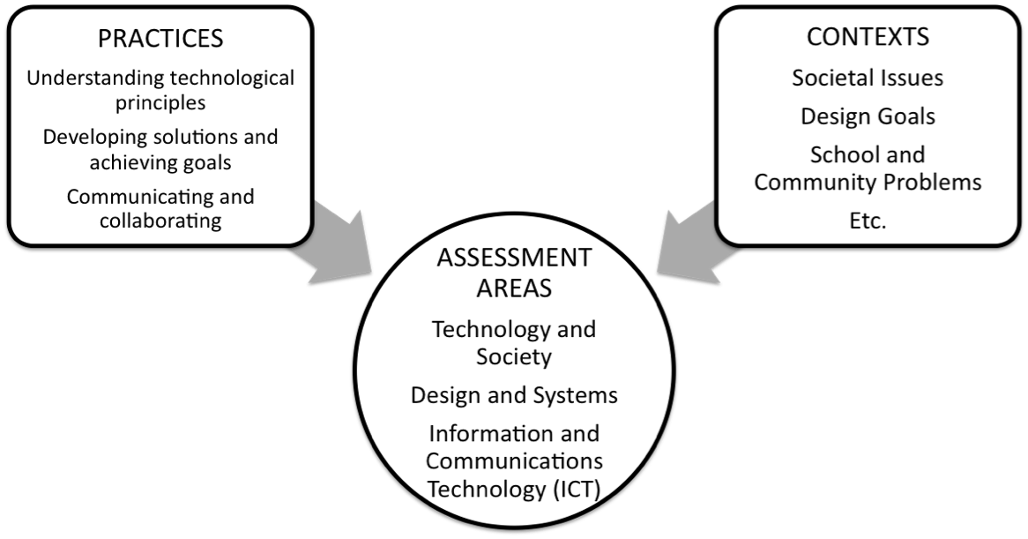
Figure 2 – Elements of the NAEP Technology and Engineering Literacy Assessment

As indicated in figure 2, the practices expected of students are general, crosscutting reasoning processes that students must use to show that they understand and can use their technological knowledge and skills. The contexts in which technology and engineering literacy tasks and items appear will include typical issues, problems, and goals that students might encounter in school or practical situations. The particular knowledge and skills that are the targets of the assessment lie in the three assessment areas. Together, the assessment targets, practices, and contexts provide a structure for the generation of tasks and items. This chapter describes the practices and contexts in some detail and provides examples of the types of tasks and items that result when these three elements are combined.

Practices

Practices contribute to the framework by articulating the general kinds of thinking and reasoning that students are expected to demonstrate when responding to assessment tasks and items. The framework specifies three generic kinds of practices that apply across the three assessment areas: (1) understanding technological principles; (2) developing solutions and achieving goals; and (3) communicating and collaborating.

Building on the pyramid of major assessment areas introduced in chapter two, the practices are distributed around a circle in which the pyramid sits. As critical components of technological literacy, these crosscutting practices are applied across all three major assessment areas. For example, communicating effectively and collaborating with others are necessary skills for understanding the effects of technology on the natural world, designing an engineering solution to a technological problem, and achieving a goal using information and communication technologies.

The Science Framework for the 2009 National Assessment of Educational Progress served as the primary source for these practices. Developers of the science framework had examined the sections on Science and Technology and the Designed World from the National Science Education Standards as well as Benchmarks for Scientific Literacy and cognitive research on science learning. Learning research has shown that these three kinds of cognitive processes represent how all individuals build their content knowledge and understanding in a subject area and how they develop strategies for using their knowledge in their thinking, reasoning, and application to new situations. To create the practices for the NAEP Technology and Engineering Literacy Framework, the crosscutting practices from the Science Framework for the 2009 NAEP were modified so that they applied to processes relevant to technological literacy, primarily by indicating that technology and engineering literacy depends on having and using knowledge about technologies to reason, develop solutions, communicate, and collaborate. In addition, the national, international, and state technology and engineering literacy frameworks cited in chapter two were used as reference points.

Although the practices are related and not independent of each other, classifying the assessment targets in chapter two according to the three crosscutting practices will help developers produce a range of rich and challenging assessment tasks and items. A brief description of each of these three practices is offered below.

Understanding Technological Principles focuses on students’ knowledge and understanding of technology and their capability to think and reason with that knowledge. This practice ranges from the knowledge of simple declarative facts and concepts to higher-level reasoning about facts, concepts, and principles and their interrelationships. Students should be able to call
on their recognition and understanding of technological principles to explain features and functions of technologies and systems, how components fit together, and to make predictions, comparisons, and evaluations. The assessment targets that elicit this practice require students to identify examples, explain, describe, analyze, compare, relate, and represent the technological principles specified in chapter two. This practice also includes understanding the relationships among components of systems and interactive processes.

Developing Solutions and Achieving Goals refers to students’ systematic application of technological knowledge, tools, and skills to address problems and achieve goals presented in societal, design, curriculum, and realistic contexts. This practice includes both procedural and strategic capabilities—knowing how to apply simple steps and use technological tools to address authentic tasks, as well as when and where to apply the tools and design and problem-solving strategies. This practice draws on the previous practice—to understand technological principles—and adds the dimension of applying this knowledge to solve problems and achieve goals. This practice involves using fundamental problem-solving processes such as planning, monitoring, evaluating, and revising, and how these generic problem-solving strategies can be employed in the three assessment areas. It may engage students in analyzing goals, planning, designing, and implementing as well as in iteratively revising and evaluating possible solutions to meet the requirements of a problem or to achieve a goal. For the NAEP Technology and Engineering Literacy Assessment, a distinguishing feature of this practice is that the students respond to questions and tasks during the process of solving a multistage problem or working through how best to achieve a goal, using their understanding of technological principles to do so.

Communicating and Collaborating centers on students’ capabilities to use contemporary technologies to communicate for a variety of purposes and in a variety of ways, working individually or in teams. In the three major assessment areas, in order to address societal issues, solve problems, achieve goals, and design processes and products, students must develop representations and share ideas, designs, data, explanations, models, arguments, and presentations. Effective teamwork and collaboration with peers and experts who are either present or in another location are important skills that can help students achieve their goals. In the assessment, collaboration tasks will engage individual students with virtual (computer-generated) peers and experts. Communication and collaboration are critical, crosscutting practices in all subject domains. For technology and engineering literacy, these practices are distinguished by students’ facility with a range of technologies to communicate and collaborate.

Table 3.1 presents generic examples of how these 3 practices can be used to classify targets in the 3 major assessment areas. These are sample ideas for items and tasks and will not be used in the actual assessment. It should again be noted that the boundaries between the practices are not entirely distinct, but referring to these three practices can be helpful in the development of tasks and items and the interpretation of student performance for a range of cognitive demands.

Table 3.1 Classification of types of assessment targets in the three major assessment areas according to the practices for technology and engineering literacy

 | Technology and Society | Design and Systems | Information and Communication Technology (ICT)
Understanding Technological Principles | Analyze advantages and disadvantages of an existing technology  Explain costs and benefits  Compare effects of two technologies on individuals  Propose solutions and alternatives  Predict consequences of a technology  Select among alternatives | Describe features of a system or process  Identify examples of a system or process  Explain the properties of different materials that determine which is suitable to use for a given application or product  Analyze a need  Classify the elements of a system | Describe features and functions of ICT tools  Explain how parts of a whole interact  Analyze and compare relevant features  Critique a process or outcome  Evaluate examples of effective resolution of opposing points of view  Justify tool choice for a given purpose
Developing Solutions and Achieving Goals | Select appropriate technology to solve a societal problem  Develop a plan to investigate an issue  Gather and Organize data and information  Analyze and Compare advantages and disadvantages of a proposed solution  Investigate environmental and economic impacts of a proposed solution  Evaluate trade-offs and impacts of a proposed solution | Design and Build a product using appropriate processes and materials  Develop forecasting techniques  Construct and Test a model or prototype  Produce an alternative design or product  Evaluate trade-offs  Determine how to meet a need by choosing resources required to meet or satisfy that need  Plan for durability  Troubleshoot malfunctions | Select and Use appropriate tools to achieve a goal  Search media and digital resources  Evaluate credibility and solutions  Propose and Implement strategies  Predict outcomes of a proposed approach  Plan research and presentations  Organize data and information  Transform from one representational form to another  Conduct experiments using digital tools and simulations
Communicating and Collaborating | Present innovative, sustainable solutions  Represent alternative analyses and solutions  Display positive and negative consequences using data and media  Compose a multimedia presentation  Produce an accurate timeline of a technological development  Delegate team assignments  Exchange data and information with virtual peers and experts | Display design ideas using models and blueprints  Use a variety of media and formats to communicate data, information, and ideas  Exhibit design of a prototype  Represent data in graphs, tables, and models  Organize, Monitor, and Evaluate the effectiveness of design teams  Request input from virtual experts and peers  Provide and Integrate feedback | Plan delegation of tasks among team members  Provide and Integrate feedback from virtual peers and experts to make changes in a presentation  Critique presentations  Express historical issues in a multimedia presentation  Argue from an opposing point of view  Explain to a specified audience how something works  Address multiple audiences  Synthesize data and points of view

Examples of Practices Applied in Each of the Assessment Areas

The following sections describe how the three practices of Understanding Technological Principles, Developing Solutions and Achieving Goals, and Communicating and Collaborating can be used to classify the general types of thinking and reasoning intended by the assessment targets in the three major assessment areas of Technology and Society, Design and Systems, and Information and Communication Technology (ICT).

Practices Applied in Technology and Society

Assessment targets in the area of Technology and Society are concerned with the effects of technology on human society, the natural world, and the world of information and knowledge as well as with issues of ethics, equity, and responsibility.

Understanding Technological Principles

To provide evidence that they understand principles in these three subareas, students could be asked to perform a variety of tasks, such as recognizing examples of the effects of technologies; identifying examples of ethical and equity issues; describing local and global effects of technologies; explaining the effects of rapidly changing technologies on knowledge creation, access, and management; analyzing beneficial and negative impacts; recognizing examples of responsible, ethical uses of technologies; comparing costs and benefits of technologies; predicting potential impacts on society and the environment; and explaining the relationships among technologies.

Developing Solutions and Achieving Goals

Students must use their understanding of the technological principles for Technology and Society specified in chapter two to apply that knowledge as they address novel issues and problems. To demonstrate their capacity to address issues and problems in the assessment area of Technology and Society, students could be asked, for example, to develop alternative proposals for a new technology based on an analysis of potential positive and negative impacts. Problem-solving practices could be demonstrated in a series of tasks and items involved in analyzing the uses of the new technology, gathering data and information on its impacts, analyzing the data, interpreting results, and evaluating alternatives.

Communicating and Collaborating

To communicate and collaborate with others (virtual others in the assessment) in the course to respond to issues, students must draw on their understanding of the technological principles specified in chapter two and apply their knowledge as they work through given problems and issues. For example, to address issues in Technology and Society, students can use a variety of modalities to represent and exchange data, ideas, and arguments about the advantages and disadvantages of technologies. Students can collaborate (virtually) to form teams that will gather and integrate information about the potential impacts of a technology on human society or the natural world. Students can evaluate the qualifications, credibility, and objectivity of virtual experts. Tasks can require students to demonstrate their capability to interact, collaborate, and contribute to work as a team. Students can use various media and representations to share their analyses and recommendations.

Table 3.2 provides some examples of how the 3 practices can be applied to assessment targets for Technology and Society to generate tasks and items at the middle school level. The key principles and targets were selected from tables 2.2-2.5 in chapter two. These are sample ideas for items and tasks and will not be used in the actual assessment. Simpler tasks could be developed for grade 4 targets and more complex tasks could be developed for grade 12 targets.

Table 3.2 Examples of grade 8 tasks representing practices in each subarea of
Technology and Society

 | A. Interaction of Technology and Humans | B. Effects of Technology on the Natural World | C. Impacts on the World of Information and Knowledge | D. Ethics, Equity, and Responsibility
Selected  Principles  Practices | The relationship between technology and society is reciprocal. Society drives technological change, while changing technologies in turn shape society. | Reusing, recycling, and using fewer resources can reduce environmental impacts. | Information technology is evolving rapidly, enabling ever-increasing amounts of information and data to be stored, managed, enhanced, analyzed, and accessed through a wide array of devices in various media formats. | Technology by itself is neither good nor bad, but its use may affect others.
Understanding Technological Principles | Explain what factors need to go into a decision to change the use of a river and identify possible consequences of doing so. | Identify and provide a rationale for appropriate and inappropriate procedures for disposing of electronic devices. | Compare the impact of geographical information systems and 14th-century maps on people’s capability to explore new territory. | What are the positive and negative consequences of the predicted change from print to digital news?
Developing Solutions and Achieving Goals | The community has decided to implement a new wind turbine system. Design an investigation into the impact on the community. | Given a specific consumer electronics product such as a cellular telephone, design a new way to increase its appropriate disposal. | Use a simulation to test the adequacy of exit routes for evacuating residents of a mountain town during a wildfire. | What processes and digital tools might the city council put into place in order to make sure all citizens have a say?
Communicating and Collaborating | Collaborate with engineers and urban planners (virtual) through a website to collect and communicate data about the effects of a wind turbine system on the community. | Organize a campaign with a virtual team to inform the public of the dangers of improper disposal of consumer electronic products. | Present a set of images from two artists of the period that represent different perspectives on a major event. | Debate with a virtual team member the privacy and safety issues involved in establishing international projects.

Illustrative Tasks and Items

The following examples represent three types of tasks and items that could be used to assess targets related to the Technology and Society assessment area. The first example is a scenario-based set of items, and the next two are familiar, conventional constructed and selected-response items.

Scenario-Based Item Sets

Items of this type present students with a problem or goal set within a broader context. The example below calls on the student to employ the practice of Developing Solutions and Achieving Goals. In this task, the student must use ICT tools to analyze the impacts of technology on human society. This example employs a computer-based interactive format in which students search for information concerning video games and violence and then use word-processing, spreadsheet, and Web-based tools to develop a PowerPoint presentation. The PowerPoint presentation calls on the crosscutting practice of Communicating and Collaborating.

Context: Human Society
Topic: Video Games and Violence
Target Level: Grade 12

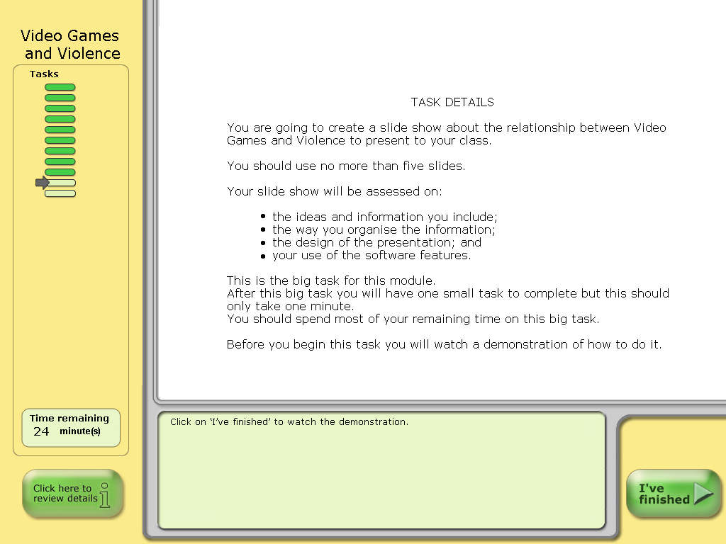

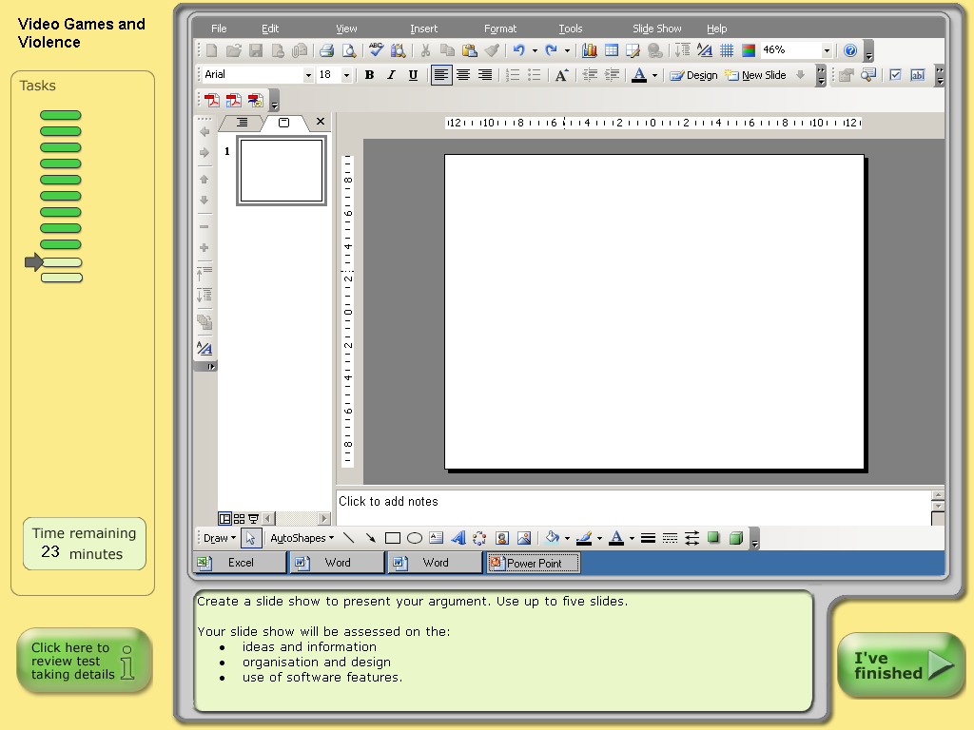

(Source: Australian Ministerial Council for Education, Early Childhood Development and Youth Affairs [MCEECDYA], 2008)
Conventional Items

These items will ask for students to select or construct their answers. The examples below are of the familiar constructed- and selected-response formats.

Constructed Response

This task illustrates students’ skill in using simulations in a problem-solving activity. The student constructs a response by manipulating force arrows in a simulation-based scenario in which an emergency rescue truck must deal with various problems along a fire road in a forest. The student constructs text-based explanations of the balanced and unbalanced forces acting on the truck. While designed to be used as a middle school science item about force and motion, such a simulation could be adapted for the NAEP Technology and Engineering Literacy Assessment to study how the design of the technological system (transportation) affects the environment positively by making it possible to contain forest fires and rescue people and also negatively because of the cutting of trees and the disruption of wildlife habitat. This task also illustrates an interactive item in which students can manipulate different factors in a simulated environment and then provide responses to questions related to the scenario. For the NAEP Technology and Engineering Literacy Assessment, a series of items could call on the practices of Understanding Technological Principles (for example, describing positive and negative effects of roads in the forest) and Developing Solutions and Achieving Goals (for example, designing a fire road that would not cross wildlife migration corridors).
Context: Transportation
Topic: Emergency Rescue
Target Level: Grade 8
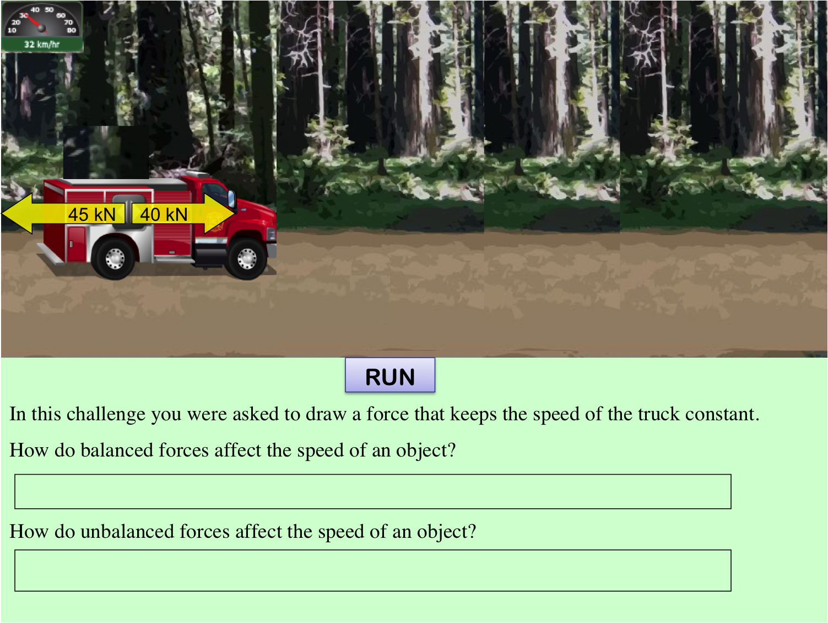
(Source: Quellmalz, Timms, and Buckley, 2009)

Selected Response—Multiple Choice

In this conventional multiple-choice item, the student selects an answer that describes the effect of fossil fuel on the natural environment, employing the practice of Understanding Technological Principles to analyze positive and negative effects. This item assesses student understanding of the interaction of a technology (energy production) and climate change. The combination of the two can be thought of as a system, with each affecting the other, and the item below also assesses a student’s system thinking, albeit on a relatively simple level. Similar items in the NAEP Technology and Engineering Literacy Assessment could focus on the effects of technology on the environment.
Context: Natural World
Topic: Climate Change
Target Level: Grade 8
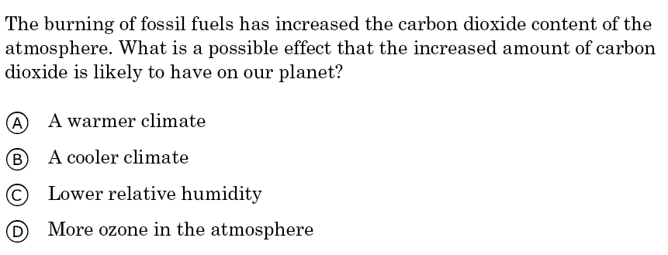
(Source: Trends in International Mathematics and Science Study, 2003)

Practices Applied in Design and Systems

Assessment targets in the area of Design and Systems relate to the nature of technology, the engineering design process, maintenance and troubleshooting, and systems thinking. The sections below describe how the three crosscutting practices apply to targets in the area of Design and Systems.

Understanding Technological Principles

Technological principles for Design and Systems in chapter two specify for this assessment the core understandings that students should have about the different types of technologies, processes for designing technologies, approaches to preventing failures, and how components of technological systems interrelate. The practices for Understanding Technological Principles in these areas could, for example, ask students to draw on their knowledge to identify examples of technologies, components of the design process, components of a system, or maintenance and troubleshooting methods. Students could be asked to explain the relationship among technologies in a system, analyze the components of a system, recognize design constraints, or evaluate alternative representations of a system.

Developing Solutions and Achieving Goals

Problem-solving is a major part of the engineering design process. Thus there are many opportunities for students to demonstrate their problem-solving skills in assessment tasks for this area. Such tasks could require them to develop designs, to propose or critique solutions to problems after being given criteria and constraints, to select appropriate resources by considering trade-offs, to construct and test a model or prototype, to troubleshoot systems and applications, or to determine the consequences of making a change in a system. Students must use their understandings about the technological principles specified for Design and Systems in chapter two as they plan, try out, critique, and revise attempted solutions.

Communicating and Collaborating

Communication and collaboration practices are integral to achieving the goals of technological design and systems. Students can demonstrate teamwork in tasks where design assignments are distributed among team members, progress and results are integrated and shared, and products are presented jointly. Designs and the design process can be represented in visual and verbal forms. Students can create instructions for system assembly and prepare documentation of a procedure for maintaining a system. Students must use their understandings of the technological principles specified for both Design and Systems and ICT in chapter two to use tools and strategies to communicate and collaborate. Because students are completing the assessment individually on the computer, collaborators will be virtual—that is, presented by the computer.

Table 3.3 offers examples of how the 3 practices can be applied to assessment targets for Design and Systems to generate tasks and items for the middle school level. The key principles and grade 8 targets were selected from tables 2.6-2.9 in chapter two. The chapter two tables present simpler versions of the targets for grade 4 and more challenging versions of the targets for grade 12. Again, these are sample ideas for items and tasks and will not be used in the actual assessment.

Table 3.3 Examples of grade 8 tasks representing practices
in each subarea of Design and Systems

 | A. Nature of Technology | B. Engineering  Design | C. Systems Thinking | D. Maintenance and Troubleshooting
Selected  Principles  Practices | Technologies developed for one purpose are sometimes adapted to serve other purposes.  Technological development involves creative thinking. | Requirements for a design challenge include the criteria for success and the constraints or limits that cannot be violated in a solution. | All technological systems have parts that work together to accomplish a goal. | Tools and machines must undergo regular maintenance to ensure their proper functioning.
Understanding Technological Principles | Describe the properties of a spring that inspired the invention of the Slinky. (animation) | List three important criteria for a device that will toast bread, and justify each one. | How do the physical and human components of the school cafeteria food service system work together?  (animation) | Why do Bill and Sally oil their bike chains and axles and check the brakes each month? What may happen if they do not?
Developing Solutions and Achieving Goals | Given a collection of objects, design a new toy (for example, for a baby, young child). What are the criteria for a toy, and how does your design meet them? | Design a process to serve 50 slices of warm toast in 5 minutes, given specific equipment and resources. | Design modifications to the cafeteria for people with a particular physical disability (for example, vision, mobility).  (animation) | Bill’s new bike gears are not working correctly. What should he do?
Communicating and Collaborating | Select a team of people who could design and build a new toy for a 5-year-old, and justify the choices. Work individually, or collaborate with a virtual person to make your selections. | How would an industrial toaster salesperson develop talking points for selling a particular toaster to a given restaurant? | Collaborate with a virtual group of people to redesign the tasks of the cafeteria staff, given the new machines. | Bill, Sally, and many other students would like to ride their bikes to school. Present a design for a bike parking lot at the school.

Illustrative Tasks and Items

These items from existing tests were selected as examples that could be adapted for assessing targets in Design and Systems. Each item is analyzed for the ways in which it would call on the practices.

Scenario-Based Item Set

In this example, students are asked a series of questions related to a simulation of a nuclear reactor. In the NAEP Technology and Engineering Literacy Assessment, the questions might relate to all three practices. Students may be asked to demonstrate the practice of Understanding Technological Principles by identifying the inputs and outputs of the system or analyzing the potential hazards. Students might employ the practice of Developing Solutions and Achieving Goals in items asking for results of investigations based on manipulating the simulation to find safe levels of temperature and power. The practice of Communicating and Collaborating could be elicited in tasks involving virtual (that is, computer-generated) experts in preparing a report of findings.
Context: Energy
Topic: Nuclear Reactor
Target Level: Grade 8

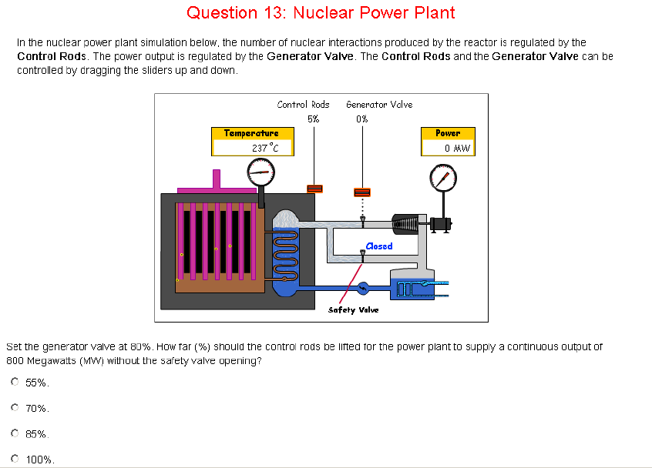
(Source: Organisation for Economic Co-operation and Development, 2005)
Conventional Items

These items will ask for students to select or construct their answers. The examples below are of the familiar constructed- and selected-response formats.

Constructed Response

Similar to the previous example, this item represents a sample task in which students must use their knowledge about the engineering design process to answer a constructed-response item. The practice of Understanding Technological Principles is measured by this computer-based item. In this item, students use various tools to explore the factors that affect plant growth in a greenhouse. In the NAEP Technology and Engineering Literacy Assessment, a similar item might ask students to evaluate different greenhouse designs in terms of their effects on plant growth.

Context: Plant Growth
Topic: Designing a Greenhouse
Target Level: Grade 12
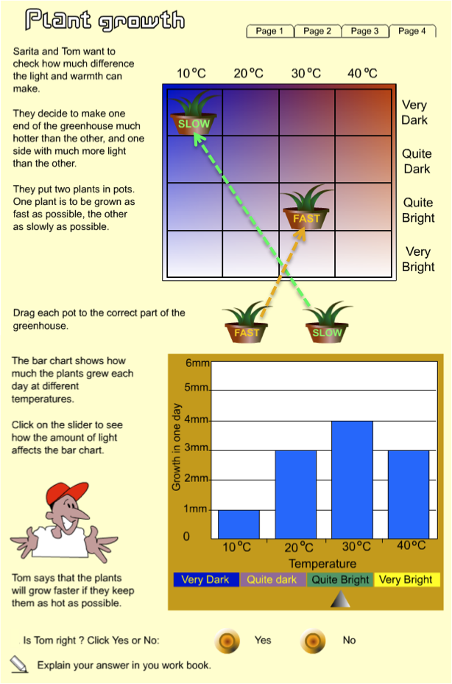
(Source: Adapted from Ripley, 2009)

Selected Response–Multiple Choice

The following item is another conventional item type—in this case, multiple choice. Students would employ the practice of Understanding Technological Principles by demonstrating their knowledge about the engineering design process.
Context: Product Design
Topic: The Design Process
Target Level: Grade 12

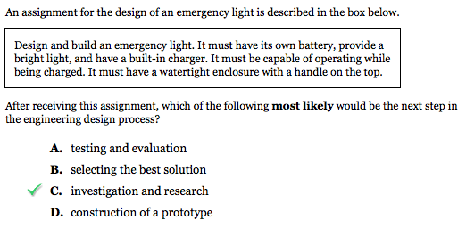
(Source: Massachusetts Department of Elementary and Secondary Education, 2009)

Practices Applied in Information and Communication Technology (ICT)

ICT literacy includes the capability to communicate ideas and solutions, to collaborate with peers and experts, to conduct research, to investigate solutions to academic and real-world problems, to find ways to meet the ever-changing needs of society, to properly acknowledge the source of ideas and information, and to select and use appropriate digital tools. The sections below describe how the three practices apply to the ICT assessment targets.

Understanding Technological Principles

The principles in the ICT assessment area involve understanding the variety of ICT tools and how and when they can be used to accomplish a wide variety of tasks in school and in practical, out-of-school situations. Students will need to know about the general features and functions of types of ICT tools, which tools are appropriate for particular purposes, and to understand criteria for determining if the tools were used appropriately and well.

Developing Solutions and Achieving Goals

ICT tools can be employed to support problem-solving and achievement of goals in all three of the technology and engineering literacy areas. The types of problems addressed in the ICT assessment area relate to the selection and use of appropriate tools to achieve goals related to information research, investigating problems, meeting the needs of society, constructing and exchanging information and ideas, and acknowledging ideas and information. ICT problem-solving practices could be elicited by tasks and items asking students to select and use applications effectively and productively; to access and use information and data to solve a problem or achieve a goal; to use ICT tools to solve a problem or achieve a goal; or to use ICT tools to plan an approach to solving a problem, represent data, analyze results, and summarize and present findings. Students must use their understandings about the features and functions of ICT tools in order to apply the tools appropriately and effectively to develop solutions and achieve goals for given tasks and problems.

Communicating and Collaborating

ICT capabilities rely heavily on students’ command of communication and collaboration skills. Students can be asked to demonstrate the capability to contribute effectively to a body of knowledge or to take part in group deliberations through social media (simulated in the assessment) and the use of other contemporary communication tools and structures. Students can be asked to investigate a problem or pursue a goal as individuals or with a group (virtually), to integrate input (provided in the task) from multiple collaborators (virtual) who are peers or experts, and to reach consensus. Students can integrate feedback from others, provide constructive criticism, and communicate to multiple audiences using a variety of media and genres. Findings can be represented in a variety of ways, such as diagrams, tables, graphs, and digital media. To communicate and collaborate effectively, students will need to use their understandings about features and functions of communication and collaboration tools and apply their knowledge and understanding of the ICT tools and strategies.

Table 3.4 provides some examples of how the 3 practices can be applied to assessment targets for Information and Communication Technologies to generate tasks and items at the middle school level. The key principles and grade 8 targets were selected from tables 2.10-2.14 in chapter two. Those tables further describe simpler targets at grade 4 or more complex targets at grade 12. These are sample ideas for items and tasks and will not be used in the actual assessment.

Table 3.4 Examples of grade 8 tasks representing practices that apply to each subarea of Information and Communication Technologies (ICT)

 | A. Construction and Exchange of Ideas and Solutions | B. Information Research | C. Investigation of Academic and Real-World Problems | D. Acknowledg-ment of Ideas and Information | E. Selection and Use of Digital Tools
Selected Principles  Practices | Digital tools offer many options for formal and nonformal expression in nearly every academic and professional discipline. | Important strategies for ensuring quality of information include 1) assessing the source of information and 2) using multiple sources to verify the information in question. Information can be distorted, exaggerated, or otherwise misrepresented. | Digital tools can be very helpful in generating ideas and solving problems in academic subjects as well as in researching practical problems. | There are multiple guiding principles (laws, policies, and guidelines) that govern the use of ideas and information. | Knowledge about the common uses of readily available digital tools supports effective tool selection.
Understanding Technological Principles | Describe how graphics, text, and tables convey a message. | From among a group of Web pages select the particular one that contains an example of exaggeration. | Identify the combination of data tools that will best present a particular set of data. | Select the example that shows an appropriate way to give credit to another student’s graphic. | Critique a digital tool suggested for designing an online story.
Developing Solutions and Achieving Goals | Develop an online survey for elementary school students concerning the design of a new playground. | Create a digital story about a historical period by choosing images of art from the period. | Use simulations and visualizations to describe the rate of deforestation in Brazil. | Identify which online images can legally be used in a student presentation. | Predict trends in rates of software piracy based on provided data.
Communicating and Collaborating | Respond to suggestions from two virtual (computer-generated) collaborators explaining why the search results of only one of the collaborators have sufficient information for the report. | Ask a virtual collaborator for help on developing a digital presentation. | Enter costs from several sources and communicate to the principal the most economical printer for school play posters. | Post a copyright-free image to a website and communicate to friends that it is available. | Use two digital tools to create a public service announcement on software piracy.
Illustrative Tasks and Items

The following tasks and items illustrate how the three practices apply to ICT assessment targets. The practices may be elicited by extended, scenario-based task and item sets or by separate items.

Scenario-Based Item Sets

In this simulation, students navigate among a file manager, an email client, a Web browser, a word processor, and a spreadsheet to make a travel brochure for a fictional town, Pepford. They are assessed on how they use these ICT tools to accomplish the task, not on the quality of the brochure. The process is more important than the outcome. Students use the practice of Understanding Technological Principles by calling on their knowledge of which ICT tools to use to accomplish the goal and how to use them. Students also apply the practice of Developing Solutions and Achieving Goals as they conduct their information research. The practice of Communicating and Collaborating is not assessed directly in this task, although it could be added by including tasks assessing the quality of the brochure for communicating to the intended audience and tasks involving the assignment of information gathering from virtual (computer-generated) collaborators and the integration of their (virtual) input into the brochure.
Context: Travel and Tourism
Topic: Promotional Brochure
Target Level: Grade 8

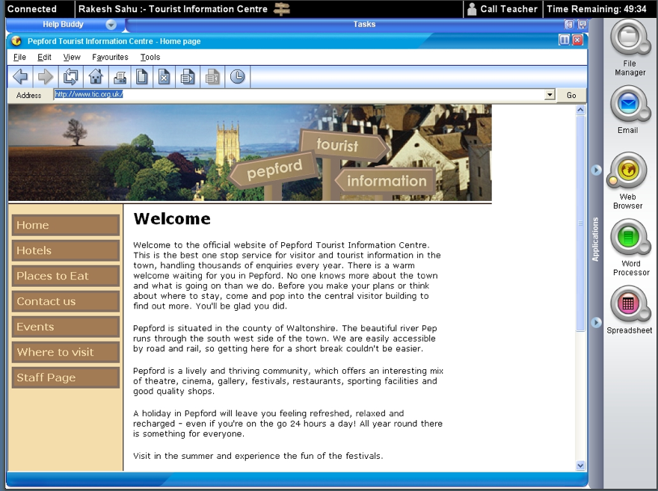

(Source: Ripley, 2009)

Conventional Items

These items will ask for students to select or construct their answers. The examples below are of the familiar constructed- and selected-response formats.

Constructed and Selected Response

In this task, students are presented with a list of websites from the results of a Web search. Students must decide which website has the most reliable information and justify their response. The practice of Understanding Technological Principles is applied to students’ knowledge of criteria for how to judge the credibility and quality of information sources—one of the ICT targets in Information Research.
Context: Medicine
Topic: Web Search
Target Level: Grade 8

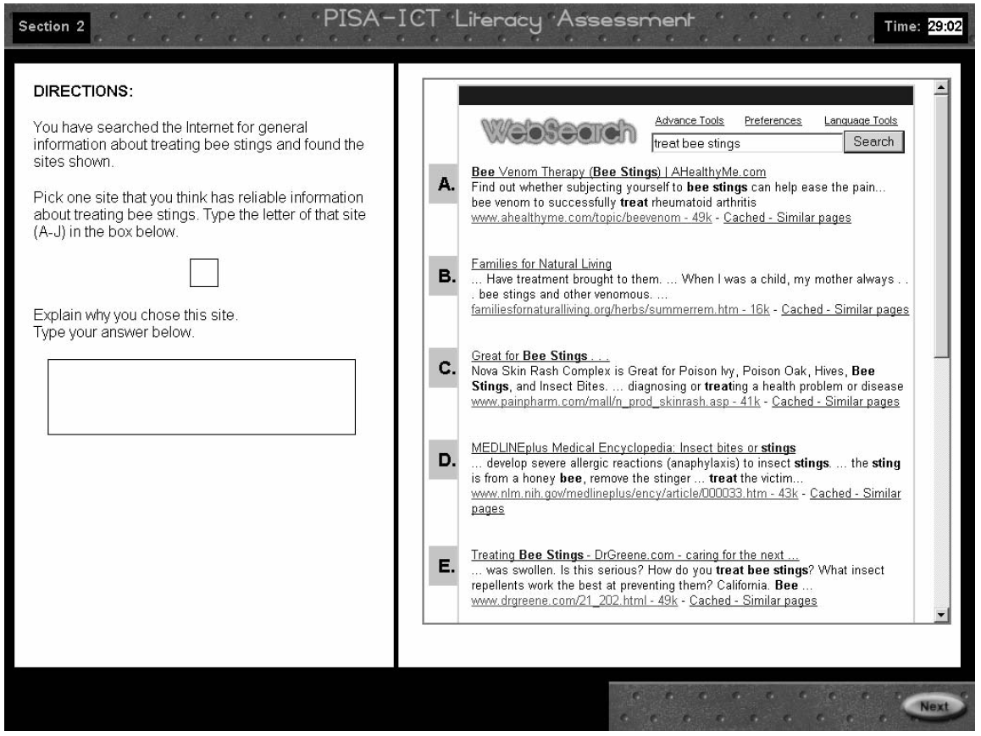

(Source: Lennon et al., 2003)

Selected Response—Multiple Choice

This multiple-choice item also assesses a student’s capability to evaluate websites, an example of the practice, Understanding Technological Principles. This example also demonstrates a computer-based selected-response format.
Context: The Internet
Topic: Website Search
Target Level: Grade 12

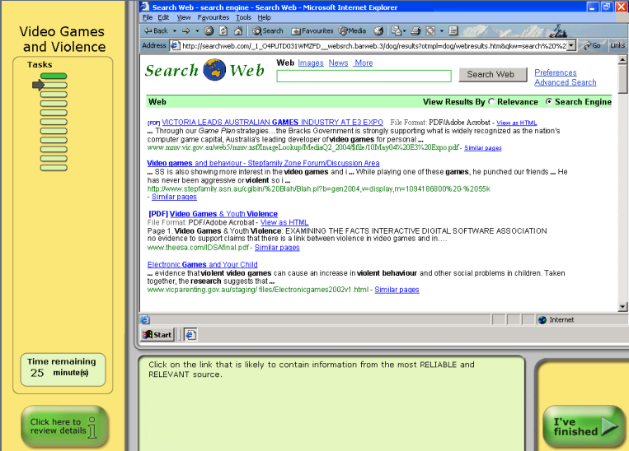

(Source: Australian MCEECDYA, 2008)

Contexts

Technology and engineering literacy requires not just that students know about technology but also that they are able to recognize the technologies around them, understand the complex relationship between technology and its effects on society, and use technological principles and tools to develop solutions to problems and meet goals. Consequently, NAEP Technology and Engineering Literacy Assessment items will measure students’ technology and engineering literacy in the context of relevant societal issues, design problems, and school and community goals. As the three areas of technological literacy to be measured by NAEP tend to focus on somewhat different types of issues, problems, and goals, the contexts and situations that will frame the technology assessment items in these areas will differ somewhat as well.

Contexts in Technology and Society

The complex and multifaceted interactions between technology and society often manifest themselves in unexpected and unpredictable ways as new technologies are used in particular contexts or situations. A new technology may succeed in meeting the need that it was intended to meet and bring about far-reaching benefits, but it may also have negative, unintended consequences. For example, mobile communication devices have transformed business and personal interactions, yet a large number of traffic accidents have been blamed on drivers using these devices while operating their vehicles. Similarly, farming practices have increased crop production, but they have also risked contaminating sources of groundwater. Such issues can clearly be used as contexts for NAEP Technology and Engineering Literacy Assessment items (as illustrated in ISTE’s NETS•S, the framework of the Partnership for 21st Century Skills, and ITEEA’s Standards for Technology Literacy). The contexts for tasks and items in the area of Technology and Society may include such technologies with positive and negative effects and may also present ways that technology improves people’s lives, such as water purification, sewage treatment, and medicine, or the various ways that people regularly interact with technology, from brushing teeth in the morning to crawling into a warm, comfortable bed at night. The following are examples of topics in the contexts of health, energy, and electronic communications that could be used to generate assessment tasks and items for sample targets in the 3 subareas of Technology and Society for grade 8:
- Agriculture and health contexts: water as a scarce resource;
- Energy context: wind turbines for homes; and
- Electronic communications context: personal communication devices.

Table 3.5 Examples of how different contexts may be used to generate
tasks and items for Technology and Society for grade 8

 | A. Interaction of Technology and Humans |  | B. Effects of Technology on the Natural World | C. Effects of Technology on the World of Information and Knowledge |  | D. Ethics, Equity, and Responsibility
Key Principles | Society drives technological change, while changing technologies in turn shape society. |  | Some technological decisions put environmental and economic concerns in competition with one another, while others have positive effects for both the economy and the environment. | Information technology is evolving rapidly, enabling ever-increasing amounts of information and data to be stored, managed, enhanced, analyzed, and accessed through a wide array of devices in various media formats. |  | Technology by itself is neither good nor bad, but its use may affect others.
Context: Agriculture and Health: Water as a Resource | What societal needs drove the changes made to a river’s natural flow? |  | What issues need to be addressed to ensure that the water system stays healthy? | Find two reports describing alternative water purification methods. |  | How might the decision to divert water from the rivers affect farmers and small towns downstream?
Context: Energy: Wind Turbine | Describe the positive and negative impacts that residential wind turbines might have on society. |  | Compare and contrast the environmental and economic impacts of wind turbines with other potential sources of energy. | Compare the persuasiveness of two multimedia presentations on alternative wind turbine designs. |  | Describe a process for citizens to evaluate the effect that wind turbines might have on others in the community.
Context: Electronic Communication | What are the positive and negative effects that personal communication devices may have on traditional human communication? |  | Describe the effect of video evidence of environmental destruction on society’s awareness of the global impact of pollution. | Describe ways that personal communication devices provide access to information and expertise. |  | What might the effect be of allowing personal communication devices to be used in school?

Contexts in Design and Systems

Nearly all of the products and processes in human society result from the development of one or more kinds of technology. Homes, factories, and farmhouses are built using construction technologies. Fruits and vegetables are grown and processed using agricultural technologies and are brought to market and to the dinner table with transportation technologies. Methods of extracting and using fuels to produce power involve energy and power technologies, and the tools and processes used by doctors, nurses, and pharmacists are a part of medical technologies. Although these technologies can be classified in various ways, in order to provide guidance to item writers, this framework identifies the following technology areas that can be used as contexts to measure students’ understanding of design and systems (drawn primarily from ITEEA, 2007):
- Agricultural and related biotechnologies;
- Construction technologies;
- Energy and power technologies;
- Information and communication technologies;
- Materials and manufacturing;
- Medical technologies; and
- Transportation technologies.

The section on the next page presents potential scenario topics placed in contexts from the types of technologies listed above. The table illustrates how the topics in these contexts can be used to generate tasks and items in the 4 subareas of Design and Systems for grade 8. The scenarios would be simpler for grade 4 and more complex for grade 12.
Table 3.6 Examples of how different contexts may be used to generate
tasks and items for Design and Systems for grade 8

 | A. Nature of Technology | B. Engineering Design | C. Systems Thinking | D. Maintenance and Troubleshooting
Key Principles | Scientists are concerned with what exists in nature; engineers modify natural materials to meet human needs and wants. | Requirements for a design challenge include the criteria for success, or goals to be achieved, and the constraints or limits that cannot be violated in a solution. | Systems may include subsystems and may interact with other systems. Systems may also be embedded within larger systems. | Tools and machines must undergo regular maintenance to ensure their proper functioning.
Context: Transportation | How have transportation methods changed over time? | Propose two ways to modify an intersection to make it safer. | What are the advantages of container cargo ships over other ways to transport goods to market? | What problems might occur if engines are not oiled periodically?
Context: Medical Technology | What were the technological advances that allowed medical researchers to develop vaccines? | Identify the requirements for a prosthetic arm that will enable a person to play tennis. | Name several elements of the nation’s medical system and describe how they are related. | What procedures would you recommend for maintaining the school’s first-aid kits?
Context: Energy: Wind Turbine | What natural constraints exist in a city that might cause a homeowner to choose wind power over other “green” energy alternatives? | Compare the aesthetic qualities of the two types of wind turbines (vertical or horizontal). | Using the simulation model of a residential wind turbine, identify the goals, inputs, processes, outputs, and feedback and control features. | Using the simulation model of a residential wind turbine, describe which parts of the machine would require the most maintenance.
Context: Information and Communication Technologies | Trace the evolution of features on early cellphones compared with current smartphones. | Compare the trade-offs of functions available in two specific devices designed for a workplace or personal use. | Explain two ways in which personal communication devices can work together for a team to achieve its project goal. | Describe a set of troubleshooting steps that would be appropriate for analyzing a problem with a printer.

It is important to note that students are not expected to be familiar with the specific components and working details of any particular technology. For example, they will not be tested on their knowledge of genetic engineering, an important biotechnology, or on their understanding of energy and power or networking technologies. While these topics may be used to provide the context for test items, the information required for students to respond to the test questions will be provided in the scenario or background of the question. Students will be tested on the broad set of principles concerning design and systems and capabilities described in chapter two. However, one of the technologies from the list in the previous section has been chosen for more emphasis in the 2014 NAEP Technology and Engineering Literacy Framework, and that is Information and Communication Technology.

Contexts in Information and Communication Technology (ICT)

In contrast to other types of technologies, students will be expected to be fluent in the use of information and communication technologies, as described in the tables in chapter two. The reason for this additional attention to ICT is that it is pervasive in society, and some level of technology and engineering literacy is required for virtually every profession, in every school subject, and in all walks of life. Furthermore, it is likely that literacy with information and communication technologies will become even more important in the decades ahead.

Because of the ubiquity of ICT, it is difficult to describe all of the particular contexts for items that NAEP will design to assess students’ knowledge of it and their capabilities to put it to use. ICT knowledge and skills can be applied in the context of developing and using any of the technologies included in table 3.7, and it can be applied to any of the ways that technology interacts with society. ICT principles and tools should be a part of every person’s set of capabilities in and out of school for solving problems or working to meet a goal. ICT tools have become integral supports for learning school subjects. People who are literate in technology and engineering should be able to select and use technological tools to research a period in history, compare cultures, collect and display data in a scientific investigation, develop a story or presentation, or produce a work of art. The types of scenarios used to assess students’ knowledge and skills in this area will require that the item provide an opportunity for students to demonstrate their understanding of and capabilities to use ICT to address goals and problems in Technology and Society, in Design and Systems, and, more generally, in various disciplines, and in real-world, practical applications. The following table illustrates how topics set in different contexts can be used to generate tasks and items for targets in the five subareas of ICT.

Table 3.7 Examples of how different contexts may be used to generate tasks and items for Information and Communication Technology (ICT) for grade 8
 | A. Construction and Exchange of Ideas and Solutions | B. Information Research | C. Investigation of Problems | D. Acknowledg-ment of Ideas and Information | E. Selection and Use of Digital Tools
Key Principles | Digital tools offer many options for formal and nonformal expression in nearly every academic and professional discipline. | Important strategies for ensuring quality of information include 1) assessing the source of information and 2) using multiple sources to verify the information in question. | Digital tools can be very helpful in generating ideas and solving problems in academic subjects as well as in researching practical problems. | Fair use guidelines are designed to support the use of copyrighted materials for academic purposes and for journalism and other forms of writing and commentary. | A fundamental aspect of technological literacy is the possession of foundational ICT skills in the use of common productivity tools.
Context: Practical Applications: Local Community Action | Web pages have been created to persuade people to move to your community. Use a rubric to evaluate mock-up samples of Web pages, including the appropriate use of media to provide information to appropriate audiences and also the appropriate citation of sources. | Synthesize data from a variety of sources (census, local economy, demographics, industry, history) to show the availability of jobs in your town. | Watch an example video of a successful local campaign to declare a local building as a historic landmark. Answer a series of questions about the effectiveness of the video. | Review examples of media that could be used for a presentation at a local community meeting and then make decisions as to the appropriateness and legality of using them. | Using articles and simulated websites, create a media-rich presentation designed to persuade people to move to your city.
Context:  Energy:  Wind Turbine | Using information from the text and the provided slide-making tools, design a presentation that presents the positive and negative impacts of residential wind turbines to a group of homeowners. | Using the provided Internet search and slide-making tools, research and create a presentation comparing and contrasting the benefits of residential wind turbines with other “green” energy alternatives. | Using the simulation model and the available city data, determine which cities in the United States would be most appropriate for installing residential wind turbines. Be sure to use data from the simulation to support your conclusions. | Examine a set of slides and associated resources from a wind turbine manufacturer and determine how best to give appropriate credit for the information and images used in a presentation to promote residential wind turbines. | Using the information provided in the text, choose from the available digital tools and create a multimedia information packet to promote residential wind turbines.
Context: School Subject: History | Taking the role of a student during the Civil War, refer to examples from the online archives to compose a letter and photo essay describing the First Battle of Bull Run. | Conduct research in online libraries (for example, Library of Congress) synthesizing news accounts and pictures on the events and their impacts. | Working with online archives, compare the hardship endured by civilians during the First Battle of Bull Run and the Battle of Gettysburg. | Develop credits and acknowledgments for your online sources. | Explain how the ICT tools you used contributed to a presentation on the Battle of Gettysburg.

The intent of placing technology and engineering literacy assessment tasks and items in a range of contexts is to ensure that students have the opportunity to demonstrate what they know and can do across many types of problems and situations. By sampling student knowledge and skills in a variety of contexts and practices, the assessment will provide a broad and deep picture of technology and engineering literacy proficiencies.

Chapter Four: Overview of the Assessment Design

Introduction

This chapter provides an overview of the major components of the assessment design. It begins with a brief description of the 2014 NAEP Technology and Engineering Literacy Assessment and follows that with a discussion of the types of assessment tasks and items, how they can be used to measure student understanding and skills, how students will respond to these tasks, and how their responses will be monitored and evaluated. In addition, this chapter describes how the assessment should be balanced across the major assessment areas in technology and engineering literacy as well as across the practices. The types of items to be included in the assessment are described, and examples are provided. English language learners and students with disabilities were recognized from the start as an important part of the student population to be included in the 2014 NAEP Technology and Engineering Literacy Assessment, and thus were considered as the assessment framework was developed. Concepts of universal design for assessment were considered as one way for the assessment to be more inclusive of all students.

Overview of the NAEP Technology and Engineering Literacy Assessment

In 2014, the NAEP Technology and Engineering Literacy Assessment will be conducted at the national level for grade 8. The assessment will include tasks and items sampled from the domain of technology and engineering literacy achievement identified by the intersection of the three major areas of technology and engineering literacy and the crosscutting practices. The assessment will be administered by computer and will be composed of sets of long scenarios, short scenarios, and discrete items. Within each of these types of tasks there will be a variety of selected-response items and short and extended constructed-response items. Student responses will be measured both directly and, in the scenario-based tasks, through their interactions with simulated tools and their manipulation of components of systems.

Types of Tasks and Items

Allowing students to demonstrate the wide range of knowledge and skills detailed in the NAEP Technology and Engineering Literacy Assessment targets will require a departure from the typical assessment designs used in other NAEP content areas. Thus students will be asked to perform a variety of actions using a diverse set of tools in the process of solving problems and meeting goals within rich, complex scenarios that reflect realistic situations. Consequently, this assessment will rely primarily on scenario-based assessment sets that test students through their interaction with multimedia tasks that include conventional item types, such as selected-response items, and also monitor student actions as they manipulate components of the systems and models that are presented as part of the task.

The following sections describe in detail the scenario-based assessment sets and the sets of discrete, conventional items that will be developed for the NAEP Technology and Engineering Literacy Assessment. Note that the examples of items shown are drawn from what is available at the time of developing this framework (spring 2010). It is expected that, as the use of such innovative items expands and technology advances, these examples will become dated, but they still illustrate the principle components that are important in this assessment.

The assessment will be administered to a nationally representative sample of students to report on student achievement at the group level. The assessment is not designed to measure the performance of any individual student or school. To obtain reliable estimates across the population that is tested, a large pool of assessment items will be developed. That pool of items will be too large to give to any individual student, so subsets of items will be selected to administer to each individual student. The NAEP Technology and Engineering Literacy Assessment will be given in approximately 50 minutes, with additional time for background questionnaire completion. The assessment sets that will be developed for the NAEP Technology and Engineering Literacy Assessment are described below.

Scenario-Based Assessment Sets

There will be two types of scenario-based assessment sets, one long and one short. The long scenarios will take students approximately 25 minutes. The short scenarios will take students about 12 to 15 minutes to respond. The two types of scenarios have common characteristics, but they differ in complexity and in the number of embedded assessment tasks and items to which a student is asked to respond. Long scenarios will provide about 10 to 15 measures of performance, and the short scenarios will capture approximately 5 to 10 measures of performance. Measures will include innovative measures of a student’s interaction with aspects of the scenario as well as conventional selected-response items and short constructed-response items. The different measures are discussed later in this chapter.

Discrete Item Sets

One of the challenges for this assessment is that the use of scenario-based assessment sets reduces the number of independent measures in the assessment as a whole. Because of their capability to replicate authentic situations examinees may encounter in their lives, scenarios have the potential to provide a level of authenticity other types of assessment tasks cannot provide, which, in turn, may contribute to the validity of the entire assessment. At the same time, however, the choice to use these complex tasks reduces the number of measures that can be included in any one test and causes many of the measures to be interdependent because they are related to the same scenario. To counteract this interdependency and ensure reliability, the NAEP assessment of technology and engineering literacy will also include sets of discrete items that produce independent measures. Discrete item sets will include conventional selected-response items and short constructed-response items.

Definitions of the Scenario-Based and Discrete Item Assessment Sets

Scenario-Based Assessment Sets

As this framework is written, the use of computer-based scenarios for assessment purposes is an emerging but growing area. The 2009 NAEP Science Framework called for the use of interactive computer tasks as part of its assessment, and in 2009, 3 long and 6 short interactive tasks were administered to national samples of students in grades 4, 8 and 12. Another set of interactive assessment tasks has been used in state tests of science achievement in an Enhanced Assessment Grants project funded by the U.S. Department of Education to determine how simulation-based scenarios in science might form part of district and state accountability systems. As assessment developers gain more experience in this emerging field, they will develop a better sense of how to create the tasks efficiently and how to ensure that the tests produce valid and reliable measures.

Here a descriptive outline is provided of the main features of the scenarios that will be developed for the NAEP Technology and Engineering Literacy Assessment. At the beginning of the scenario, it is important to set the context for the activities in which the student will be involved. This introduction provides a setting for the assessment tasks that, as far as possible, should reflect tasks that might be performed in society, either within an academic setting or outside of school. In addition, near the start of the scenario, a motivating question or goal will be introduced. This goal provides the driving rationale for the tasks that the student will perform, and it offers a storyline that helps define the relevance and coherence of the tasks and motivates the student to undertake them. The motivating goal might be to solve a particular problem or to achieve a certain goal within the scenario.

An advantage of computer delivery of the assessment is that the introductions to the scenarios can use appropriate multimedia to present the settings for the assessment tasks. As a result, there is less need for text and therefore less of a reading demand. The multimedia can include video segments or animations that the student observes, and it will also generally use text, numbers, and graphics to convey information necessary for the tasks to be accomplished. All of the representations, such as graphics, video, or simulations, must be carefully chosen to serve a purpose in the assessment tasks, and none should be present simply for visual interest.

One type of assessment scenario will include a representation of a system. Depending on the context for the particular scenario, this might be an engineering system such as an irrigation system or a dam. Whatever the system, it will have components that are dynamically related, so that a student can observe the role of a particular component (for example, watch what happens when a valve is opened in an irrigation system) or interact with a component (for example, by setting a value for a parameter or moving a part of the system) and see a resulting change of state in the system (for example, a rise in water levels or flooding of fields).

A second type of scenario will lay out an overarching goal or problem that students will reach or solve by conducting various interrelated tasks. Such a goal might be, for instance, to develop a play about a historical period. Component tasks could involve searching for information about a famous incident in the period, analyzing the necessary ticket sales, and creating a playbill advertising the production.

Within a scenario, students may be asked to select tools from a toolkit and use them within the system. Students might be asked, for example, to select a graphing or spreadsheet tool or to use a simulation. Various tools may be made available, depending on the scenario. Word-processing, texting, or presentation tools might be available for communication tasks, for example, and Web design or page layout tools might be used for the presentation of large amounts of information. For some scenarios it might be appropriate to provide more specialized tools, such as computer-aided design, geographical information systems, or video editing tools.

By interacting with the components of the system or task that are key elements for achieving the goal, students are able to respond to tasks that ask them to explore alternative outcomes, control certain variables, and observe the resulting changes in the system. The students can observe and describe the patterns or characteristics of the outcomes and can interpret the feedback from the system. They can then evaluate the outcomes of the choices they made in manipulating the components of the system or in using particular tools, and, finally, they can form conclusions.

In some cases it might be necessary to simulate virtual features of real-world equipment that can be used within a scenario. For example, a temperature gauge might give feedback from a heating system, an anemometer might be used to measure wind speed in a scenario about wind turbines, or a table might be used in an ICT scenario requiring the collection of data about the types of symbolism in Shakespeare’s plays. Alternatively, graphics or images might be constructed or selected to communicate a design or idea.

In providing tools in a scenario, it is necessary to determine which elements of a tool are necessary for the activities in the scenario and which features of the tool will be used by students. It is not necessary to provide or simulate a fully featured version of a tool. For example, only certain functions of a spreadsheet tool might be provided in order that students could take a table of data resulting from actions in the system and transform it into a graphical representation of their choice (a line graph, say, or a bar graph or pie chart). It would not be necessary to provide all of the other features of the spreadsheet tool, and, in fact, it would be distracting to students and produce measurement “noise.”

Throughout their interaction with a system, students may be asked to use tools to find relevant resources; to communicate to others about their actions, decisions, or results (for example, texting a virtual team member); or, at the end, to convey their conclusions (for example, creating a slideshow presentation).

Discrete Item Sets

The discrete item sets will comprise approximately 10 to 15 stand-alone items in either selected- or constructed-response format to be completed within a 25-minute block. These items would not be part of a complex scenario or related to one another. Each discrete item would provide a stimulus that presents enough information to answer the particular question posed in the stem of the item. Items in discrete sets will be selected-response items (for example, multiple choice) or short constructed-response items in which a student writes a text-based response.

Descriptions of the Response Types Used in the Assessment Sets

In conventional items on previous NAEP assessments, students have responded either by selecting the correct response from among a number of choices or else by writing a short or long text-based response to the questions posed. In the computer-based NAEP Technology and Engineering Literacy Assessment, with its scenario-based assessment sets, there are opportunities to greatly extend the ways in which a student can respond to an assessment task. Thus this assessment can move beyond the old ways of thinking of response types in terms of simply multiple-choice or written responses and begin to consider new types of responses.

In this assessment, three response types are used: short constructed response, long constructed response, and selected response. Although these are the same names as used in other NAEP assessment frameworks, in the context of the NAEP Technology and Engineering Literacy Assessment they have different and expanded meanings. These meanings are described in the following sections.

Constructed Response

Constructed responses are ones in which the student “constructs” the response rather than choosing a response from a limited choice of alternatives, as is the case with selected-response items. Constructed responses in the NAEP Technology and Engineering Literacy Assessment will include short constructed-response tasks and items as well as extended constructed-response tasks and items. These are described in detail in the following sections.

Short Constructed Response

Short constructed responses might be used in either the discrete-item assessment sets or in the scenario-based assessment sets. They generally require students to do such things as supply the correct word, phrase, or quantitative relationship in response to the question given in the item, to identify components or draw an arrow showing causal relationships, to illustrate with a brief example, or to write a concise explanation for a given situation or result. Thus students must generate the relevant information rather than simply recognize the correct answer from a set of given choices, as is the case in selected-response items. When used as part of a discrete item set, all of the background information needed to respond is contained within the stimulus material.

The following is an example of a short constructed-response item that might be used in a discrete item set. In this computer-based item, students use a spreadsheet program to create a pie chart.

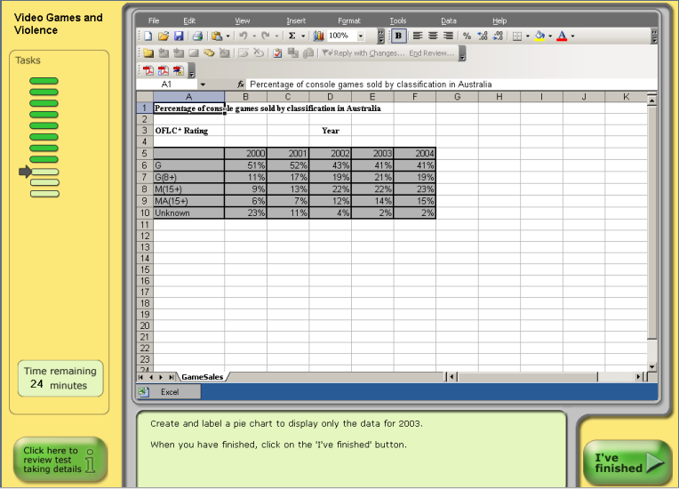

(Source: Australian MCEECDYA, 2008)

Extended Constructed Response

Extended constructed responses will be used in the long scenario-based assessment sets. In a scenario-based assessment set, the real-world scenario is developed and elaborated on as the student moves through the assessment set. As previously described, the introduction of the scenario will provide context and motivation for the tasks in the assessment set. As the scenario builds, the student undertakes a series of tasks that combine to create the response. For example, a student might be asked to enter a search term to gather information about a famous composer and to request information from virtual team members. Students could vary the size of populations to test a model of a city’s transportation system, or, in a different scenario, they might be asked to construct a wind turbine from a set of virtual components in which there are several combinations of turbine blades and generators.

Additional measures of the students’ responses can be made by capturing data about which combinations of components the students selected, whether they covered all possible combinations, and what data they chose to record from their tests of the components. A follow-on task might ask the students to select different types of graphic representations for the tabulated data they captured. Observing whether they have selected an appropriate type of graph provides additional information about how they use data analysis tools.

Finally, the students could be asked to interpret their data, make a recommendation for the best combination of turbine blade and generator, and justify their choice in a short written (typed) response. In this way, both the task and the response are extended.

Thus, unlike short constructed-response items in which all the information to answer a particular task is contained in a single stimulus, the information necessary to answer an extended constructed response is contained in several parts of the overall task. In this example, it would not be possible for a student to make recommendations about which combination of blades and generators is best without having done all parts of the previous tasks.

Designing extended constructed-response tasks presents certain challenges. Enough information must be provided in the scenario to allow the student to perform well-defined, meaningful tasks that yield measurable evidence about whether the student possesses the knowledge and skills defined in the assessment targets. Another challenge is to ensure that the dependencies among the tasks that a student performs within an extended response are minimized. For example, in the wind turbine scenario described above, students could run tests of combinations of certain turbine blades and generators, and their responses could be assessed. Then, the students could be given data from another set of tests of different blades and generators that someone else did and asked to interpret those data. In this way the dependency between a student’s own data-gathering and the data analysis stage is minimized. The goal is to make sure that mistakes or deficiencies in the first part of the task are not carried forward into the second task, thereby giving all students the same opportunity to show their data analysis skills, regardless of how well they did on the first task.

In the following simulation, students are given the scenario of a population of small birds—chortlers—whose population is declining. The students are asked to use various tools to analyze data in a variety of ways and to determine some possible causes for the population decrease so that they can then present their findings on the impacts on the chortlers. The multiple developments of the graphs are extended-constructed responses, as is the development of the conclusions to be presented, which in this example are not written on the computer.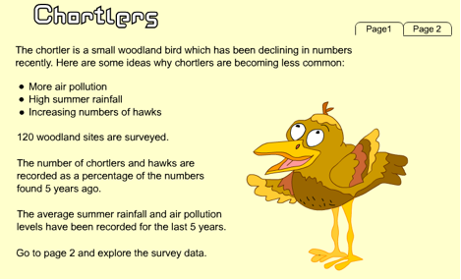

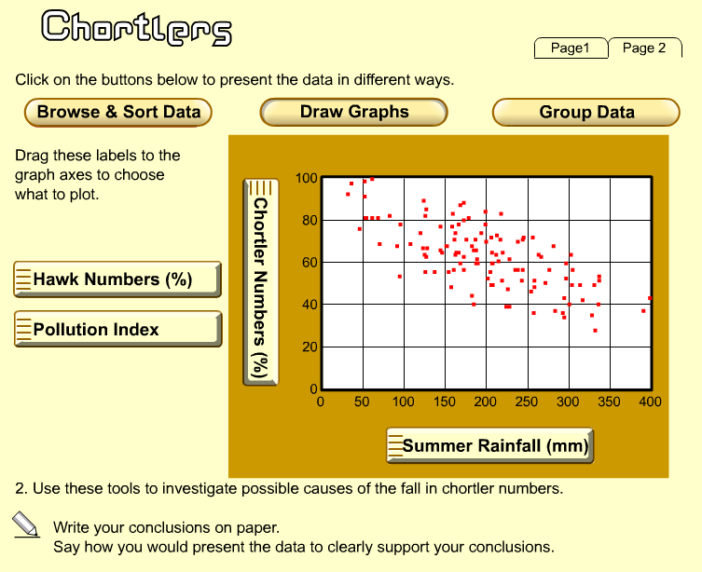

(Source: Ripley, 2009)
Extended responses can provide particularly useful insight into a student’s level of conceptual understanding and reasoning. They can also be used to probe a student’s capability to analyze a situation and choose and carry out a plan to address that situation, as well as to interpret the student’s response. Students may also be given an opportunity to explain their responses, their reasoning processes, or their approaches to the problem situation. They can also be asked to communicate about the outcomes of their approach to the situation. Care must be taken, however, particularly with fourth graders and English language learners, that language capability is not confounded with technology and engineering literacy.

Selected Response

As the name implies, selected-response items are those in which students read a question and are presented with a set of responses from which they choose the best answer. In other NAEP assessments, selected-response items most often take the form of multiple-choice items, in which students select an answer from, say, four options provided. The choices include the most applicable response—the “answer”—as well as three “distractors.” The distractors should appear plausible to students but should not be justifiable as a correct response, and, when feasible, the distractors should also be designed to reflect current understanding about students’ mental models in the content area. The NAEP Technology and Engineering Literacy Assessment will include such multiple-choice items within both the scenario-based and the discrete-item assessment sets as one type of selected response.

In addition to the conventional multiple-choice selected-response items, the scenario-based sets in the NAEP Technology and Engineering Literacy Assessment will include other types of selected-response formats. The computer-based nature of the scenarios will allow a variety of types of student selections to be measured. For example, a student might be given a task to perform and asked to select an individual tool from a set of virtual tools. When a student selects a tool by clicking on it, it provides a measurable response that is, in essence, a selected response.

A selected-response item in such a scenario might have fewer choices than in a conventional multiple-choice item. For example, a student might select between two alternatives, such as deciding whether a switch in a circuit should be open or closed in order to produce a particular outcome, but the student might also have to justify or explain the selection. In this case, the first part of the answer is a selected response, but it might be necessary to score the two parts of the item together so that the selection and justification together determine the score. In complex, real-world scenarios, it might be the case that there is not a “correct” selection, and in such a situation what matters is that the selection is justified adequately.

An example of a selected-response item that might be part of a series of items embedded in a scenario-based assessment set is shown on the next page. The question was part of an ICT assessment about reintroducing lynx into a Canadian park overrun by hares. The assessment was designed for 13-year-olds.

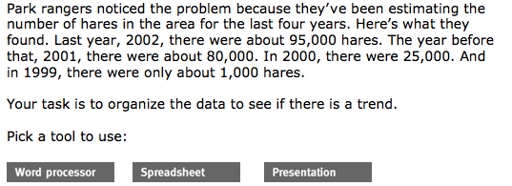
(Source: Quellmalz & Kozma, 2004)

Other selected-response types within a scenario-based assessment set might include a task in which a student selects all of the options that apply from a given set of choices. Again, in a real-world situation there might be one “best” combination of choices but also one or more other combinations that are partially correct. In such a situation, it makes sense to use a scoring rubric that rewards different combinations of selected-response items with different scores.

In the following item, students observe organisms interacting in an ecosystem before choosing all of the organisms that are consumers. The assessment was designed for grade 8. In the NAEP Technology and Engineering Literacy Assessment, students might choose all of the organisms in an ecosystem most immediately affected by a pollutant.

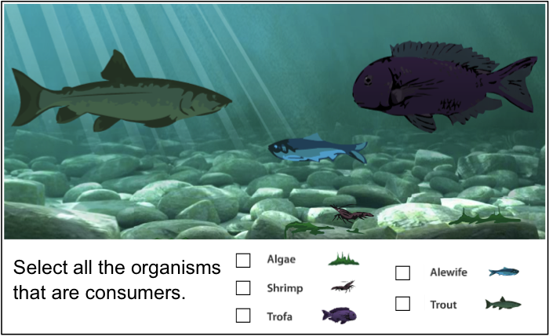

(Source: Quellmalz, Timms, & Buckley, 2009)
Another form of selected response is a “hot spot” in which a student answers by clicking on a spot on an image such as a map, picture, or diagram. The example below was designed for grade 8 students as part of a set of items on a state science test. For the NAEP Technology and Engineering Literacy Assessment, a task might be designed that asks students to click on the places in the image where pollution originated in the water system.
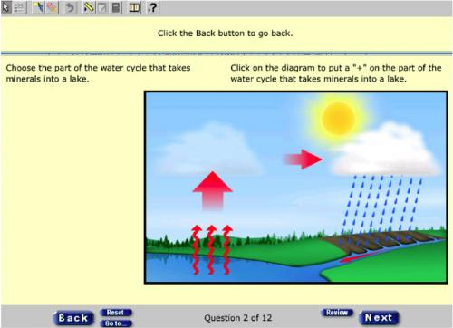
(Source: Minnesota Department of Education, 2009)

Ways of Measuring Student Responses

The computer-based administration of the scenario-based assessments combined with the broad range of selected and constructed responses possible with this approach will provide many opportunities to measure students’ capabilities as defined in the assessment targets. The range of measures will be greater than those generated in a typical NAEP assessment of other subjects, so it is necessary to describe how all of these measures might be handled. It is helpful to think of the measures as falling into two categories: student direct responses, and pattern-tracking measures that are based on student interactions with the tools and systems portrayed in the scenarios.

Conventional items always involve the student in a direct response. For example, after being presented with information in a diagram, the student is asked a text-based question and given a limited set of choices from which to select the best answer. Student direct responses can also be used in scenarios. For example, an assessment task in the scenario may have asked the student to set two different values for a component of the system and observe what happens. The student direct response comes when, after observing the interaction with the system, the student is asked, for example, to compare and contrast the two outcomes and explain in a short written response why they happened as they did. This is a student direct response because, although the student interacted with the system, none of that interaction was captured to score the appropriateness of the student response to the item. Only the written observation and explanation are to be scored.

One type of student direct response is selection from a set of choices—for example, multiple choice, checking all of the boxes that apply, or, in a scenario-based assessment, selecting an object or choosing a tool for the task. Other types of direct response include providing a written analysis of a set of results and writing a short explanation of why a selection was made in a scenario.

By contrast, in pattern-tracking measures the interactions that the student engaged in may provide relevant evidence about whether the student possesses a skill that is an assessment target and that should, therefore, be captured, measured, and interpreted. For example, a student may have been asked to pinpoint a malfunction in a technological system, such as a leak in a lawn sprinkling system. In responding to that task, the student’s manipulation of the components of the system shows whether the student is testing the sprinkler components in a random or systematic way. Thus the things that the student chose to manipulate, how the student manipulated them, and how long it took might all be measured and interpreted in combination so as to provide a measure of whether the student possesses a particular skill related to troubleshooting.

One type of pattern-tracking measure is the observation of patterns of action—for example, capturing a sequence of actions taken to determine if the correct set of actions was taken and if the actions were executed in the optimal order. Another pattern-tracking measure is tracking the manipulations that the student performs in a scenario. How, for instance, did the student change the features of a Web search query (for example, narrowing the topic) or vary the parameters that control a component of a system (for example, changing the gauge of wire mesh for bird protection in a model of a rooftop wind turbine) or transform an object from one form into another (for example, transforming database entries into a graph or table for a presentation)? Pattern-tracking measures might be used to assess certain aspects of communication or collaboration skills. For example, measuring the number of times a student communicates with virtual team members with particular expertise can provide a measure of the efficiency of the student’s collaboration strategies.

Balance of the Assessment

To ensure an appropriate distribution of the test time, it is important to balance the different components of the assessment. This section discusses how this can be done. Note that “total test time” refers to the length of time that it would take to administer all available assessment blocks (see figure 3), which is the equivalent of approximately 5 hours of test time. Many students will be in the sample population during each administration of the test, but each of these students will spend approximately 50 minutes on the assessment tasks, so there must be a plan for distributing each assessment block to many students. Figure 3 also shows a simple example of how assessment types might be grouped together.

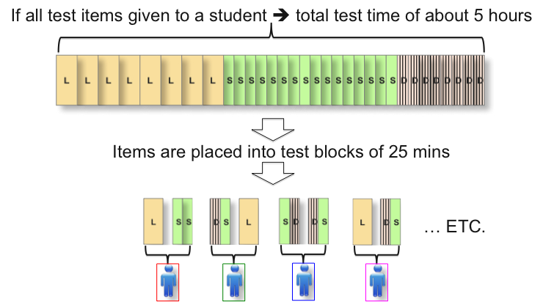

Legend:
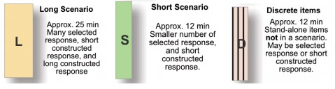

Figure 3 – Potential Balance of Total Test Time

This section discusses four separate aspects of the assessment that should be considered in determining an overall balance:
- Balance by Major Assessment Area
  - Technology and Society
  - Design and Systems
  - Information and Communication Technology
- Balance by Practice
  - Understanding Technological Principles
  - Developing Solutions and Achieving Goals
  - Communicating and Collaborating
- Balance by Set Type
  - Long scenarios
  - Short scenarios
  - Discrete items sets
- Balance by Response Type
  - Selected response
  - Constructed response

The balance required at each grade level is specified in the following sections as a percentage of the total test time. In other words, the percentage expresses what proportion of the total amount of testing time—as represented in the total item pool shown at the top of the diagram in table 4.1—would be allocated. Since a student is assigned to take only one of the groups of item sets shown in table 4.1, the percentages do not necessarily represent the distribution of time in any single student’s test session. It should also be noted that the percentage of testing time distributions shown in tables 4.1 through 4.4 are to be regarded as targets, and it is understood that percentages in the actual assessment may vary slightly from the target percentages.

The balances shown in the following tables 4.1 through 4.4 were determined after careful consideration and deliberation by both the planning committee and the steering committee members. They reflect the expert judgment of the committees after they took into account how the knowledge and skills in the area of technology and engineering literacy are taught at different grade levels and how they develop over time. The percentages shown in the tables were derived from a process in which planning committee members made individual judgments, the group results were tabulated, and then discussion followed to come to a consensus that is represented in tables 4.1 through 4.4.

Assessment Balance by Major Assessment Area

Table 4.1 shows the balance by major assessment area at each of the 3 grade levels. At fourth grade there is an emphasis on ICT because the focus of technology and engineering literacy instruction at that grade is on using common information and communication technologies. At eighth grade the balance is weighted to Design and Systems because in middle school there is more emphasis on systems, and there is slightly less time spent on ICT than in the early grades. At 12th grade the balance is slightly weighted to Design and Systems and to ICT.
Table 4.1 Assessment balance by major assessment areas and grades

Grade  Major  Assessment Area | Grade 4  (% total test time) | Grade 8  (% total test time) | Grade 12  (% total test time)
Technology and Society | 25 | 25 | 30
Design and Systems | 30 | 40 | 35
Information and Communication Technology (ICT) | 45 | 35 | 35

Assessment Balance by Practice

The balance of the assessment by crosscutting practices across the 3 grade levels is shown in table 4.2. At all grades the balance of total test time is:
- Understanding Technological Principles – 30 percent
- Developing Solutions and Achieving Goals – 40 percent
- Communicating and Collaborating – 30 percent

The rationale for a slight emphasis on the practice of Developing Solutions and Achieving Goals is that it is important for students to be able to use their knowledge of technological principles in developing solutions to problems.

Table 4.2 Assessment balance by practices and grades

Grade  Practice | Grade 4  (% total test time) | Grade 8  (% total test time) | Grade 12  (% total test time)
Understanding Technological Principles | 30 | 30 | 30
Developing Solutions and Achieving Goals | 40 | 40 | 40
Collaborating and Communicating | 30 | 30 | 30

Assessment Balance by Set Type

In addition to ensuring a balance across the content of the assessment, table 4.3 specifies how the total amount of testing time should be balanced across the 3 types of assessment sets—long scenario, short scenario, and discrete item sets. There is an emphasis on the scenarios because they allow for a wide range of interactive tasks that are well-suited to assessing the types of practices that students need to apply in practical investigations. The 20 percent of discrete items allow for more independent testing of knowledge and skills that help to maintain test reliability.

Table 4.3 Assessment balance by set types and grades

Grade  Set Type | Grade 4  (% total test time) | Grade 8  (% total test time) | Grade 12  (% total test time)
Long Scenarios  (Approx. 25 minutes) | 40 | 40 | 40
Short Scenarios  (Approx. 12-15 minutes) | 40 | 40 | 40
Discrete items  (Approx. 1-2 minutes per item; approx. 12-15 minutes per block) | 20 | 20 | 20

Assessment Balance by Response Type

Table 4.4 specifies the balance of assessment response types across the total testing time. Across all grade levels, there will be an emphasis on constructed-response items because the more complex tasks involved in scenarios demand that students are involved in activities that create products rather than simply select among choices of responses. Since the balance of types of assessment types specified in table 4.3 is weighted toward scenarios, there is a corresponding weighting toward constructed responses, although selected responses also form an important part of the assessment.

Table 4.4 Assessment balance by response types and grades

Grade  Response Type | Grade 4  (% total test time) | Grade 8  (% total test time) | Grade 12  (% total test time)
Selected Response | 40 | 40 | 40
Constructed Response | 60 | 60 | 60

Assessment Design and Student Diversity

Students should have the opportunity to demonstrate their knowledge of the concepts and ideas that the NAEP Technology and Engineering Literacy Assessment is intended to measure. The assessment needs to be responsive to the challenges that stem from an increasingly diverse student population in the nation, the inclusion of all types of students in the general curriculum, and an increased emphasis and commitment to serve and be accountable for all students. NAEP should strive to develop assessments that allow for the participation of the widest possible range of students so that interpretation of scores of all who participate leads to valid inferences about the levels of their performance.

As the NAEP Technology and Engineering Literacy Assessment will be computer-delivered and will contain a large proportion of scenario-based assessment items, great attention needs to be paid to ensuring that the assessments are valid and accessible to a wide range of students. Two types of populations need to be considered in order to properly address student diversity in the design of the assessment, English language learners—students who are developing English as their second language—and students with disabilities. Both populations are tremendously heterogeneous: the former, because of the wide range of students’ first languages, cultural influences, and stages in English development; the latter, because of the wide range of disabilities—from physical to sensory to cognitive. Whereas both populations may have common sets of needs, some design issues may be particularly relevant to one or the other. Both populations should be considered carefully in the design of the NAEP Technology and Engineering Literacy Assessment.

To effectively include English language learners and students with disabilities in the technology and engineering literacy assessments, two areas that need to be addressed include the participation of students in the pilot stages of test development and the use of testing accommodations. These aspects are discussed in more detail in the Assessment and Item Specifications for the 2014 NAEP Technology and Engineering Literacy Assessment.

Pilot Student Samples

The term “inclusion” does not refer solely to the participation of students with special needs in large-scale testing. It also refers to the notion that, to attain equity in testing, appropriate actions should be taken to ensure that these students participate in the process of assessment development.

Issues related to students with special needs should not be addressed only at the end of the process of assessment development, guided by the erroneous belief that testing accommodations provided during test administration will ensure equitable testing. Rather, English language learners and students with disabilities should be included in all of the assessment tryout stages in which information is collected from pilot students about the ways in which they interpret stimulus materials and test items and the difficulties they experience in providing their responses. Even when assessments are to be administered only in English, English language learners can provide test developers with valuable information for improving the assessment (for example, the wording of its items). Also, the information provided by students with disabilities can help to identify and address usability issues that are relevant to administering the assessment to all students.

A potential challenge in the testing of students with special needs is the fact that the critical characteristics of these students are not always carefully identified (Solano-Flores, 2009). As a result, they are not properly represented in the samples of students who participate in the pilot stages of assessment development. The use of very small samples of English language learners and students with disabilities makes it difficult for test developers to properly address the heterogeneity of these groups. Thus, preparation for the operational assessment should address the diversity within the population of English language learners (for example, diverse first language backgrounds and different levels of English development) and within the population of students with disabilities (for example, diverse types of disabilities and various levels of severity of disability).

Universal Design

The items in the NAEP Technology and Engineering Literacy Assessment that make use of the multimedia capabilities of the computer offer a chance to more easily reach a wide range of students than traditional paper-and-pencil items allow. Universal design is a concept that started in architecture and has been applied to assessment by identifying the relevant essential elements for assessment (Thompson, Thurlow, & Malouf, 2004). Since its early explication, the concept has been applied to instruction as universal design for learning (Orkwis & McLane, 1998; Rose & Meyer, 2002). At the time of the writing of this framework, NAEP is considering how the principles of universal design might be applied in its assessments, but no policy has yet been adopted.

The Universal Design for Computer-Based Testing (UD-CBT) framework and a detailed set of UD-CBT guidelines (Dolan et al, 2007) specifically address the design of novel computer-delivered assessments such as the one that will be developed for the NAEP Technology and Engineering Literacy Framework. The UD-CBT represents, at the time of publication of the NAEP Technology and Engineering Literacy Framework, a useful guideline for developing interactive scenario-based assessments. However, developers of the assessment will need to pay attention to developments in the field as a greater number of innovative assessments are developed and more information is available about how to apply the principles of universal design to them.

Accommodations

NAEP strives to assess all students selected by its sampling process. Rigorous criteria are applied to maximize the number of English language learners and students with disabilities included in NAEP assessments. Participating students with special needs are permitted to use accommodations, as stated in current NAEP policy:

All special-needs students may use the same accommodations in NAEP assessments that they use in their usual classroom testing unless the accommodation would make it impossible to measure the ability, skill, or proficiency being assessed, or the accommodation is not possible for the NAEP program to administer (NCES, 2005, Current Policy section, ¶ 4).

To meet this commitment, it will be necessary for the assessment delivery system to include tool options that allow the students to benefit from the sorts of accommodations that they need. An example of these tool options is screen magnification, which can benefit blind or low-vision students. Another example is text-to-speech, which may also benefit blind or low-vision students as well as English language learners whose proficiency in English is better in the listening mode than in the reading mode.

To make accommodations more likely to successfully serve students with special needs, an important fact should be taken into account in assessment design. Each English language learner is unique as to his or her level of English proficiency in the listening, speaking, reading, and writing modes and each student with disabilities is unique as to the kind and severity of his or her disabilities. As a consequence, what works for one student does not necessarily work for another student within the same group of students with special needs. Designing an assessment delivery system that is capable of providing all NAEP-authorized accommodations and that allows selection of the set of accommodations that best meets the needs of each student is critical to properly meeting the goals of inclusion in the NAEP Technology and Engineering Literacy Assessment.

Chapter Five: Reporting Results of the NAEP Technology and Engineering Literacy Assessment

Introduction

The purpose of this chapter is to explain how the results of the NAEP Technology and Engineering Literacy Assessment will be reported. A probe will be administered in 2014 as a trial of the NAEP Technology and Engineering Literacy Assessment. In the NAEP context, a probe is a smaller-scale, focused assessment on a timely topic that explores a particular question or issue and may be limited to particular grades. The description in this chapter is for the initial probe assessment, but can be applied to future administrations of the assessment beyond that first assessment. Key sections of the chapter are as follows:
- How NAEP Results Are Reported;
- Reporting Scale Scores and Achievement Levels;
- Reporting Background Variables; and
- Uses of NAEP Reporting.

How NAEP Results Are Reported

The National Assessment of Educational Progress provides the only nationally representative report on student achievement in a variety of subjects. Starting in 2013, NAEP results will be published mainly online, on a website that will give the public access to an interactive version of the report card. An executive summary will be available in print to accompany the online data. The online resource provides detailed information on the nature of the assessment, the demographics of the students who participate, and the assessment results.

The Nation’s Report Card includes information on the performance of various subgroups of students at the national level. Subgroups for NAEP include:
- Gender;
- Race/ethnicity;
- Eligibility for free/reduced-price lunch;
- Students with disabilities; and
- English language learners.

Detailed data on NAEP results, demographic variables, and subject-specific background information are available via the NAEP Data Explorer on the website. Additional restricted data are available for scholarly research, subject to National Center for Education Statistics (NCES) licensing procedures.

The Nation’s Report Card provides results on the performance of students in public schools in various states as well as in the NAEP Trial Urban Districts. The Trial Urban District Assessment was initiated in 2002 to report on the achievement of public school students in large urban districts. The NAEP Technology and Engineering Literacy Assessment will not be administered as part of the Trial Urban District Assessment program. Results will be reported only at the national level.

Reporting Scale Scores and Achievement Levels

Results of the NAEP Technology and Engineering Literacy Assessment will be reported in terms of percentages of students who attain each of the three achievement levels, Basic, Proficient, and Advanced, discussed below. The NAEP Technology and Engineering Literacy Assessment is an assessment of overall achievement, not a tool for diagnosing the needs of individuals or groups of students. Reported scores are always at the aggregate level. By law and by design, scores are not produced for individual schools or students. Results will be reported for the nation as a whole as well as for regions of the nation. The NAEP Technology and Engineering Literacy Assessment will not provide results for individual states, as the student samples will be drawn to report at the national level only.

The project committees have recommended that the results of the assessment be reported in terms of three subscores, each of them reflecting performance in one of the three main areas of technology and engineering literacy: Technology and Society, Design and Systems, and Information and Communication Technology. An overall composite score will also be reported. At this time technology instruction in most K-12 schools focuses on one or another of the three areas rather than a fusion of the three, so a composite score can be expected to have less relevance than the scores from the three areas.

Reporting on achievement levels is the primary way in which NAEP results reach the general public and policymakers. Achievement level results indicate the degree to which student performance meets the standards set for what students should know and be able to do at the Basic, Proficient, and Advanced levels. Definitions of achievement levels articulate expectations of performance at each grade level. They are reported as percentages of students within each achievement level range, as well as the percentage of students at or above Basic and at or above Proficient ranges. Results for students not reaching the Basic achievement level are reported as below Basic. Results are also reported for subgroups of students using demographic data and background variables specific to the NAEP Technology and Engineering Literacy Assessment. An individual student’s performance cannot be reported based on NAEP results.

Table 5.1 displays the Governing Board’s generic policy definitions for Basic, Proficient, and Advanced achievement that pertain to all NAEP subjects and grades.

Table 5.1 Generic achievement level policy definitions for NAEP

Achievement Level | Definition
Advanced | This level signifies superior performance.
Proficient | This level represents solid academic performance for each grade assessed. Students reaching this level have demonstrated competency over challenging subject matter, including subject-matter knowledge, application of such knowledge to real-world situations, and analytical skills appropriate to the subject matter.
Basic | This level denotes partial mastery of prerequisite knowledge and skills that are fundamental for proficient work at each grade.

There are three components to the NAEP achievement levels:
- Achievement level definitions;
- Cut scores; and
- Examples of students’ responses.

Achievement Level Definitions

Since 1990, the Governing Board has used student achievement levels for reporting results on NAEP assessments. The achievement levels represent an informed judgment of “how good is good enough” in the various subjects that are assessed. Generic policy definitions for achievement at the Basic, Proficient, and Advanced levels describe in very general terms what students at each grade level should know and be able to do on the assessment. Technology and engineering literacy achievement levels specific to the 2014 NAEP Technology and Engineering Literacy Framework will be developed to elaborate the generic policy definitions of Basic, Proficient, and Advanced achievement for NAEP assessments. Preliminary achievement level definitions have been developed for each of the three areas to be reported separately in the assessment and they will be used to guide item development and initial stages of standard setting for the 2014 NAEP Technology and Engineering Literacy Assessment. (See appendix G for these preliminary definitions.)

The preliminary achievement level definitions will be revised when actual student responses have been collected and analyzed. The Governing Board will convene panels of experts to examine the preliminary achievement level definitions and to recommend final achievement level definitions for each grade level. A broadly representative panel of exceptional teachers, educators, and professionals will then be convened to engage in a standard-setting process to determine the cut scores that correspond to these achievement level definitions. The panelists will be trained and will engage in a series of discussions designed to ensure informed judgments about mapping cut scores to the assessment.

Cut Scores

Cut scores, the second component of reporting on achievement levels, represent the minimum score required for performance at each NAEP achievement level. Cut scores are reported along with the percentage of students who scored at or above the cut score. As described in chapter four, the assessment design for the 2014 NAEP Technology and Engineering Literacy Assessment incorporates scores from selected responses and written responses, as well as measures of the patterns of action a student takes in problem-solving. Selected responses in which there is a single best answer will be scored as correct or incorrect and written responses will be scored using a rubric that rewards answers according to their match to descriptions in the rubric. The pattern-tracking will be evaluated by comparing the pattern of action against a set of possible patterns, and students will get more credit for a course of action that is optimal than for alternative patterns of action. Scores can then be combined to produce overall scores so that cut score decisions can be made.

Examples of Students’ Responses

The third component of achievement level reporting includes examples of student responses on released tasks from the NAEP Technology and Engineering Literacy Assessment. These examples provide illustrations of student skills within each level of achievement for each of the three areas and will be developed after the first administration of the assessment. Example responses will be annotated to explain the score for the response.

Reporting Background Variables

Background data on students, teachers, and schools are needed to fulfill the statutory requirement that NAEP include information, whenever feasible, for groups identified in the first section of this chapter (for example, gender, race/ethnicity). Therefore, students, teachers, and school administrators participating in NAEP are asked to respond to questionnaires designed to gather demographic information. Information is also gathered from non-NAEP sources, such as state, district, or school records. For the 2014 NAEP Technology and Engineering Literacy Assessment, only student and school information will be collected, since many students will not have taken a separate course in technology and engineering literacy taught by a specific teacher.

In addition to demographic information, background questionnaires include questions about variables related to opportunities to learn and achievement in technology and engineering literacy. The variables are selected to be of topical interest, to be timely, and to be directly related to academic achievement and current trends and issues in technology and engineering literacy. Questions do not solicit information about personal topics or information irrelevant to the collection of data on technology and engineering literacy achievement.

The important components of NAEP reporting are summarized in table 5.2. Recommendations for background variables for the 2014 NAEP Technology and Engineering Literacy Assessment are presented in the separate background variables document.

Table 5.2 Summary of NAEP reporting components

 |  | Key Characteristics
Components of NAEP Reporting | How Information Is Reported | Starting in 2013, elements released to the public will include:  - Results published mainly online with an interactive report card  - Dedicated website: www.nationsreportcard.gov  - Performance of various subgroups at the national level published in print and online
Components of NAEP Reporting | What Is Reported | NAEP data are reported by:  - Percentage of students attaining achievement levels  - Scale scores  - Sample responses to illustrate achievement level definitions
Components of NAEP Reporting | What Information Is Gathered | Types of background variables distributed to students and schools:  - These are presented in the separate background variables document.

Uses of NAEP Reporting

The information available from results of the probe for the 2014 NAEP Technology and Engineering Literacy Assessment will provide important data that can be used throughout the tenure of the framework. The results of the probe will begin the trend line for the new assessment, and policymakers, educators, and the public can use data from the assessments as a tool for monitoring certain aspects of student achievement in technology and engineering literacy over time. NAEP reports from any subsequent administrations of the assessment will compare student performance in the three areas of Technology and Society, Design and Systems, and ICT among groups of students within the same grade. Long-term achievement trends (for example, the comparison of score performance with previous administrations) can also be reported starting with the second administration.

The scores from the assessment will be of value and interest not just to technology and engineering teachers but to a broad range of educators. As discussed earlier, many different types of teachers are involved in teaching their students about technology and its applications in grades K-12, from those specializing in science, math, and engineering, to those teaching social sciences, humanities, and the arts as well as members of cross-disciplinary teams.

Because the NAEP Technology and Engineering Literacy Assessment will measure some technology and engineering literacy experiences but not all, there will be limitations to the range and scope of information it can produce. NAEP publishes data on student performance in relation to various achievement levels and demographic subgroups; the information reported does not evaluate results or provide conclusive statements about the level of achievement among the nation’s K-12 students. Furthermore, the NAEP Technology and Engineering Literacy Assessment is not designed to inform instruction—to guide how technology and engineering literacy is taught—but only to measure the performance of a representative sample of the American student population at the designated grade within the assessment context outlined in this framework.

Appendixes

Appendix A: Glossary of Abbreviations, Words, and Terms Used in the Framework

The glossary is divided into five sections. The first section presents acronyms and abbreviations used in the framework, followed by sections on basic framework terminology, assessment terms, and terms related to education content and pedagogy. The final section presents terms specific to the three major assessment areas of technology and engineering literacy: Technology and Society, Design and Systems, and Information and Communication Technology. Relevant terms and definitions from each area are included, and they are defined within the context of the framework.

Acronyms and Abbreviations for Associations, Educational Organizations, or Reports

AAAS American Association for the Advancement of Science
CCSSO Council of Chief State School Officers
IBO International Baccalaureate Organization
ISTE International Society for Technology in Education
ITEEA International Technology and Engineering Educators Association
NAE National Academy of Engineering
NAEP National Assessment of Educational Progress
NCES National Center for Education Statistics
NETS•S National Educational Technology Standards for Students
NRC National Research Council
NSTA National Science Teachers Association
OECD Organisation for Economic Co-operation and Development
PISA Programme for International Student Assessment
SETDA State Educational Technology Directors Association
STEM Science, Technology, Engineering, and Mathematics
TIMSS Trends in International Mathematics and Science Study

Basic Framework Terminology

Technology Any modification of the natural or designed world done to fulfill human needs or desires.

Engineering A systematic and often iterative approach to designing objects, processes, and systems to meet human needs and wants.

Technology and Capacity to use, understand, and evaluate technology as
engineering literacy well as to understand technological principles and strategies
needed to develop solutions and achieve goals. It encompasses the three areas of Technology and Society, Design and Systems, and Information and Communication Technology.
Educational technology Various types of equipment, tools, and processes used as aids in teaching and learning.

Technology educators All those whose teaching responsibilities include imparting the knowledge, capabilities, and skills described in this framework.

Technology education The knowledge and skills taught to students in the three areas of Technology and Society, Design and Systems, and Information and Communication Technology.

Framework A NAEP framework is a document that defines the parameters of a NAEP assessment. It guides the test makers in developing an assessment.

Technological processes Procedures using technological knowledge, tools, and skills to develop solutions and achieve goals.

Technological principles Sets of foundational and fundamental assumptions that underlie each of the three areas of technology and engineering literacy defined in this framework.

Technological practices Types of thinking and reasoning that students are expected to demonstrate when responding to an assessment item. The framework specifies three practices: understanding technological principles; developing solutions and achieving goals; and communicating and collaboration.

Assessment Terms

Advanced achievement level The highest of NAEP’s three levels of performance. This level signifies superior performance.

Assessment areas or targets The three assessment foci of this framework on technological literary: Technology and Society, Design and Systems, and Information and Communication Technology.

Assessment balance Appropriate distribution of items according to major assessment area, technological practice, assessment set type, and response type.

Assessment specifications Assessment requirements that framework developers give to test developers. These include, for example, the foci of the assessment, the number and types of items, the specific areas to be assessed, the accommodations for students with disabilities, etc.

Background variables Demographic and contextual data related to the NAEP assessment gathered through questionnaires usually completed by school administrators, teachers, and students.

Basic achievement level The lowest of NAEP’s three levels of performance. This level denotes partial mastery of prerequisite knowledge and skills that are fundamental for proficient work at each grade.

Constructed response Items in which the student “constructs” the response
rather than choosing a response from a limited number of alternatives. Constructed responses may be short (students supply a word or short sentence) or extended (students complete a task).

Cut scores The minimum score required for performance at each NAEP achievement level.

Discrete item set A group of questions that include conventional selected-response items and short constructed-response items.

Item A single question or set of instructions.

Item specifications Assessment requirements that framework developers give to test developers; for example, the number and types of items to be included.

Probe (noun) A smaller-scale, focused assessment on a timely topic that explores a particular question or issue and may be limited to particular grades.

Proficient achievement level The middle of NAEP’s three levels of performance. This level represents solid academic performance for each grade assessed. Students reaching this level have demonstrated competency over challenging subject matter, including subject matter knowledge, application of such knowledge to practical situations, and analytical skills appropriate to the subject matter.

Response type The activity an item asks a student to perform when responding. In this assessment there are three item response types: short constructed response, long constructed response, and selected response.

Scale scores Scores that allow for comparison of students’ performances on different administrations of a test. For example, students’ scores might be converted to a score on a scale that ranges from 0 to 500 points.
Scenario-based assessment In the context of this framework, scenarios are interactive computer tasks that constitute the bulk of the items. Scenarios may be short or long, depending on what they require the student to do.

Selected response A type of item in which students read a question and choose the best answer from a set of options.

Universal design for Guidelines for ensuring that the largest number of disabled
assessment students and English language learners participate in an assessment.

Education Content and Pedagogy

Academic problem An assigned task that a teacher may give to a student.

Collaboration To work together with other individuals. However, for this NAEP assessment, it will mean using contemporary technologies to work with virtual (computer-generated) individuals to solve problems or achieve goals.

Diffuse curriculum Curriculum without a clear scope, sequence, and series of courses.

Disaggregation Separation into component parts, such as the breaking down of achievement data by racial/ethnic subgroup.

Equity Fair access to opportunities to learn that are based on need rather than on some arbitrary factor.

Fluency A smooth and easy flow of knowledge and skills.

Habits of mind Customary ways of thinking and acting.

Literacy The capacity to use, understand, and evaluate a body of knowledge and skills as well as to apply concepts and processes to solve problems and reach one’s goals.

Sequential curriculum Curriculum that has a scope, sequence, and a series of courses.

Area-Specific Terms

Technology and Society

Artifacts Products and items that a society’s population develops, uses, and updates to meet needs and wants.

Human-made Term describing an artifact that has been designed and developed by means that are outside the boundaries and capabilities of the natural world.

Modeling and simulation Utilizing technology to analyze and test the possible effects, impacts, and trade-offs that are associated with a new technological innovation to evaluate efficiency, discover potential problems, and develop workable solutions.

Natural world Plants, animals, water, and other organisms and elements that exist without contributions from humans.

Practical problem A situation that a person may encounter in everyday life that requires a solution.
Product life cycle The span of time that an artifact is commissioned to satisfy a societal need that can start from the point of design, manipulation of raw materials, and manufacturing processes, to eventual obsolescence and disposal.

Regulating technologies Technological innovations that are responsible for contributing to the protection of natural resources in areas such as transportation, energy, and waste disposal.

Technological inequalities Instances where countries and societies use antiquated technologies due to economic circumstances or cultural preferences.

Trade-off A decision where complete awareness of both the advantages and disadvantages of the result are explored and the impacts of both are taken into consideration.

Design and Systems

Constraint A boundary, limit, or restriction, such as time, money, or resources, in the requirements for a project.

Criteria Characteristics (or specifications) of a successful solution, such as a desired function or a particular level of efficiency.

Engineering design method An iterative, systematic process for solving problems that (sometimes called involves creativity, experience, and accumulated
technological design) disciplinary knowledge.

Life cycle Important phases in the development of a system from initial concept through design, testing, use, and maintenance to retirement.

Optimization Finding the best possible solution when some criterion or constraint is identified as the most important and others are given less weight.

Problem-solving The cognitive process of finding answers to questions and solutions to undesired situations.

Prototype First version, or generation, of an entity created from a particular design plan using the engineering design method.

Requirements Combination of criteria and constraints for a given project.

Reverse engineering Disassembling an item in a systematic way to understand how it works, usually so it can be repaired, copied, or improved.

Systems thinking Way of investigating or thinking about a system using a set of principles.

Troubleshooting Systematic method of dealing with failures.

Information and Communication Technology

Digital assistants Also called personal digital assistants (PDAs), devices used as organizers to enter and store data such as addresses, expenses, or calendar items. Some are capable of being used as hand-held computers and may also have Internet capabilities.

Digital models An electronic representation of a system.

Digital tools Any technology that stores and transmits data electronically.

Fair use A condition under U.S. copyright law that permits limited use of copyrighted material without procuring permission from the copyright holder.

Geographical information Any system that gathers, saves, evaluates, and presents data
system related to geographic locations. A common example is a GPS, used to obtain driving directions.

Information and Technologies used to access, gather, store, analyze, and
Communication report information.
Technologies
Information (or digital) Skills needed to access, evaluate, and use information from
literacy a variety of sources.

Interactive whiteboards An interactive display system that connects to a projector and a computer. Using special software, it is possible to project the computer’s desktop and then control the computer using a stylus, personal response system, or even a finger.

Media literacy The capacity to access and evaluate messages created using a variety of media, such as advertisements, commercials, or speeches, etc. It also refers to the skills required to develop and communicate a message using media.

Media player Software used on a computer to manage and play video or audio files or to view digital images. It can also be hand-held hardware that provides the same functions and is also used to store files.

Mobile wireless devices Small, lightweight hardware, often called hand-held technology, that has the capability to connect wirelessly to the Internet. Examples include hand-held computers, smartphones, and netbooks.

Wiki A website that allows users to work collaboratively to view, edit, and add information. One of the best-known examples of this type of site is Wikipedia, a collaboratively written encyclopedia.

Appendix B: Steering Committee Guidelines*

December 18, 2008
Provisional Approval: September 16, 2009

Introduction

The steering committee guidelines that follow are framed, in part, by the Issues and Recommendations paper prepared by Sharif Shakrani (Michigan State University) and Greg Pearson (National Academy of Engineering) for the National Assessment Governing Board. The guidelines were developed over a two-day period (December 17-18, 2008) by the steering committee for the 2012 NAEP Technological Literacy Assessment Project. The steering committee presented these guidelines to the planning committee in a joint session on December 18, 2008. The guidelines were revised and reorganized according to decisions made during the steering committee’s meeting on March 11-12, 2009, and again shared with the planning committee. In addition, the steering committee sought input from leaders in education, industry, business, engineering, research, and allied organizations (including the International Society for Technology in Education [ISTE], the International Technology and Engineering Educators Association [ITEEA], and the Partnership for 21st Century Skills); feedback resulting from these reviews served to further refine the guidelines.

Suggested Definition for Technological Literacy

The steering committee has identified various elements that illustrate the knowledge, ways of thinking and acting, and capabilities that define technological literacy. Technological literacy, as viewed by the steering committee, is the capacity to use, understand, and evaluate technology as well as to understand technological principles and strategies needed to develop solutions and achieve goals. It encompasses the three areas of Technology and Society, Design and Systems, and Information and Communication Technology.

Recommended Grade Level to Be Assessed

The National Assessment Governing Board requested that the two committees recommend to the Board at what grade(s) the national probe should be conducted in 2012. Hence, the steering and planning committees of the NAEP Technological Literacy Framework Development Project, in a joint session on March 11, 2009, discussed the matter. On the basis of this discussion, the two committees recommend to the Governing Board that the proposed 2012 NAEP Technological Literacy probe be administered at grade 8. If funding is available for an additional probe, the committees recommend that it be given at grade 12. The lowest priority would be for a probe at grade 4. The rationale for choosing grade 8 included:

- Students are cognitively mature and are more likely to have taken a technology-related course or curriculum units.
- This is the last grade before student dropout rates increase.
- Grade 8 is aligned with the Trends in International Mathematics and Science Study (TIMSS) and the Programme for International Student Assessment (PISA) assessments, allowing for more data analysis.
- Differences in performance by gender are less pronounced than at grade 12.
- There is more opportunity to measure impact from schooling than at grade 4.
- Students may be better equipped to take a computer-based test than at grade 4.
- Grade 8 is specifically targeted in No Child Left Behind, which requires that every student is technologically literate by the time the student finishes the eighth grade.

Guiding Principles

The assessment shall consist of technological content areas making up the scale scores to be reported and technological practices that characterize the field.

  - There are two content areas that must be assessed and where the data must be reported out as subscales:
Figure B-1: The relationship between major assessment content areas (blue) and technological practices (yellow).

    - Design and Systems
    - Information and Communication Technology (ICT)

If possible, the following area should be explored as a third content area of focus:
    - Technology and Society

See the addendum for examples of targets to be included in the three content areas.

  - Suggested technological practices are listed below:

  - Understanding Technological Principles
  - Developing Solutions and Achieving Goals
  - Communicating and Collaborating

The relationships of these practices to the content areas and to each other are reflected in figure B-1.

  - Content and context for the assessment should be informed by existing state standards and assessments, national (for example, International Society for Technology in Education [ISTE], International Technology and Engineering Educators Association [ITEEA]) and international standards, and research (National Academy of Engineering, National Research Council). Examples from industry, federal agencies responsible for carrying out STEM-based research (NASA, National Oceanic and Atmospheric Administration [NOAA], U.S. Department of Agriculture, National Science Foundation [NSF], U.S. Department of Energy, U.S. Department of Transportation, etc.), and science and technology museums might also be collected for building assessment ideas.

  - The assessment should have tasks that are applied to real-world contexts and should be scaffolded to ensure that reliance on students’ prior knowledge of specific technology systems will be minimized. The focus should be on concepts and not on specific vocational skills or technologies.

  - “Life situations” and local and contemporaneous conditions should be used as a way to confer relevance to each grade level. Content and context of the assessment items should have relevance and meaning to the learner. If possible, options should be generated in the assessment representing different situations to remove bias due to the background of the student.

  - The planning committee must develop examples of items and tasks that measure only knowledge and practices that are assessable. The examples should not be limited, to multiple choice, but should illustrate, if possible, different styles and technological tools.

  - Considerable work has already been put into the development of state standards for technology, ICT fluency, and engineering. These existing state standards and assessments should inform the development of the NAEP framework, but should not limit the framework. The planning committee should consider differences in how technological literacy is defined and treated in state standards, whether as discrete standards or as part of core content standards, e.g. mathematics, science, and language arts. Attention should also be paid to the confusion around Educational Technology versus Technological Education. There are numerous studies that specify the nature of technological literacy within the standards of various states. States each have their own definition of technological literacy, which may vary from the definition used in the NAEP framework.

  - To avoid the potential problem of obsolescence, the 2012 Technological Literacy Assessment should focus on a broad base of knowledge and skills, not on specific technologies that may change. For example, specific communication technologies in use today (Internet-connected multimedia, smartphones and PDAs) would not have been familiar to students a decade ago, and will most likely be obsolete a decade from now.

  - The assessment should use innovative computer-based assessment strategies that are informed by research on learning and are related to the assessment target (for example, problem-solving). These strategies should also reflect existing state computer-based assessments and the computer-based assessment aspects of the 2009 NAEP Science Framework. To effectively integrate innovative computer-based assessment strategies in the NAEP Technological Literacy Framework, the planning committee and/or assessment developers need to know the affordances and constraints of various technologies, how particular ones could support assessment goals, and how to use them. Specific examples of tools available for assessment tasks include probeware, presentation software, authoring tools, electronic whiteboards, drawing software, and typing tutors.

  - Computer-based assessment strategies should be informed by what is known about all learners, including those with special needs (English language learners and students with disabilities). These strategies should also be informed by the ways students currently use computers to access, process, and utilize information (Web 2.0, social networking, etc.). Effective assessment design incorporates current understandings of how people learn, how experts organize information, and the skills of effective learners. Development of the framework and item specifications should draw on expertise in engineering and technology to suggest types of problems that might be adapted to computer-based testing. The kinds of technological tools scientists and engineers use, such as simulations and visualizations, should be considered for use in the technological literacy assessment.

Addendum

The steering committee formulated the following list of targets they thought should be included in each of the content areas. Although they consider these sets of targets to be necessary, they agree that the specified targets may not be sufficient. In addition, the committee recognized that guidelines are normally “big ideas” and that this list contains detail in some areas and not in others. In the areas where detail appears, the committee considers these details sufficiently important to enumerate them for the planning committee’s consideration on individual targets.
Major Assessment Areas | Targets
Technology and Society | - Where does technology come from?  - Why is it created?  - How is society affected by scientific and technological concepts and capabilities?  - How technology affects the environment and vice versa  - Assessing consequences of technology (intended and unintended)  - Green technology  - Digital citizenship  - Safety  - Ethics  - Responsible use of technology
Design and Systems | - Artifacts are the products of technological systems that meet a need or solve a problem  - Identifying the technological dimensions of an artifact  - Constraints  - Models (and their importance and limitations)  - Evaluation  - Efficiency  - Ethics  - Economy  - Trade-offs/cost, benefit  - Consequences  - Systems thinking
Information and Communication Technology (ICT) | - Research and use of information  - Recognizing bias  - Extracting critical information  - Media literacy  - Use of digital information systems for innovation and creative expression  - Information/communication operations and concepts  - Use of ICT and learning technologies to learn new content and create knowledge (such as wikis, blogs, probeware, and other collaboration technologies)  - Data-driven decision-making  - Global awareness  - Ethics

Appendix C: Alignment Table – Comparing the NAEP Technology and Engineering Literacy Assessment Areas to U.S. Source Documents

2014 NAEP – Technology and Society | ISTE – National Education Technology Standards  (2007) | ITEEA – Standards for Technological Literacy  (2007)
Interaction of Technology and Humans | Digital Citizenship: Students understand human, cultural, and societal issues related to technology and practice legal and ethical behavior  5.d. Students exhibit leadership for digital citizenship. | Standard 4: Students will develop an understanding of the cultural, social, economic, and political effects of technology.  Standard 6: Students will develop an understanding of the role of society in the development and use of technology.  Standard 7: Students will develop an understanding of the influence of technology on history.  Standard 13: Students will develop abilities to assess the impact of products and systems.
Effects of Technology on the Natural World |  | Standard 5: Students will develop an understanding of the effects of technology on the environment.  Standard 13: Students will develop abilities to assess the impact of products and systems.
Effects of Technology on the World of Information and Knowledge | 5. Digital Citizenship:  5.a. Students advocate and practice safe, legal, and responsible use of information and technology.  5.b. Students exhibit a positive attitude toward using technology that supports collaboration, learning, and productivity. | Standard 13: Students will develop abilities to assess the impact of products and systems.
Ethics, Equity, and Responsibility | 5. Digital Citizenship:  5.a. Students advocate and practice safe, legal, and responsible use of information and technology.

2014 NAEP – Design and Systems | ISTE – National Education Technology Standards  (2007) | ITEEA – Standards for Technological Literacy  (2007)
Nature of Technology | 1. Creativity and Innovation:  1.a. Students apply existing knowledge to generate new ideas, products, or processes.  6. Technology Operations and Concepts:  6.a. Students understand and use technology systems. | Standard 1: Students will develop an understanding of the characteristics and scope of technology.  Standard 2: Students will develop an understanding of the core concepts of technology.  Standard 3: Students will develop an understanding of the relationships among technologies and the connections between technology and other fields of study.
Engineering Design | 1. Creativity and Innovation:  1.a. Students apply existing knowledge to generate new ideas, products, or processes.  1.c. Students use models and simulations to explore complex systems and issues.  3. Research and Information Fluency:  3.a. Students plan strategies to guide inquiry.  3.d. Students process data and report results.  4. Critical Thinking, Problem-Solving, and Decision-Making:  Students use critical-thinking skills to plan and conduct research, manage projects, solve problems, and make informed decisions using appropriate digital tools and resources. | Standard 8: Students will develop an understanding of the attributes of design.  Standard 9: Students will develop an understanding of engineering design.  Standard 11: Students will develop abilities to apply the design process.
Systems Thinking | 1. Creativity and Innovation:  1.a. Students apply existing knowledge to generate new ideas, products, or processes.  6. Technology Operations and Concepts:  6.a. Students understand and use technology systems. | Standard 13: Students will develop abilities to assess the impact of products and systems.
Maintenance and Troubleshooting | 6. Technology Operations and Concepts:  6.c. Students troubleshoot systems and applications. | Standard 10: Students will develop an understanding of the role of troubleshooting, research and development, invention and innovation, and experimentation in problem-solving.  Standard 12: Students will develop abilities to use and maintain technological products and systems.

2014 NAEP – Information and Communication Technology (ICT) | ISTE – National Education Technology Standards  (2007) | ITEEA – Standards for Technological Literacy  (2007)
Construction and Exchange of Ideas and Solutions | 2. Communication and Collaboration: Students use digital media and environments to communicate and work collaboratively, including at a distance, to support individual learning and contribute to the learning of others.
Information Research | 3. Research and Information Fluency: Students apply digital tools to gather, evaluate, and use information.
Investigation of Problems | 4. Critical Thinking, Problem-Solving, and Decision-Making: Students use critical-thinking skills to plan and conduct research, manage projects, solve problems, and make informed decisions using appropriate digital tools and resources. | Standard 8: Students will develop an understanding of the attributes of design.  Standard 9: Students will develop an understanding of engineering design.  Standard 11: Students will develop abilities to apply the design process.
Acknowledgment of Ideas and Information | 5. Digital Citizenship: Students understand human, cultural, and societal issues related to technology and practice legal and ethical behavior.
Selection and Use of Digital Tools | 6. Technology Operations and Concepts: Students demonstrate a sound understanding of technology concepts, systems, and operations. | Standard 17: Students will develop an understanding of and be able to select and use information and communication technologies.

Appendix D: Alignment Table – Comparing the NAEP Technology and Engineering Literacy Assessment Areas to International Source Documents
2014 NAEP | International Baccalaureate Organization  Middle Years Programme  Technology (2006) | EU Key Competences for Lifelong Learning – A European Framework  (2007) | UK Framework for Secondary ICT  (2008) | PISA Framework for  Assessment of ICT Literacy  (2006)
Technology and Society
Interaction of Technology and Humans | Students identify the problem to be solved. | Understanding the potential of IST to support creativity and innovation for personal fulfillment, social inclusion and employability.  Interest in using IST to broaden horizons by taking part in communities and networks for cultural, social, and professional purposes.
Effects of Technology on the Natural World | Students identify the problem to be solved.
Effects of Technology on the World of Information and Knowledge
Ethics, Equity, and Responsibility | During the course, students should:  • Carry out units of work in technology using materials and techniques safely and responsibly  • Provide evidence of personal engagement with the subject (motivation, independence, general  positive attitude) when working in technology. | Positive attitude and sensitivity to safe and responsible use of the Internet, including privacy issues and cultural differences.

2014 NAEP | International Baccalaureate Organization  Middle Years Programme  Technology (2006) | EU Key Competences for Lifelong Learning – A European Framework  (2007) | UK Framework for Secondary ICT  (2008) | PISA Framework for  Assessment of ICT Literacy  (2006)
Design and Systems
Nature of Technology
Engineering Design | Students formulate a design specification. Students design the product/solution. Students plan the product/solution.  Students follow the plan.  Students create the product/solution. |  | 2 Developing ideas  2.2 Models and modeling  4 Evaluating  4.1 Evaluating work
Maintenance and Troubleshooting
Systems Thinking

2014 NAEP | International Baccalaureate Organization  Middle Years Programme  Technology (2006) | EU Key Competences for Lifelong Learning – A European Framework  (2007) | UK Framework for Secondary ICT  (2008) | PISA Framework for  Assessment of ICT Literacy  (2006)
Information and Communication Technology (ICT)
Construction and Exchange of Ideas and Solutions | During the course, students should work effectively as members of a team, collaborating, acknowledging, and supporting the views of others. | Propensity to use IST to work autonomously and in teams; critical and reflective attitude in the assessment of available information.  Ability to use appropriate aids (presentations, graphs, charts, maps) to produce, present, or understand complex information. | 3 Communicating information  3.1 Fitness for purpose  3.2 Refining and presenting information  3.3 Communicating | Processes  - communicating with others
Information Research | Students should develop the design brief. | Ability to search, collect, and process electronic information, data, and concepts and to use them in a systematic way.  Ability to access and search a website and to use Internet-based services such as discussion forums and email. | 1 Finding information  1.1 Using data and information sources  1.2 Searching and selecting  1.3 Organizing and investigating | Processes  - accessing information  - managing information  - integrating information  - evaluating information  - constructing new knowledge
Investigation of Problems |  | Ability to use IST to support critical thinking, creativity, and innovation in different contexts at home, leisure, and work. | 2 Developing ideas  2.1 Analyzing and automating processes  2.2 Models and modeling  2.3 Sequencing instructions | Context  - ICT for personal use  - ICT for public use  - ICT for educational  - ICT for occupational purposes
Acknowledgment of Ideas and Information | During the course, students should work effectively as members of a team, collaborating, acknowledging, and supporting the views of others. | Basic understanding of the reliability and validity of the information available (accessibility/acceptability) and awareness of the need to respect ethical principles in the interactive use of IST.
Selection and Use of Digital Tools |  | Understanding the main computer applications, including word processing, spreadsheets, databases, information storage, and management.  Awareness of the opportunities given by the use of the Internet and communication via electronic media (email, videoconferencing, other network tools); and the differences between the real and virtual world. |  | Technology Environments  - Web  - desktop  - e-learning environments

Appendix E: Alignment Table – Comparing ICT Subareas to the ISTE NETS•S and the Framework for 21st Century Learning

A. Construction and Exchange of Ideas and Solutions
Fourth-grade students should be able to collaborate and communicate by working with other members of a (virtual) team to make decisions and develop presentations using a variety of formats. Eighth-grade students should be able to take into account the perspectives of different audiences, use a variety of media to create effective messages, and modify presentations based on feedback (virtual). Twelfth-grade students should have developed strategies to be effective collaborators, should be able to take into account multiple viewpoints, and should be able to synthesize information from a variety of sources.
Grade 4 | Grade 8 | Grade 12
Students know that:  I.4.1: People collaborating as a team can often produce a better product than people working alone. There are common digital tools that can be used to facilitate virtual or face-to-face collaboration. | Students know that:  I.8.1: Collaboration can take many forms. Pairs or teams of people can work together in the same space or at a distance, at the same time or at different times, and on creative projects or on technical tasks. Different communications technologies are used to support these different forms of collaboration. | Students know that:  I.12.1: Effective collaboration requires careful selection of team members, monitoring of progress, strategies for reaching agreement when there are opposing points of view, and iterative improvement of collaborative processes. Information and communication technologies can be used to record and share different viewpoints and to collect and tabulate the views of groups of people.
Students are able to:  I.4.2: Utilize input from (virtual, that is, computer-generated) collaborators and experts or sources in the decision-making process to design a product or presentation. | Students are able to:  I.8.2: Provide feedback to a (virtual) collaborator on a product or presentation, taking into account the other person’s goals and using constructive, rather than negative, criticism. | Students are able to:  I.12.2: Work through a simulation of a collaborative process. Negotiate team roles and resources, draw on the expertise and strengths of other team members and remote experts, monitor progress toward goals, and reflect on and refine team processes for achieving goals.
I.4.3: Communicate information and ideas effectively to an audience in order to accomplish a specified purpose. | I.8.3: Communicate information and ideas effectively using a variety of media, genres, and formats for multiple purposes and a variety of audiences. | I.12.3: Synthesize input from multiple sources to communicate ideas to a variety of audiences using various media, genres, and formats.
NETS•S Category 2: Communication and Collaboration
Students use digital media and environments to communicate and work collaboratively, including at a distance, to support individual learning and contribute to the learning of others. Students:
- Interact, collaborate, and publish with peers, experts, or others employing a variety of digital environments and media.
- Communicate information and ideas effectively to multiple audiences using a variety of media and formats.
- Develop cultural understanding and global awareness by engaging with learners of other cultures.
- Contribute to project teams to produce original works or solve problems.
Framework for 21st Century Learning: Communication and Collaboration
Communicate Clearly
- Articulate thoughts and ideas effectively using oral, written, and nonverbal communication skills in a variety of forms and contexts.
- Listen effectively to decipher meaning, including knowledge, values, attitudes, and intentions.
- Use communication for a range of purposes (for example, to inform, instruct, motivate, and persuade).
- Utilize multiple media and technologies, and know how to judge their effectiveness a priori as well as assess their impact.
- Communicate effectively in diverse environments (including multilingual).
Collaborate With Others
- Demonstrate ability to work effectively and respectfully with diverse teams.
- Exercise flexibility and willingness to be helpful in making necessary compromises to accomplish a common goal.
- Assume shared responsibility for collaborative work, and value the individual contributions made by each team member.

B. Information Research
Fourth-grade students can use digital and network tools to find information and identify sources that may be biased in some way. Eighth-grade students are able to use digital resources to find information and also to recognize when information may be distorted, exaggerated, or otherwise misrepresented. Twelfth-grade students can use advanced search methods and select the best digital tools and resources for various purposes, can evaluate information for timeliness and accuracy, and can check the credibility of sources.
Grade 4 | Grade 8 | Grade 12
Students know that:  I.4.4: Digital and network tools and media resources are helpful for answering questions, but they can sometimes be biased or wrong. | Students know that:  I.8.4: Increases in the quantity of information available through electronic means and the ease by which knowledge can be published have heightened the need to check sources for possible distortion, exaggeration, or misrepresentation. | Students know that:  I.12.4: Advanced search techniques can be used with digital and network tools and media resources to locate information and to check the credibility and expertise of sources.
Students are able to:  I.4.5: Use digital and network tools and media resources to collect, organize, and display data in order to answer questions and solve problems. | Students are able to:  I.8.5: Select and use appropriate digital and network tools and media resources to collect, organize, analyze, and display supporting data to answer questions and test hypotheses. | Students are able to:  I.12.5: Select digital and network tools and media resources to gather information and data on a practical task, and justify choices based on the tools’ efficiency and effectiveness for a given purpose.
I.4.6: Search media and digital sources on a community issue and identify sources that may be biased. | I.8.6: Search media and digital resources on a community or world issue and identify specific examples of distortion, exaggeration, or misrepresentation of information. | I.12.6: Search media and digital resources on a community or world issue and evaluate the timeliness and accuracy of the information as well as the credibility of the source.
NETS•S Category 3: Research and Information Fluency
Students apply digital tools to gather, evaluate, and use information. Students:
- Plan strategies to guide inquiry.
- Locate, organize, analyze, evaluate, synthesize, and ethically use information from a variety of sources and media.
- Evaluate and select information sources and digital tools based on the appropriateness to specific tasks.
- Process data and report results.

Framework for 21st Century Learning: Communication and Collaboration
Information Literacy
Access and Evaluate Information
- Access information efficiently (time) and effectively (sources).
- Evaluate information critically and competently.
Use and Manage Information
- Use information accurately and creatively for the issue or problem at hand.
- Manage the flow of information from a wide variety of sources.
- Apply a fundamental understanding of the ethical and legal issues surrounding the access and use of information.

C. Investigation of Academic and Practical Problems
Fourth-grade students are able to use digital tools to investigate local issues, test hypotheses, and build models. Eighth-grade students are able to use digital tools to investigate alternative solutions to global issues, test moderately complicated hypotheses, build models, and conduct simulations. Twelfth-grade students can conduct more sophisticated investigations and simulations as well as recognize their limitations. For all levels the focus is on types of hardware and software rather than on use of particular hardware or software products.
Grade 4 | Grade 8 | Grade 12
Students are able to:  I.4.7: Use digital tools and resources to identify and investigate a local issue and generate possible solutions. | Students are able to:  I.8.7: Use digital tools to identify a global issue and investigate possible solutions. Select and present the most promising sustainable solution. | Students are able to:  I.12.7: Use digital tools and resources to identify a complicated global issue and develop a systematic plan of investigation. Present findings in terms of pros and cons of two or more innovative sustainable solutions.
I.4.8: Use digital tools to test simple hypotheses in various subject areas. | I.8.8: Use digital tools to gather and display data in order to test hypotheses of moderate complexity in various subject areas. Draw and report conclusions consistent with observations. | I.12.8: Use digital tools to collect, analyze, and display data in order to design and conduct complicated investigations in various subject areas. Explain rationale for the design and justify conclusions based on observed patterns in the data.
I.4.9: Use digital models to describe how parts of a whole interact with each other in a model of a system. | I.8.9: Use a digital model of a system to conduct a simulation. Explain how changes in the model result in different outcomes. | I.12.9: Having conducted a simulation of a system using a digital model, draw conclusions about the system, or propose possible solutions to a problem or ways to reach a goal based on outcomes of the simulation. Critique the conclusions based on the adequacy of the model.
NETS•S Category 4: Critical Thinking and Decision-Making
Students use critical-thinking skills to plan and conduct research, manage projects, solve problems, and make informed decisions using appropriate digital tools and resources. Students:
- Identify and define authentic problems and significant questions for investigation.
- Plan and manage activities to develop a solution or complete a project.
- Collect and analyze data to identify solutions and/or make informed decisions.
- Use multiple processes and diverse perspectives to explore alternative solutions.

Framework for 21st Century Learning: Communication and Collaboration
Critical Thinking and Problem-Solving
Reason Effectively
- Use various types of reasoning (inductive, deductive, etc.) as appropriate to the situation.
Use Systems Thinking
- Analyze how parts of a whole interact with each other to produce overall outcomes in complex systems.
Make Judgments and Decisions
- Effectively analyze and evaluate evidence, arguments, claims, and beliefs.
- Analyze and evaluate major alternative points of view.
- Synthesize and make connections between information and arguments.
- Interpret information and draw conclusions based on the best analysis.
- Reflect critically on learning experiences and processes.
Solve Problems
- Solve different kinds of nonfamiliar problems in both conventional and innovative ways.
- Identify and ask significant questions that clarify various points of view and lead to better solutions.

D. Acknowledgment of Ideas and Information
Fourth-grade students exhibit digital citizenship by understanding that it is permissible to use others’ ideas as long as appropriate credit is given but that copyrighted materials cannot be shared freely. Eighth-grade students should be aware of and comply with laws and ethical guidelines for incorporating ideas, text, and images into their own work. Twelfth-grade students should understand the reasons for protecting intellectual property and demonstrate responsible and ethical behaviors when using ideas, quotes, and images from others.
Grade 4 | Grade 8 | Grade 12
Students know that:  I.4.10: It is allowable to use other people’s ideas in one’s own work provided that proper credit is given to the original source, whether information is shared in person or through ICT media. | Students know that:  I.8.10: Style guides provide detailed examples for how to give appropriate credit to others when incorporating their ideas, text, or images in one’s own work. | Students know that:  I.12.10: Legal requirements governing the use of copyrighted information and ethical guidelines for appropriate citations are intended to protect intellectual property.
Students are able to:  I.4.11: Identify or provide examples demonstrating respect for copyrighted material, such as resisting the request from a friend to copy a song from a CD or placing copyrighted material online. | Students are able to:  I.8.11: Identify or provide examples of fair use practices that apply appropriate citation of sources when using information from books or digital resources. | Students are able to:  I.12.11: Identify or provide examples of responsible and ethical behavior that follow the letter and spirit of current laws concerning personal and commercial uses of copyrighted material as well as accepted ethical practices when using verbatim quotes, images, or ideas generated by others.
NETS•S Category 5: Digital Citizenship
Students understand human, cultural, and societal issues related to technology and practice legal and ethical behavior. Students:
- Advocate and practice safe, legal, and responsible use of information and technology.
- Exhibit a positive attitude toward using technology that supports collaboration, learning, and productivity.
- Demonstrate personal responsibility for lifelong learning.
- Exhibit leadership for digital citizenship.

Framework for 21st Century Learning: Communication and Collaboration
Life and Career Skills: Leadership and Responsibility
Guide and Lead Others
- Use interpersonal and problem-solving skills to influence and guide others toward a goal.
- Leverage strengths of others to accomplish a common goal.
- Inspire others to reach their very best via example and selflessness.
- Demonstrate integrity and ethical behavior in using influence and power.
Be Responsible to Others
- Act responsibly with the interests of the larger community in mind.

E. Selection and Use of Digital Tools
Fourth-grade students know that different digital tools have different purposes and are able to use a number of different tools. Eighth-grade students can categorize digital tools by function and can select appropriate tools and demonstrate effective use of the tools for different purposes. Twelfth-grade students are competent in the use of a broad variety of digital tools and can justify why certain tools are chosen over others that might accomplish the same task, by referencing specific features.
Grade 4 | Grade 8 | Grade 12
Students know that:  I.4.12: Different digital tools have different purposes. | Students know that:  I.8.12: Certain digital tools are appropriate for gathering, organizing, analyzing, and presenting information, while other kinds of tools are appropriate for creating text, visualizations, and models and for communicating with others. | Students know that:  I.12.12: A variety of digital tools exist for a given purpose. The tools differ in features, capacities, operating modes, and style. Knowledge about many different ICT tools is helpful in selecting the best tool for a given task.
Students are able to:  I.4.13: Use digital tools (appropriate for fourth-grade students) effectively for different purposes, such as searching, organizing, and presenting information. | Students are able to:  I.8.13: Use appropriate digital tools to accomplish a variety of tasks, including gathering, analyzing, and presenting information as well as creating text, visualizations, and models and communicating with others. | Students are able to:  I.12.13: Demonstrate the capability to use a variety of digital tools to accomplish a task or develop a solution for a practical problem. Justify the choice of tools, explain why other tools were not used based on specific features of the tools, and summarize the results.
NETS•S Category 6: Technology Operations and Concepts
Students demonstrate a sound understanding of technology concepts, systems, and operations. Students:
- Understand and use technology systems.
- Select and use applications effectively and productively.
- Troubleshoot systems and applications.
- Transfer current knowledge to learning of new technologies.

Framework for 21st Century Learning: Communication and Collaboration
Apply Technology Effectively
- Use technology as a tool to research, organize, evaluate, and communicate information.
- Use digital technologies (computers, PDAs, media players, GPS, etc.), communication/networking tools, and social networks appropriately to access, manage, integrate, evaluate, and create information to successfully function in a knowledge economy.
- Apply a fundamental understanding of the ethical/legal issues surrounding the access and use of information technologies.

Appendix F: Alignment Table – Comparing Design and Systems Subareas to the ITEEA Standards for Technological Literacy

2014 NAEP | Standards for Technological Literacy
A. Nature of Technology  Fourth graders should know that technology involves tools, materials, and creative thinking used to meet human needs and wants. Eighth graders should know that technology advances through invention and innovation and requires a variety of resources. Twelfth graders should know how technology coevolves with science and other fields to allow people to accomplish challenging tasks. | Standard 1: Students will develop an understanding of the characteristics and scope of technology.  Standard 2: Students will develop an understanding of the core concepts of technology.  Standard 3: Students will develop an understanding of the relationships among technologies and the connections between technology and other fields of study.
B. Engineering Design  Fourth graders should start to answer the question “How are technologies created?” by learning to deal with simple yet systematic design challenges. Eighth graders should be able to use a more elaborate engineering design process, including problem definition, the use of prototypes, testing and iteration, and trade-offs. Twelfth graders should have a deep understanding and a broad array of design skills, including optimization. | Standard 8: Students will develop an understanding of the attributes of design.  Standard 9: Students will develop an understanding of engineering design.  Standard 11: Students will develop abilities to apply the design process.

C. Systems Thinking  Fourth graders should be able to identify systems, subsystems, components, and boundaries in their everyday world and to construct simple systems designed to accomplish particular goals. Eighth graders should be able to describe goals, inputs, outputs, and processes of systems, to use reverse engineering and life cycles to analyze systems in terms of feedback and the flow of energy, and to modify and construct moderately complicated systems. Twelfth graders should understand that systems are embedded in larger systems, to recognize factors that stabilize systems, to use systems for forecasting, and to redesign complicated systems to improve reliability. | Standard 1: Students will develop an understanding of the characteristics and scope of technology.  Standard 2: Students will develop an understanding of the core concepts of technology.  Standard 13: Students will develop abilities to assess the impact of products and systems.
D. Maintenance and Troubleshooting  Fourth graders should recognize that tools and machines need to be cared for and that devices that fail can be fixed or replaced. Eighth graders should know that tools and machines must be maintained and be able to use a troubleshooting process to diagnose problems in technological systems. Twelfth graders should understand the importance of maintenance, be able to analyze malfunctions, and be able to devise ways to reduce future failures. | Standard 10: Students will develop an understanding of the role of troubleshooting, research and development, invention and innovation, and experimentation in problem-solving.  Standard 12: Students will develop abilities to use and maintain technological products and systems.

Appendix G: NAEP Technology and Engineering Literacy Preliminary Achievement Level Definitions

Congress authorized the National Assessment Governing Board to develop appropriate student achievement levels on NAEP. The achievement level definitions are statements of what students should know and be able to do on NAEP at grades 4, 8, and 12. To fulfill its statutory responsibility, the Governing Board developed a policy to guide the development of achievement levels for all NAEP subjects. Three levels of achievement were identified to provide the public, educators, and policymakers with information on student performance on NAEP. These levels—Basic, Proficient, and Advanced—are used as a primary means of reporting NAEP results to describe “how good is good enough” at grades 4, 8, and 12.

Table G-1 displays the Governing Board’s generic policy definitions for Basic, Proficient, and Advanced achievement that pertain to all NAEP subjects and grades.

Table G-1. Generic Achievement Level Policy Definitions
for the National Assessment of Educational Progress

Achievement Level | Policy Definition
Advanced | This level signifies superior performance.
Proficient | This level represents solid academic performance for each grade assessed. Students reaching this level have demonstrated competency over challenging subject matter, including subject matter knowledge, application of such knowledge to real-world situations, and analytical skills appropriate to the subject matter.
Basic | This level denotes partial mastery of prerequisite knowledge and skills that are fundamental for proficient work at each grade.

During the framework development process the project committees are asked to develop preliminary achievement level definitions, based on the generic policy definitions, to guide item development. Essentially the purpose of these statements is to provide examples of what students performing at the Basic, Proficient, and Advanced achievement levels should know and be able to do in terms of the technology and engineering literacy content areas and practices identified in the framework. The intended audiences for these preliminary definitions are the NAEP assessment development contractor and item writers. The definitions are to be used to ensure that a broad range of items is developed at each grade level. Tables G-2, G-3, and G-4 present the preliminary achievement level definitions for grades 4, 8, and 12 as bullet points to clearly illustrate the technology and engineering literacy content and practices expected at each grade level.

The preliminary definitions include illustrative statements selected from the framework’s technology and engineering literacy content and practices. The statements are not intended to represent the entire set of objectives from the assessment targets, practices, or contexts, nor do the preliminary achievement level definitions denote a sense of priority or importance based on the statements selected.

After the assessment is administered, broadly representative panels engage in a standard-setting process to determine the achievement level cut scores on the NAEP scale. The cut scores represent the minimum score required for performance at each NAEP achievement level. Part of this standard-setting process is the development of a set of paragraphs, derived from the preliminary achievement level definitions, to be used in reporting the NAEP Technology and Engineering Literacy Assessment results to the general public and other audiences. At each grade level there will be paragraphs describing what students should know and be able to do at the Basic, Proficient, and Advanced levels in terms of the technology and engineering literacy content and practices identified in the framework.

Further information on NAEP achievement levels can be found at www.nagb.org.
Table G-2. Grade 4 Preliminary Achievement Level Definitions

 | BASIC | PROFICIENT | ADVANCED
 | Students know that: | Students know that: | Students know that:
Technology and Society | A new tool, product, or machine may have benefits and costs. | The introduction of a new tool, product, or machine may change how people live and work. | The introduction of a new tool, product, or machine usually brings both benefits and costs, and it may change how people live and work.
Design and Systems | Tools help people do their work, and certain common tools have particular uses. | Different tools are better for different purposes. | Different tools are better for different purposes because they have different features and function in different ways.
Information and Communication Technology | Digital and network tools can be used to answer questions. | Digital and network tools and media resources are helpful for answering questions, but they can sometimes be biased or wrong. | Digital and network tools and media resources are helpful for answering questions, and information-gathering can help to determine whether they are biased or wrong.
 | Students are able to: | Students are able to: | Students are able to:
Technology and Society | Name two different technologies in their own lives. | Compare the impact of two different technologies on their own lives. | Compare the ways that their lives would change if one or the other technology were to disappear.
Design and Systems | Build a model from a kit with instructions. | Build and test a model to see if it works as intended. | Build and test a model to see if it works as intended, and use test data to determine how to improve the model.
Information and Communication Technology | Use digital and network tools and media resources to collect, organize, and display data. | Use digital and network tools and media resources to collect, organize, and display data in order to answer questions and solve problems. | Select and use digital and network tools and media resources to collect, organize, and display data in order to answer questions and solve problems.
Table G-3. Grade 8 Preliminary Achievement Level Definitions

 | BASIC | PROFICIENT | ADVANCED
 | Students know that: | Students know that: | Students know that:
Technology and Society | Technology interacts with society, sometimes bringing about changes in a society’s economy. | Technology interacts with society, sometimes bringing about changes in a society’s economy and culture, and may lead to new needs and wants. | Technology interacts with society, sometimes bringing about changes in a society’s economy, politics, and culture, and often leading to the creation of new needs and wants.
Design and Systems | One tool is better than another for a given task as a result of prior improvements. | Tools have been improved over time to further the reach of hands, voices, memory, and the five human senses. | Tools have been improved over time to further the reach of hands, voices, memory, and the five human senses, and to do so more efficiently, accurately, or safely.
Information and Communication Technology | Some information available through electronic means is exaggerated or wrong. | Increases in the ease by which knowledge can be published have heightened the need to check sources for possible distortion, exaggeration, or misrepresentation. | There are various effective ways to check information available through electronic means to identify possible distortion, exaggeration, or misrepresentation.
 | Students are able to: | Students are able to: | Students are able to:
Technology and Society | Identify the impacts of a given technology in a society. | Identify the impacts of a given technology in a society, and predict how it might affect a different society. | Compare the impacts of a given technology on two different societies, noting factors that may make a technology appropriate and sustainable in one society but not in another.
Design and Systems | Design and build a simple model that meets a requirement. | Design and build a simple model that meets a requirement, fix it until it works (iteration), test it, and gather and display data that describe its properties using graphs and tables. | Design and build a simple model that meets a requirement, fix it until it works (iteration), test it, and gather and display data that describe its properties using graphs and tables. Interpret the results to suggest improvements and new designs.
Information and Communication Technology | Select and use appropriate digital and network tools and media resources to collect, organize, and display data. | Select and use appropriate digital and network tools and media resources to collect, organize, analyze, and display supporting data to answer simple questions and test basic hypotheses. | Select and use appropriate digital and network tools and media resources to collect, organize, analyze, and display supporting data to answer complicated questions and test hypotheses, and explain how to go about this to others working on the same project.

Table G-4. Grade 12 Preliminary Achievement Level Definitions

 | BASIC | PROFICIENT | ADVANCED
 | Students know that: | Students know that: | Students know that:
Technology and Society | Changes caused by the introduction and use of a new technology can be gradual or rapid as well as big or small. | Changes caused by the introduction and use of a new technology can range from gradual to rapid and from subtle to obvious, and can change over time. | Changes caused by the introduction and use of a new technology can range from gradual to rapid and from subtle to obvious and can change over time. These changes may vary from society to society as a result of differences in a society’s economy, politics, or culture.
Design and Systems | The development of tools has influenced and advanced society. | The evolution of tools and materials has played an essential role in the development and advancement of cities and industrial societies. | The evolution of tools and materials has played an essential role in the advancement of civilization, from the establishment of cities and industrial societies to today’s global trade and commerce networks.
Information and Communication Technology | Advanced search techniques can be used with digital and network tools and media resources to locate information. | Advanced search techniques can be used with digital and network tools and media resources to locate information and to check the credibility and expertise of sources. | Advanced search techniques can be used with digital and network tools and media resources to locate different kinds of information and to check credibility and expertise of different types of sources.
 | Students are able to: | Students are able to: | Students are able to:
Technology and Society | Analyze the cultural, social, economic, and/or political changes that may be triggered by the introduction of a specific technology into a society. | Analyze cultural, social, economic, and/or political changes that may be triggered by the transfer of a specific technology from one society to another. | Analyze cultural, social, economic, and/or political changes that may be triggered by the transfer of a specific technology from one society to another. Include anticipated and unanticipated effects.
Design and Systems | Construct and test a model to see if it meets the requirements of a problem, then suggest improvements. | Construct and test several models to determine which is best in meeting the requirements of a problem. | Construct and test several models to see if they meet the requirements of a problem. Combine features to achieve the best solution.
Information and Communication Technology | Select digital and network tools and media resources to gather information and data on a practical task. | Select digital and network tools and media resources to gather information and data on a practical task, and justify choices based on the tools’ efficiency and effectiveness for a given purpose. | Select digital and network tools and media resources to gather information and data on a practical task, justify choices based on the tools’ efficiency and effectiveness for a given purpose, and advise others on which tools and resources would best meet their needs.

Bibliography
American Association for the Advancement of Science. (1989). Science for all Americans: A project 2061 report. Washington, DC: Author.
American Association for the Advancement of Science. (1993). Benchmarks for science literacy. New York: Oxford University Press.
American Association of School Librarians. (2007). Standards for the 21st century learner. Available from http://www.ala.org/ala/mgrps/divs/aasl/guidelinesandstandards/ learningstandards/standards.cfm.
American Recovery and Reinvestment Act of 2009, Public Law 111-5.
Brundtland Commission. (1987). Report of the Brundtland Commission: Our common future. London: Oxford University Press.
Cunningham, C. M., Lachapelle, C. P., & Lindgren-Streicher, A. (2005). Assessing elementary school students’ conceptions of engineering and technology. Proceedings of the 2005 American Society for Engineering Education Annual Conference and Exposition, Portland, OR.
Dolan, R. P., Rose, D. H., Burling, K. S., Harms, M., & Way, W. (2007). The universal design for computer-based testing framework: A structure for developing guidelines for constructing innovative computer-administered tests. Paper presented at the National Council on Measurement in Education Annual Meeting, Chicago, IL.
Dugger, W. (2005). A historical perspective of ITEA’s Technology for All Americans Project. Reston, VA: International Technology Education Association. Available from http://www.iteaconnect.org/TAA/History/TAA_History.html.
Dugger, W. (2007). The status of technology education in the United States. The Technology Teacher, 67(1), 14–20.
European Communities. (2007). Key competencies for lifelong learning: European reference framework. Luxembourg: Office for Official Publications of the European Communities.

Hennessey, B. A., & Amabile, T. M. (2010). Creativity. Annual Review of Psychology, 61, 569-
598.
International Technology Education Association. (1996). Technology for all Americans. Reston, VA: Author.
International Technology Education Association. (2007). Standards for technological literacy. Reston, VA: Author.
International Society for Technology in Education. (2007). National educational technology standards for students (NETS•S) and performance indicators for students. Washington, DC: Author.
Koehler, C., Faraclas, E., Giblin, D., Kazerounian, K., & Moss, D. (2006). Are concepts of technical & engineering literacy included in state curriculum standards? A regional overview of the nexus between technical & engineering literacy and state science frameworks. Proceedings of 2006 ASEE Annual Conference and Exposition, Chicago, IL, Paper No. 2006-1510, June 18-21.
Kress, G. (2003). Literacy in the new media age. London: Routledge.
Lennon, M., Kirsch, I., Von Davier, M., Wagner, M., & Yamamoto, K. (2003). Feasibility study for the PISA ICT literacy assessment. Paris: Organisation for Economic Co-operation and Development.
Livingstone, S. (2002). Young people and new media: Childhood and the changing media environment. London: Sage.
Livingstone, S., Van Couvering, E., & Thumin, N. (2008). Converging traditions of research on media and information literacies: Disciplinary, critical, and methodological issues. In D. J. Leu, Jr., J. Coiro, M. Knowbel, & C. Lankshear (Eds.) Handbook of research on new literacies. Mahwah, NJ: Erlbaum.
Massachusetts Department of Elementary and Secondary Education. (2009). MCAS question search. Available at http://www.doe.mass.edu/mcas/testitems.html.
McAnear, A. (2009). Cool tools for problem solving and critical thinking. Learning and Leading with Technology, 37(3).
Ministerial Council for Education, Early Childhood Development and Youth Affairs. (2008). Video games and violence. Retrieved July 21, 2009 from http://www.mceetya.edu.au/verve/_resources/Video_Games_and_Violence.pps.
Minnesota Department of Education. (2009). Minnesota Comprehensive Assessment – II science items. Available from http://education.state.mn.us/MDE/
Accountability_Programs/Assessment_and_Testing/index.html.
Metiri Group. (2006). Technology in schools: What the research says. Paper commissioned by Cisco Systems. Available from http://www.metiri.com/.
Metiri Group. (2009). National trends report: Enhancing education through technology (EETT) Round 6, Fiscal Year 2007. Washington, DC: The State Educational Technology Directors Association.
National Academy of Engineering. (2006). Tech tally: Approaches to assessing technological literacy. Washington, DC: National Academies Press.
National Academy of Engineering & National Research Council. (2002). Technically speaking: Why all Americans need to know more about technology. Washington, DC: National Academies Press.
National Assessment Governing Board. (2008). Science Framework for the 2009 National Assessment of Educational Progress. Washington, DC: Author.
National Center for Education Statistics. (2005). NAEP inclusion policy. The Nation’s Report Card. Retrieved August 21, 2009, from http://nces.ed.gov/nationsreportcard/
about/inclusion.asp.
National Center for Education Statistics. (2008). Highlights From TIMSS 2007: Mathematics and science achievement of U.S. fourth- and eighth-grade students in an international context (NCES 2009–001 revised). Washington, DC: Author.
National Governors Association, Council of Chief State School Officers, & Achieve, Inc. (2008). Benchmarking for success: Ensuring U.S. students receive a world class education. Available from http://www.achieve.org/BenchmarkingforSuccess.
National Research Council. (1996). National science education standards. Washington, DC: National Academies Press.
National Research Council. (2009). Engineering in K-12 education: Understanding the status and improving the prospects. Washington, DC: National Academies Press.
National Science Foundation. (2008). Fostering learning in the networked world: The cyberlearning opportunity and challenge. Washington, DC: Author.
National Science Teachers Association. (2006). NSTA handbook. Arlington, VA: Author.
Neugebauer, O. (1969). The exact sciences in antiquity. New York: Dover Publications.
The New Media Consortium. (2009). The horizon report: 2009 K-12 edition. The New Media Consortium in collaboration with the Consortium for School Networking. Retrieved from: http://www.nmc.org/pdf/2009-Horizon-Report.pdf.
No Child Left Behind Act of 2001, Public Law 107–110.
Organisation for Economic Co-operation and Development. (2005). PISA CBAS-item viewer-1.4.4. Camberwell, Australia: Australian Council for Educational Research.
Organisation for Economic Co-operation and Development. (2006). Are students ready for a technology-rich world? Paris: Author.
Organisation for Economic Co-operation and Development. (2007). PISA 2006: Science competencies for tomorrow's world. Paris: Author.
Orkwis, R., & McLane, K. (1998). A curriculum every student can use: Design principles for student access. ERIC/OSEP Topical Brief. (No. ED423654). Reston, VA: U.S. Department of Education, Office of Special Education Projects.
Partnership for 21st Century Skills. (n.d.). The intellectual and policy foundations of the 21st century skills framework. Available from http://www.21stcenturyskills.org/
index.php?option=com_content&task=view&id=82&Itemid=185.
Partnership for 21st Century Skills. (2007). Framework for 21st century learning. Available from http://www.21stcenturyskills.org/index.php?option=
com_content&task=view&id=254&Itemid=120.
Partnership for 21st Century Skills. (2007). Maximizing the impact: The pivotal role of technology in a 21st century education system. Available from http://www.21stcenturyskills.org/index.php?option=com_content&task=view&id=82&Itemid=185.
Quellmalz, E. S., & Haertel, G. D. (2008). Assessing new literacies in science and mathematics. In D. J. Leu, Jr., J. Coiro, M. Knowbel, & C. Lankshear (Eds.) Handbook of research on new literacies. Mahwah, NJ: Erlbaum.
Quellmalz, E. S. & Kozma, R. (2004). Coordinated, innovative designs for international information communication technology assessment in science and mathematics education: Final report. Menlo Park, CA: SRI International, Center for Technology in Learning.
Quellmalz, E. S., Timms, M. J., & Buckley, B. C. (2009). Using science simulations to support powerful formative assessments of complex science learning. Paper presented at the annual meeting of the American Educational Research Association, San Diego, CA.
Resnik, D. B. (2007). What is ethics in research and why is it important? National Institute of Environmental Health Sciences, National Institutes of Health. Retrieved from http://www.niehs.nih.gov/research/resources/bioethics/whatis.cfm.
Ripley, M. (2009). Assessment examples. Presentation at the April 2009 meeting of the Assessment and Teaching of 21st Century Skills project.
Rose, L. & Dugger, W. (2002). ITEA/Gallup poll reveals what Americans think about technology. Reston, VA: International Technology Education Association.
Rose, L. C., Gallup, A. M., Dugger, W. E., & Starkweather, K. N. (2004). The second installment of the ITEA/Gallup poll and what it reveals as to how Americans think about technology. Reston, VA: International Technology Education Association.
Rose, D. H., & Meyer, A. (2002). Teaching every student in the digital age: Universal design for learning. Alexandria, VA: ASCD Press.
Shakrani, S. M. & Pearson, G. (2008). NAEP 2012 technological literacy framework and specifications development: Issues and recommendations. Washington, DC: National Assessment Governing Board.
Solano-Flores, G. (2009). The testing of English language learners as a stochastic process: Population misspecification, measurement error, and overgeneralization. In K. Ercikan & W. M. Roth (Eds.), Generalizing from Educational Research. New York: Routledge.
Solomon, G. & Schrum, L. (2007). Web 2.0: New tools, new schools. Washington, DC: International Society for Technology in Education.
Spark, N. (2006). A history of Murphy's law. Los Angeles, CA: Periscope Film.
Thompson, S. J., Thurlow, M. L., & Malouf, D. (2004). Creating better tests for everyone through universally designed assessments. Journal of Applied Testing Technology, 6(1), 1-15. Retrieved from http://www.testpublishers.org/jattabs.htm.
Trends in International Mathematics and Science Study. (2003). TIMSS 2003 8th grade science concepts and science items. Available at http://nces.ed.gov/timss/educators.asp.
Van De Mieroop, M. (1999). Cuneiform texts and the writing of history. London & New York: Routledge.
Yager, R. E. & Akcay, H. (2008). Comparison of student learning outcomes in middle school science classes with an STS approach and a typical textbook dominated approach. Research in Middle Level Education Online 31(7). Retrieved from http://eric.ed.gov/ERICDocs/data/ericdocs2sql/content_storage_01/0000019b/80/3e/3f/9c.pdf.

* These guidelines reflect the recommendations of the steering committee as of September 2009 and do not include the change in title and year of the assessment approved by the National Assessment Governing Board in March, 2010.

